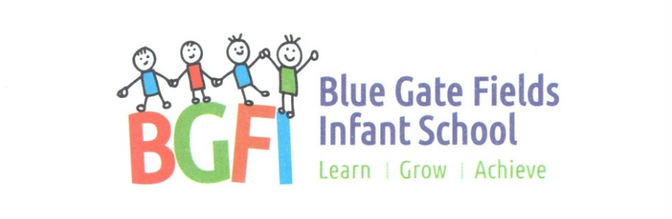

Food and Nutrition
Policy

Signed :________________ Headteacher Date: ___________
Signed :________________ Chair of Governors Date: ___________

Agreed January 2021 Review Date: January 2023
This policy is the responsibility of the Head teacher

This policy has been approved and adopted by the Governing Body and developed in consultation with the following:
• Teaching staff
• Members of the catering team
Introduction and rationale
At Blue Gate Fields Infant School, we recognise the importance of ensuring every child has access to a healthy and well balanced diet, supporting them to lead a healthy lifestyle. We also recognise the link between a healthy diet and children’s ability to learn. Our school has achieved National Healthy Schools Status.
The aims of our food policy are:
• To ensure food and healthy eating messages are embedded in the school’s ethos and consistent across all food provision and classroom activities.
• To provide a whole school approach to food and healthy eating to improve the health and wellbeing of children and their families.
Food in School
Drinks and water
All pupils have access to fresh water in the classroom and are encouraged to drink water throughout the day, including break times and lunchtimes. Children are encouraged to bring in water bottles from home, on a daily basis. Cups are available, if needed, for children without water bottles. Children are not permitted to bring in sugary drinks from home, and healthier drinks, such as milk or water, are encouraged. Our Nursery and Reception children are provided daily with a carton of milk each which is located on each class’ snack table.

School meals
Our school meals are provided by Tower Hamlets’ Catering Service, who ensure the menus are balanced and compliant with the mandatory food and nutrient based standards. The menus are regularly reviewed and a recent survey showed a good level of pupil satisfaction with school meals. Our menus are varied and include a range of meals from different cultures and countries. Copies of the menus are available at the school office.
• Universal free school meals:
Blue Gate Fields Infant School provides universal free school meals for children in reception and Key Stage One. All children at Blue Gate Fields Infant School having school dinners, choose their meals from the menu provided. Menus are on a 2 weekly cycle and include a vegetarian choice. All meat is Halal. Fresh bread, vegetables, salad and a desert are also freely available.
• Rewards: such as stickers or stars are given to children who show positive behaviour during lunchtime, such as helping another pupil, making healthy choices, or consistently positive behaviour.
• Promotion: We promote our school meals through displays and we invite parents in to eat lunch with their children throughout the year.
• Free school meals: Our school strongly encourages families to claim their free school meal (FSM) entitlement. We make sure that FSM pupils cannot be identified at any point of the school day.
• The dining room environment: Children use the hall to have their meals and packed lunches. Nursery children have their lunches in the classrooms.
• Cultural, age appropriate, and special diets: At Blue Gate Fields Infant School, we are supportive of children with any cultural and special dietary requirements and this is reflected in our food menus. All pupils’ dietary needs are recorded and communicated sensitively with the catering team. We aim to ensure portion sizes are age appropriate.
Packed lunches
As part of a healthy eating focus, rewards may be given to children who bring healthy options. Unhealthy snacks such as crisps, chocolate and sweets are strongly discouraged. This is consistent with the standards for school meals. Sugary drinks are not permitted, and if deemed appropriate by the Head teacher, inappropriate choices may be discussed with parents.
All pupils who bring in a packed lunch, are able to eat in the main dining room alongside school dinners. All wastage is sent home to help parents monitor their child’s eating. Parents will be encouraged to provide a balanced packed lunch, through information on the school website and around school. The school provides all packed lunch pupils with access to drinking water.
Playtime
At break times all children are provided with free fruit or vegetables, as part of the National Fruit and Vegetable Scheme and any surplus fruit is offered to other children in the afternoon. EYFS children are also provided with milk, which is either subsidised or free. Children are not encouraged to bring in snacks from home, unless they have a specific dietary or medical need.
Sustainable, food and drink
As a school we take pride in food culture. The system of children choosing their own meals means that there is less food wastage.
Special occasions and rewards
We understand that all children enjoy a treat on special occasions, although as a Healthy School we do not encourage parents to send sweets and cakes for birthdays or similar celebrations. Rewards in school are generally non-food based e.g. stationery, special mentions, games, stickers or healthy alternatives e.g. fruit.
School trips, clubs and events
Our standards of healthy eating are reflected beyond the usual school day and our food policy applies to school trips and other special events. At school celebrations and school fairs, we aim to provide and promote healthy alternatives, and limit unhealthy options, wherever possible.
Raising awareness of food through Curriculum
Our policy is reinforced and embedded through learning in the classroom. Food in the curriculum, is an important element, particularly in science and design and technology and we aim to provide children with the skills to design, make and evaluate food. Our curriculum will enrich children’s experience of food, physical activity and healthy balanced diets through Science, PSHE, PE and Design and Technology. We build on knowledge and practical skills through the key messages of the ‘eat well’ plate to support healthy choices for life beyond school.

This policy was approved by Governors in January 2021 and signed by the Chair of Governors.

Signed ………………………………. Chair of Governors

Date …………………………………….
It will be reviewed January 2023 or sooner in the case of any new information, changes or legislation.

