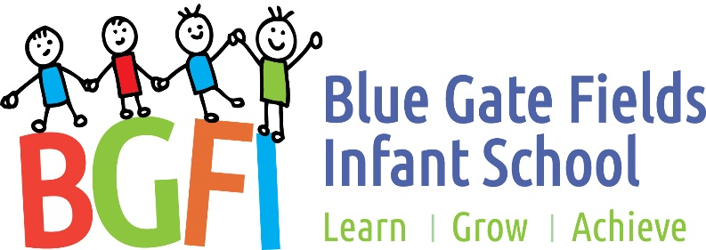

End of Year Expectations:
For Year Two

KS1 classes follow the National Curriculum.

These expectations reflect the age expected standards for each year group.

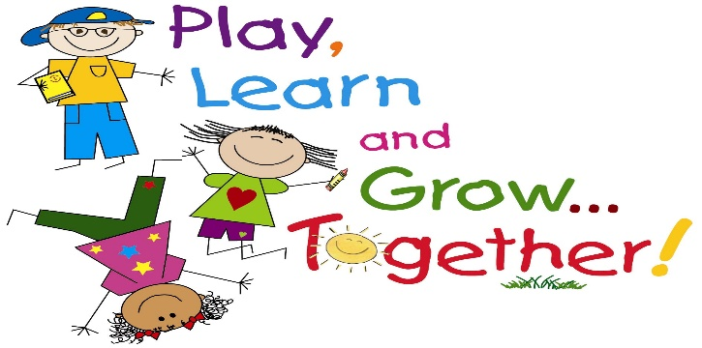

This booklet provides information for parents and carers on the end of year expectations for children within our school

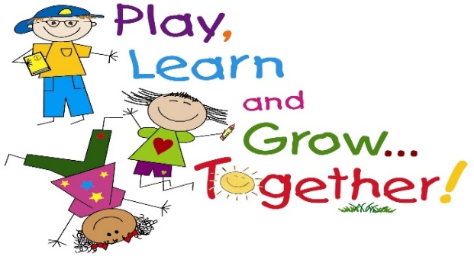

By the end of Year 2 in Mathematics:
Number
I can read and write all numbers to at least 100 in numerals and words.
I recognise odd and even numbers to 100.
I can count in steps of 2, 3 and 5 from 0.
I recognise and can define the place value of each digit in a 2 digit number.
I can compare and order numbers from 0 to 100 using the < > and = signs.
I can name the fractions 1/3, 1/4, 1/2 and 3/4 and can find fractional values of shapes, lengths and numbers.
I can recall and use multiplication and division facts for the 2, 5 and 10 x tables.
I can add and subtract a 2-digit number and ones.
I can add and subtract a 2-digit number and tens.
I can add and subtract two 2-digit numbers.
I can add three 1-digit numbers.
I can solve problems involving addition and subtraction.
I understand and can use addition, subtraction, multiplication and division.

Measurement, geometry and statistics
I can choose and use appropriate standard units to estimate length, height, temperature and capacity.
I can tell and write the time to 5 minute intervals.
I recognise and can use the symbols £ and p when solving problems involving addition and subtraction of money.
I can describe the properties of 2D and 3D shapes to include edges, vertices and faces.
I can interpret and construct pictograms, tally charts, block diagram and simple tables.

By the end of Year 2 in Oracy:
I can ask question to get more information and clarify meaning.
I can talk in complete sentences.
I can decide when I need to use specific vocabulary.
I can take turns when talking in pairs or a small group.
I am beginning to be aware that formal and informal situations require different language.
I can retell a story using narrative language and linking words and phrases.
I can hold the attention of people I am speaking to by adapting the way I talk.
I am beginning to understand how to speak for different purposes and audiences.
I can perform a simple poem from memory.

By the end of Year 2 in Reading:
Word reading
I can decode automatically and fluently.
I can blend sounds in words that contain the graphemes we have learnt.
I can recognise and read alternative sounds for graphemes.
I can read accurately words of two or more syllables.
I can read words with common suffixes.
I can read common exception words.
I can read and comment on unusual correspondence between grapheme and phoneme.
I read most words quickly and accurately when I have read them before without sounding out and blending.
I can read most suitable books accurately, showing fluency and confidence.

Comprehension
I can talk about and give an opinion on a range of texts.
I can discuss the sequence of events in books and how they relate to each other.
I use prior knowledge, including context and vocabulary, to understand texts.
I can retell stories, including fairy stories and traditional tales.
I can read for meaning and check that the text makes sense. I go back and re-read when it does not make sense.
I can find recurring language in stories and poems.
I can talk about my favourite words and phrases in stories and poems.
I can recite some poems by heart, with appropriate intonation.
I can answer and ask questions.
I can make predictions based on what I have read.
I can draw (simple) inferences from illustrations, events, characters’ actions and speech.

Spelling
I can segment spoken words into phonemes and record these as graphemes.
I can spell words with alternatives spellings, including a few common homophones.
I can spell longer words using suffixes such as ‘ment’, ‘ness’, ‘ful’, ‘less’, ‘ly’.
I can use my knowledge of alternative phonemes to narrow down possibilities for accurate spelling.
I can identify phonemes in unfamiliar words and use syllables to divide words.
Handwriting
I can form lower-case letters of the correct size relative to one another.
I can begin to use some of the diagonal and horizontal strokes needed to join letters.
I show that I know which letters are best left unjoined.
I use capital letters and digits of the correct size, orientation and relationship to one another and to lower case letters.
I use spacing between words that reflects the size of the letters.

By the end of Year 2 in Writing:
Composition
I can write narratives about personal experiences and those of others, both real and fictional.
I can write for different purposes, including real events.
I can plan and discuss the content of writing and record my ideas.
I am able to orally rehearse structured sentences or sequences of sentences.
I can evaluate my own writing independently, with friends and with an adult.
I can proof-read to check for errors in spelling, grammar and punctuation.

Grammar and punctuation
Sentence structure
I can use subordination and co-ordination.
I can use expanded noun phrases.
I can say how the grammatical patterns in a sentence indicate its function.
Text structure
I consistently use the present tense and past tense correctly.
I can use the progressive forms of verbs in the present and past tense.
Punctuation
I use capital letters for names of people, places, day of the week and the personal pronoun ‘I’.
I correctly use question marks and exclamation marks.
I can use commas to separate items in a list.
I can use apostrophes to show where letters are missing and to mark singular possession in nouns.

By the end of Year 2 in Science:
Working scientifically (Y1 and Y2)
I can ask simple scientific questions.
I can use simple equipment to make observations.
I can carry out simple tests.
I can identify and classify things.
I can suggest what I have found out.
I can use simple data to answer questions
Living things and their habitats
I can identify things that are living, dead and never lived.
I can describe how a specific habitat provides for the basic needs of things living there (plants and animals).
I can identify and name plants and animals in a range of habitats.
I can match living things to their habitat.
I can describe how animals find their food.
I can name some different sources of food for animals.
I can explain a simple food chain.
Plants
I can describe how seeds and bulbs grow into plants.
I can describe what plants need in order to grow and stay healthy (water, light & suitable temperature).
Animals, including humans
I can explain the basic stages in a life cycle for animals, including humans.
I can describe what animals and humans need to survive.
I can describe why exercise, a balanced diet and good hygiene are important for humans.
Uses of everyday materials
I can identify and name a range of materials, including wood, metal, plastic, glass, brick, rock, paper and cardboard.
I can suggest why a material might or might not be used for a specific job.
I can explore how shapes can be changed by squashing, bending, twisting and stretching.

