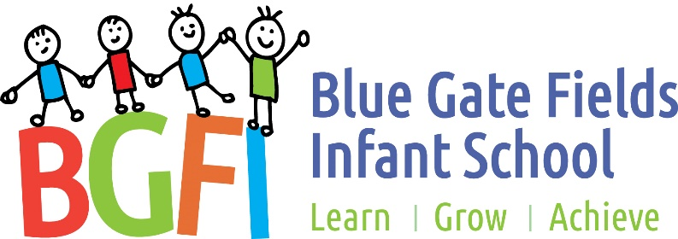

Blue Gate Fields
Infant School

Water only policy

December 2021

Context
Schools are a key setting to teach children about nutrition and healthy beverage choices. School based interventions reach all children regardless of their background.
Tower Hamlets has amongst the highest childhood excess weight and obesity levels in London.
One reason for this is the high sugar diet that many children consume. For example, a can of Coca-Cola contains 35g of sugar and a can of Pepsi contains 36g of sugar which equates to 150% of the recommended daily sugar intake for children aged between 7 and 10years. Fruit juices and smoothies also contain high levels of sugar despite often being advertised as healthy.
High levels of sugar can also contribute to tooth decay. Every day in the UK there are 180 operations to remove children’s teeth due to tooth decay, at a significant cost to the NHS and to families.
Some soft drinks, particularly sports and energy drinks, have high levels of caffeine. Such drinks can cause poor concentration in class, headaches, irritability, sleepiness, dizziness and can affect behaviour and attainment.
Promoting drinking water and banning fizzy drinks will reduce tooth decay, promote healthier choices and improve the health of pupils. On average, children should be provided with 6-8 glasses of water per day.

Policy introduction
A water only school is one where the only drink available to students is water (and milk in nursery / reception classes). Schools should ensure that children are not bringing sugary drinks onto the school premises, including for after school or with their lunch.

Water only schools policy
- The only drinks to be available to children at Blue Gate Fields Infants are:
  - Plain water (unless for medical reasons)
  - Plain reduced fat milk in nursery classes (including skimmed or semi skimmed, lactose free and soya milk).

- If a child has a medical condition that requires them to drink sugary drinks then this is treated as an exception to this policy and should be approved by the headteacher.

- Other drinks should not be made available from school. Schools should request that caterers and in house teams follow this policy, removing drinks other than water from their canteens. Drinking water provided must be free from water fountains and jugs on tables and not for sale in plastic bottles.

- Pupils must have free access to drinking water throughout the day and be encouraged to drink it.

- The water-only policy is to be applied to all breakfast and afterschool clubs, as well as extracurricular events such as sports days and school fetes.

- Teachers should be water-only role models and regularly drink water in front of their students to highlight the importance of hydration. Staff must not be seen to be drinking sugary or fizzy drinks by children and should limit other drinks to the staff room only.

- Parents are discouraged from bringing drinks other than water to the playground before and after school. Families are banned from packing drinks in lunch boxes as water is provided at school.

- Banners and posters around the school should promote water consumption.

Appendix 1: Recommendations and good practice
In schools where water is pre-poured into beakers, children were seen to drink more water, whilst in schools where children had to collect a cup from another table, they often did not and so went without a drink over lunchtime.
Water jugs are often too heavy for younger children resulting in spillages. Younger children should have water pre-poured into beakers and topped up for them regularly to avoid spillages.
For older children, water should be positioned in a visible location e.g. on dining tables so it is more difficult for children to avoid or miss.
All children should be actively encouraged to drink water during their lunch break by dining room staff, teachers and midday meal supervisors.

Appendix 2: Change4Life
Examples of water-only posters that could be put up in schools to promote drinking water:
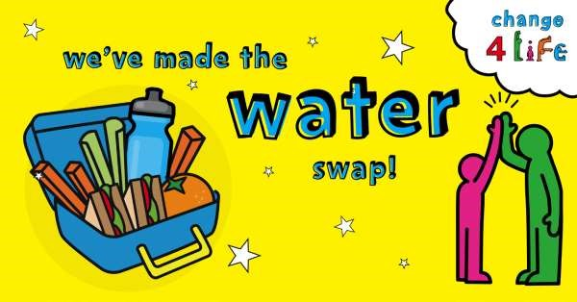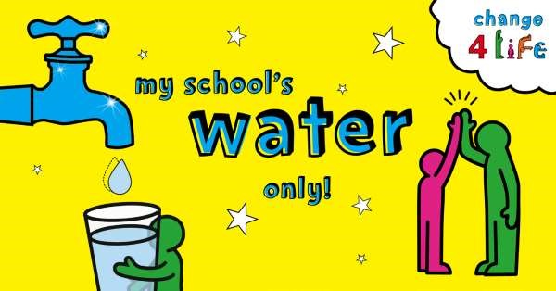

More resources are available online: https://www.nhs.uk/change4life/

