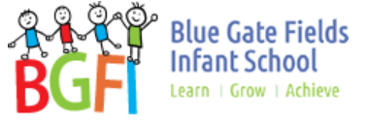
Health and Relationships Education at

Blue Gate Fields Infants School
Here is a quick overview of what it’s all about and what it will look like at Blue Gate Fields Infants
Health Education consists of 8 elements:
- Mental wellbeing
- Internet Safety and harms,
- Physical Safety and fitness,
- Healthy Eating,
- Drugs, alcohol and tobacco (we will only cover taking medication),
- Health and prevention,
- Basic First Aid,
- Changing adolescent body (we will not be covering this part of health education due to the young age of our children).

Relationships Education consists of 5 elements:
- Families and people who care for me,
- Caring Friendships,
- Respectful relationships,
- Online relationships,
- Being safe.

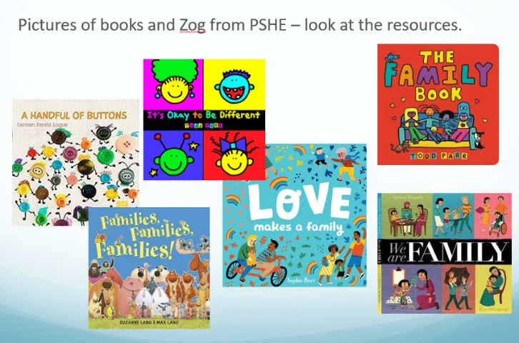
Resources:
- Jigsaw PSHE scheme of work
- Books about different types of families,
- NSPCC PANTS rules to teach children that their bodies belong to them, and they should tell someone they trust if anything makes them feel upset or worried.

Where can I find the content of what is being taught?
This can be found on the school website under the learning tab. You can then select your child’s year group and look at what is covered in the PSHE curriculum.

Do I have the right to withdraw my child?
We believe that it is important that all children receive this content, covering topics such as friendships and how to stay safe.

If I have concerns or worries, who can I talk to? Please speak to Gosia. You can also speak to Nazia who is available every Thursday.

Your views matter

As parents we feel your views and opinions matter and so we ran a zoom session last month to talk about the curriculum. Parents who attended the session had requested to see the resources so on Thursday 29th April we also had a ‘book look’ session. Feedback from the session was much appreciated. We have also removed some books from the learning pack to reflect the age and religious backgrounds of families.
Due to Covid restrictions we are unable to hold a physical coffee morning for all parents, so we have planned to put the books out in the playground every Thursday, between 9am – 9.30 am. Please do pop along to have a look at the resources and share your thoughts and opinions on the topic. Questions and feedback on what we are planning to cover is very much welcomed and Gosia and Nazia will be available to answer any questions on the day. Syeda will also be available to provide Bengali interpretive support.

