Playdough is great for little hands and fingers through rolling, squeezing and pinching as we make models.
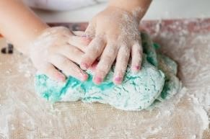

Playdough Recipe
You can help your grown-up make this recipe – except for where there is hot water, grown-ups only!
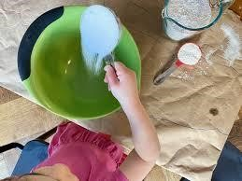
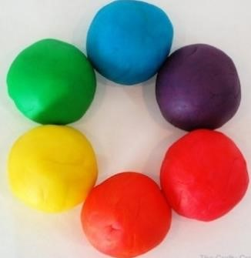
You will need:
2 cups plain flour
2 tablespoons of vegetable oil
½ cup of salt
2 tablespoons of cream of tartar
1 cup of boiling water (add only as much as you need) Food colouring if you wish
How to make your playdough:
- Mix the flour, salt, cream of tartar and oil in a large mixing bowl.
- Add food colouring to the boiling water then add to the dry ingredients (leave this bit to your grown-up!).
- Stir until it changes to a dough.
- Allow to cool then take it out of the bowl and knead it for a couple of minutes until the stickiness has gone.
- If it is still a little sticky, just add a little more flour until just right.
Saltdough is used to make models and decorations that you can keep forever!

Saltdough Recipe


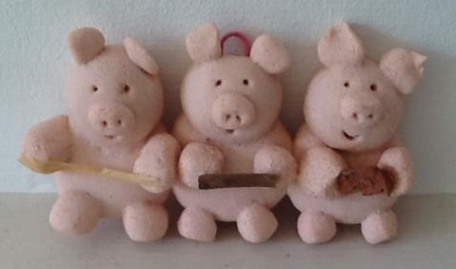
You will need:

2 cups of plain flour
1 cup of salt
1 cup of water
Food colouring if you wish

How to make your saltdough:

- Mix together the flour and salt in a large mixing bowl.
- Add food colouring to 1 cup of water if you wish.
- Stir the water into the flour and salt until it becomes a ball.
- Place the dough on a flat surface and knead it together.
- Make your model/ornament.
- The dough can be left to air dry, or (leave this bit to your grown-up!) placed on a baking sheet with greaseproof paper and dried in a low oven at 120-150ºC for about 2 hours.
- The time the dough takes to dry will depend on the size and thickness of your model/ornament.

When completely cool, you can enjoy painting and decorating your model/ornament!

