Year 2 Numeracy
Week beginning 9th November: Statistics

Day | Video Link  (Copy and paste into your browser) | Learning/Activity | Enrichment/Problem solving/Reasoning
Monday | https://vimeo.com/501669795 | LI: Make tally charts  Practical: make a tally chart of your family and friends’ favourite fruit or sport. | Have a go at the enrichment activity  https://nrich.maths.org/2341
Tuesday | https://vimeo.com/501671369 | LI: Make tally charts  See Tuesday worksheet | Explore data handling  https://www.ictgames.com/mobilePage/statistics/index.html
Wednesday | https://vimeo.com/501672753 | LI: Draw pictograms  Practical: Draw a pictogram of your family and friends’ favourite fruit or sport. | Have a go at the enrichment activity  https://nrich.maths.org/7227
Thursday | https://vimeo.com/501673699 | LI: Draw pictograms  See Thursday worksheet | Have a go at this mental maths game  https://www.topmarks.co.uk/learning-to-count/blast-off
Friday | https://vimeo.com/501674074 | LI: Interpret pictograms  See Friday worksheet | Have a go at the enrichment activity  https://nrich.maths.org/2185

Tuesday
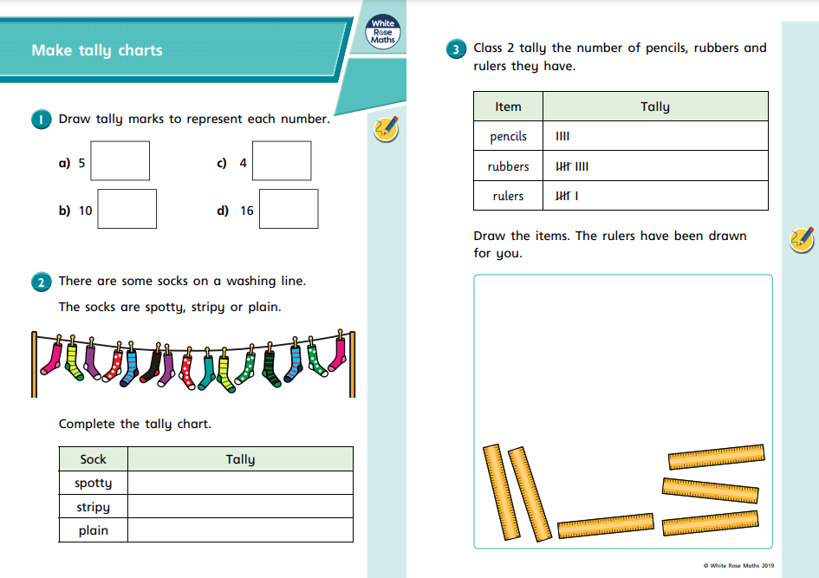
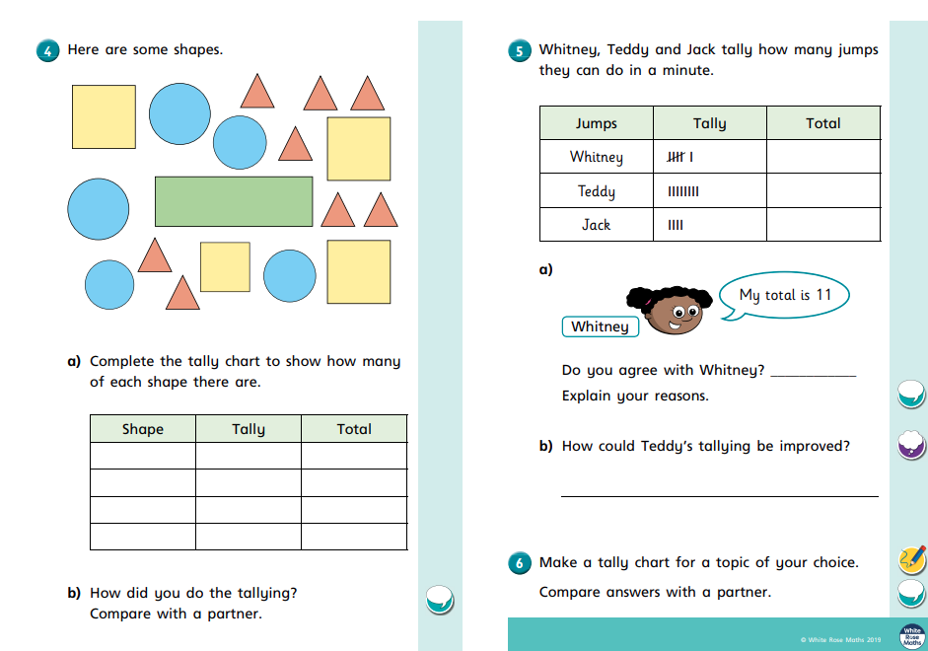
Thursday
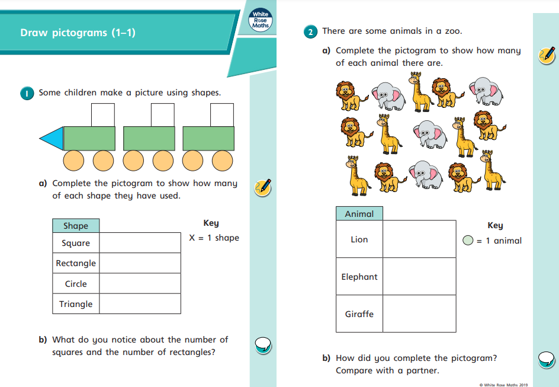
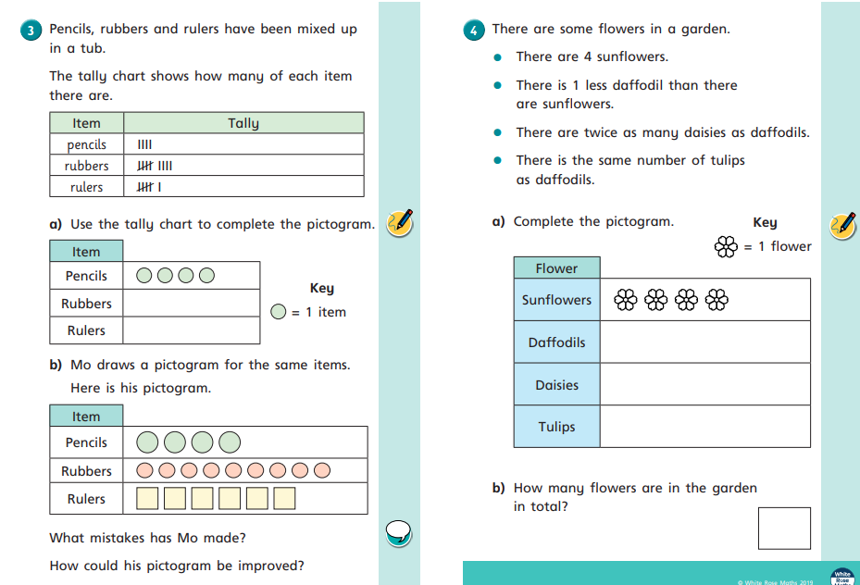
Friday


