Year 2 Literacy
Week beginning 9th November This week year 2 are learning how to write instructions.
Book: Jack and the baked beanstalk.
When opening web links hold down control key and click link.

Day | Lesson PowerPoint | Activity | Phonics
Monday |  | Identify the features of an instructional text. | Digraph ea  https://www.youtube.com/watch?v=piYgABVFHLI&list=PLuGr6z2H2KNE3ABRJaKoQWiIrXvxCUhg-&index=5
Tuesday |  | Brainstorm ideas on what you need to look after a hen. Write it in your learning book.  See resources below and watch the video link for ideas. | Digraph ir  https://www.youtube.com/watch?v=hjDpSbiY5Og&list=PLuGr6z2H2KNE3ABRJaKoQWiIrXvxCUhg-&index=4
Wednesday  and  Thursday |  | On Wednesday, write the title and a list for what you need. Draw pictures to go with your list.  On Thursday, write your set of instructions on how to look after a hen. Look at the resources below to help you. Remember to start with an imperative verb and add adverbs (carefully, gently etc) | Digraph ou  https://www.youtube.com/watch?v=uRmjH4TzITw&list=PLuGr6z2H2KNE3ABRJaKoQWiIrXvxCUhg-&index=3
Wednesday  and  Thursday |  |  | Digraph oy  https://www.youtube.com/watch?v=ZNikBc4tZic&list=PLuGr6z2H2KNE3ABRJaKoQWiIrXvxCUhg-&index=2
Friday
Friday |  | Follow the instructions on the last page and write a sentence in your learning book why it is important to follow and give instructions carefully. Use the template below. | Review: ea, ir, ou, oy  https://www.youtube.com/watch?v=VPPpxGyBkeA&list=PLuGr6z2H2KNE3ABRJaKoQWiIrXvxCUhg-&index=1

Monday

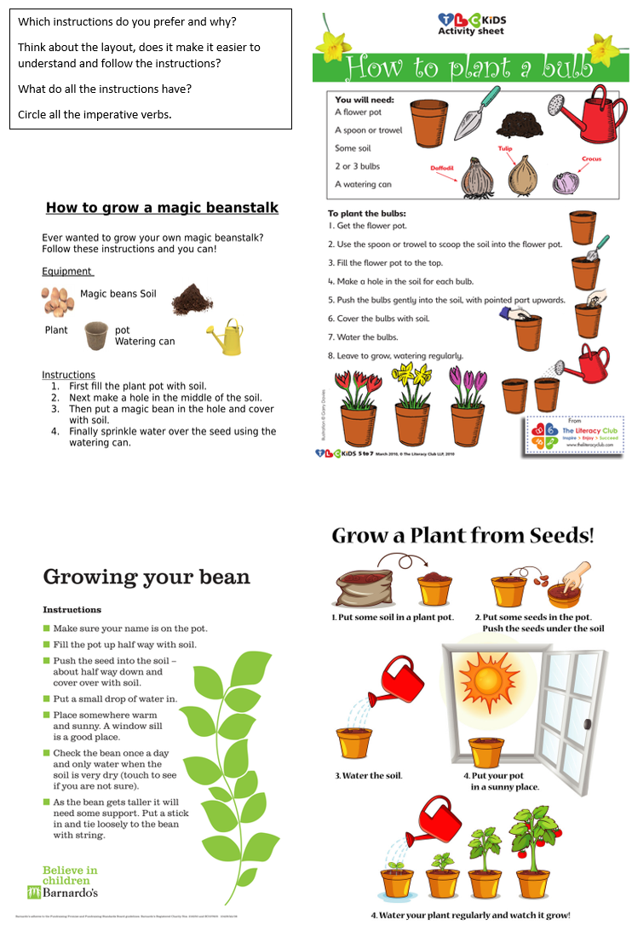

Tues
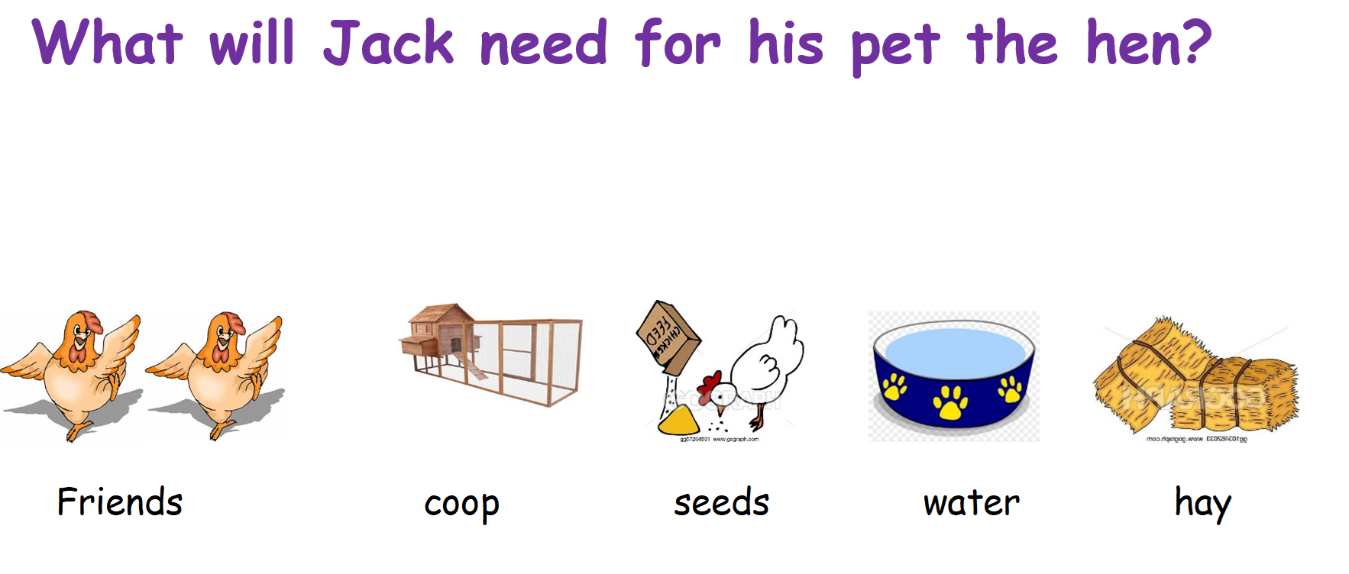
https://www.youtube.com/watch?v=VHUzVesHR8o&ab_channel=Petco

Wed and Thursday


