Year 2 Numeracy
Week beginning 2 November Measurement: Money
Day | Video Link  (Copy and paste into your browser) | Learning/Activity | Enrichment/Problem solving/Reasoning
Monday | https://vimeo.com/479814464 | LI- Comparing money  See Monday worksheet | Have a go at the enrichment activity  https://nrich.maths.org/223
Tuesday | https://vimeo.com/479815623 | LI- Finding a total  See Tuesday worksheet | https://www.topmarks.co.uk/money/toy-shop-money
Wednesday | https://vimeo.com/479816379 | LI- Finding the difference  See Wednesday worksheet | Have a go at the enrichment activity  https://nrich.maths.org/142
Thursday | https://vimeo.com/479816820 | LI- Finding change  See Thursday worksheet | https://www.topmarks.co.uk/money/coins-game
Friday | https://vimeo.com/479817217 | LI- Two step problems  See Friday worksheet | https://natwest.mymoneysense.com/students/students-5-8/coin-cruncher/

Monday
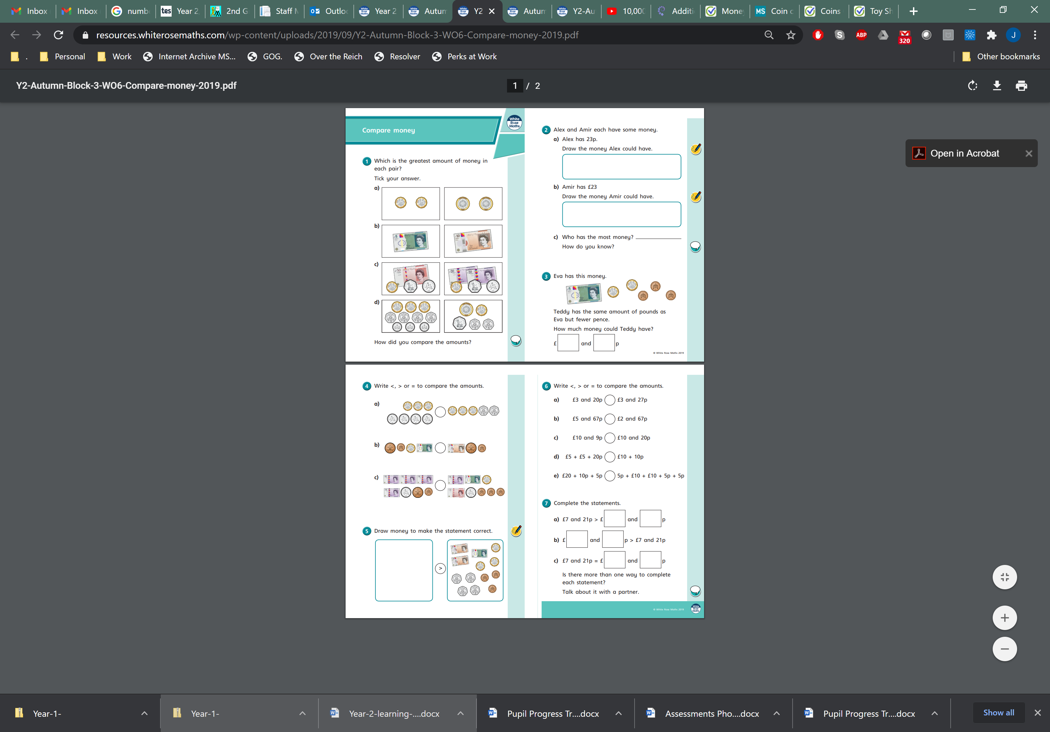
Tuesday
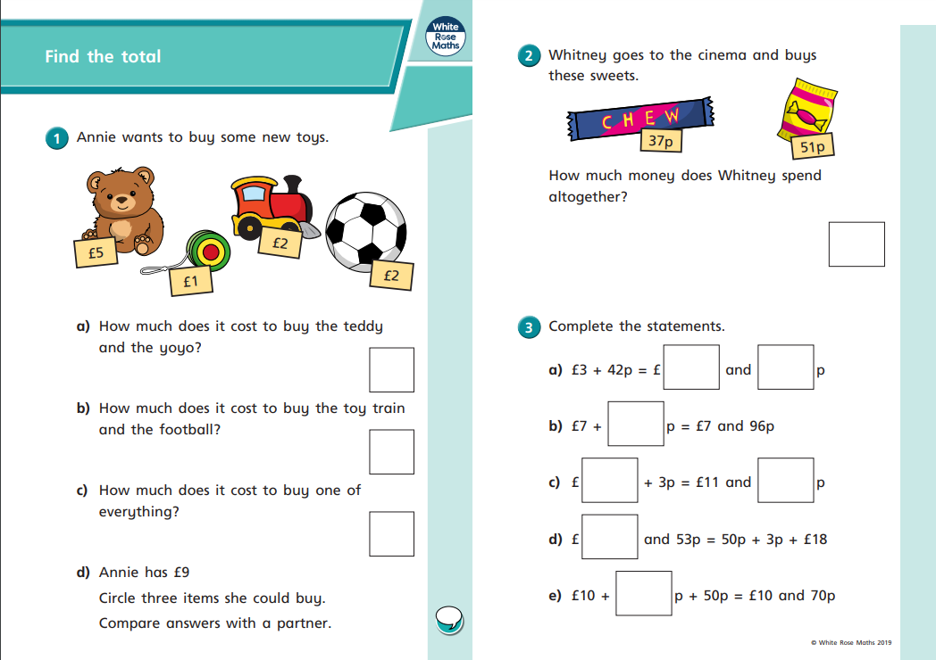
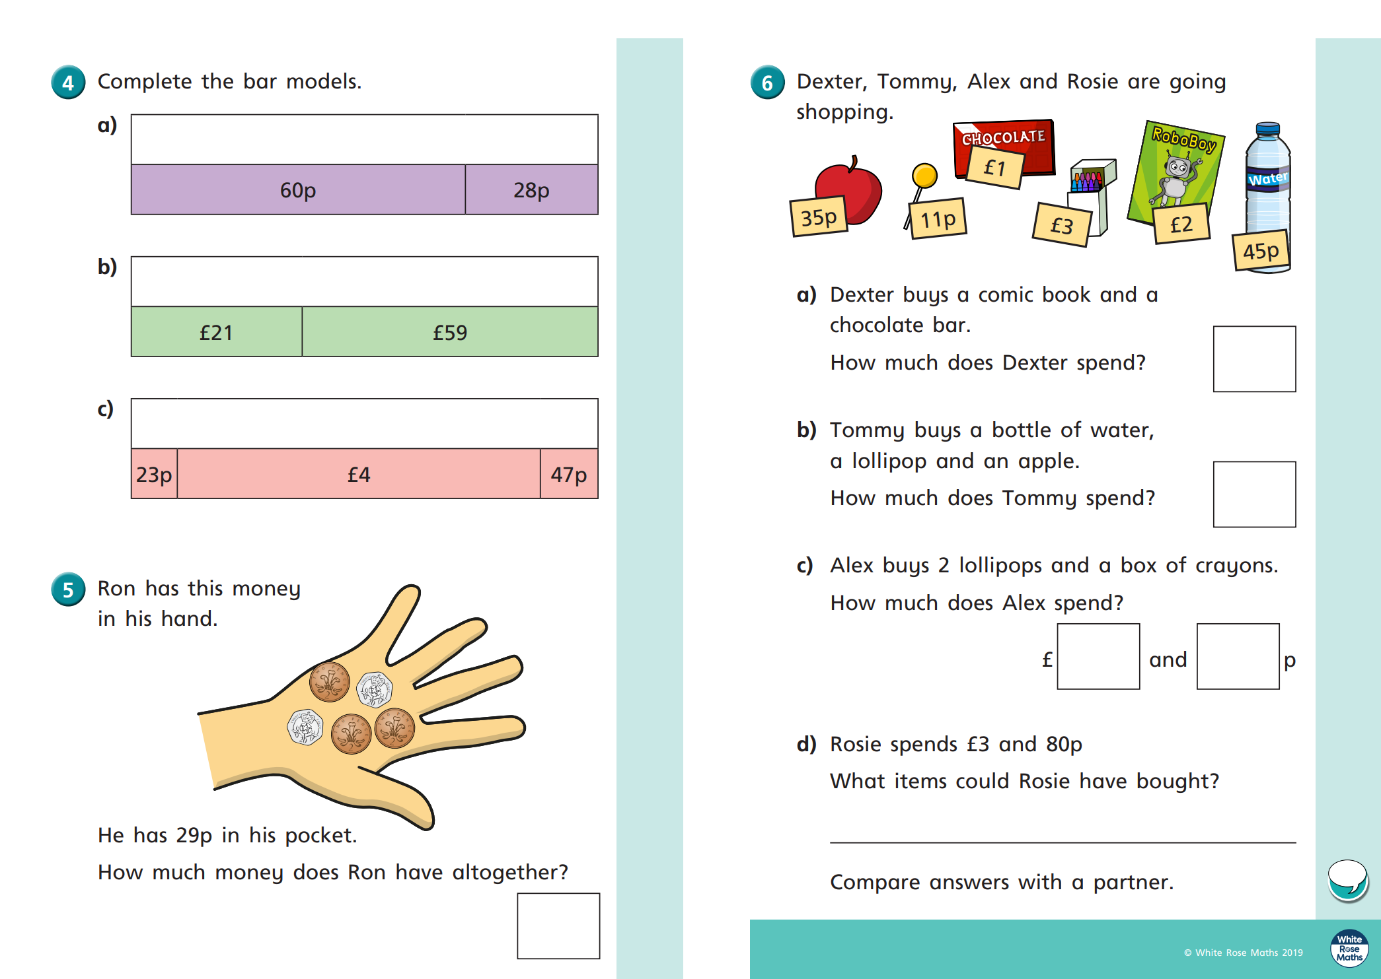
Wednesday
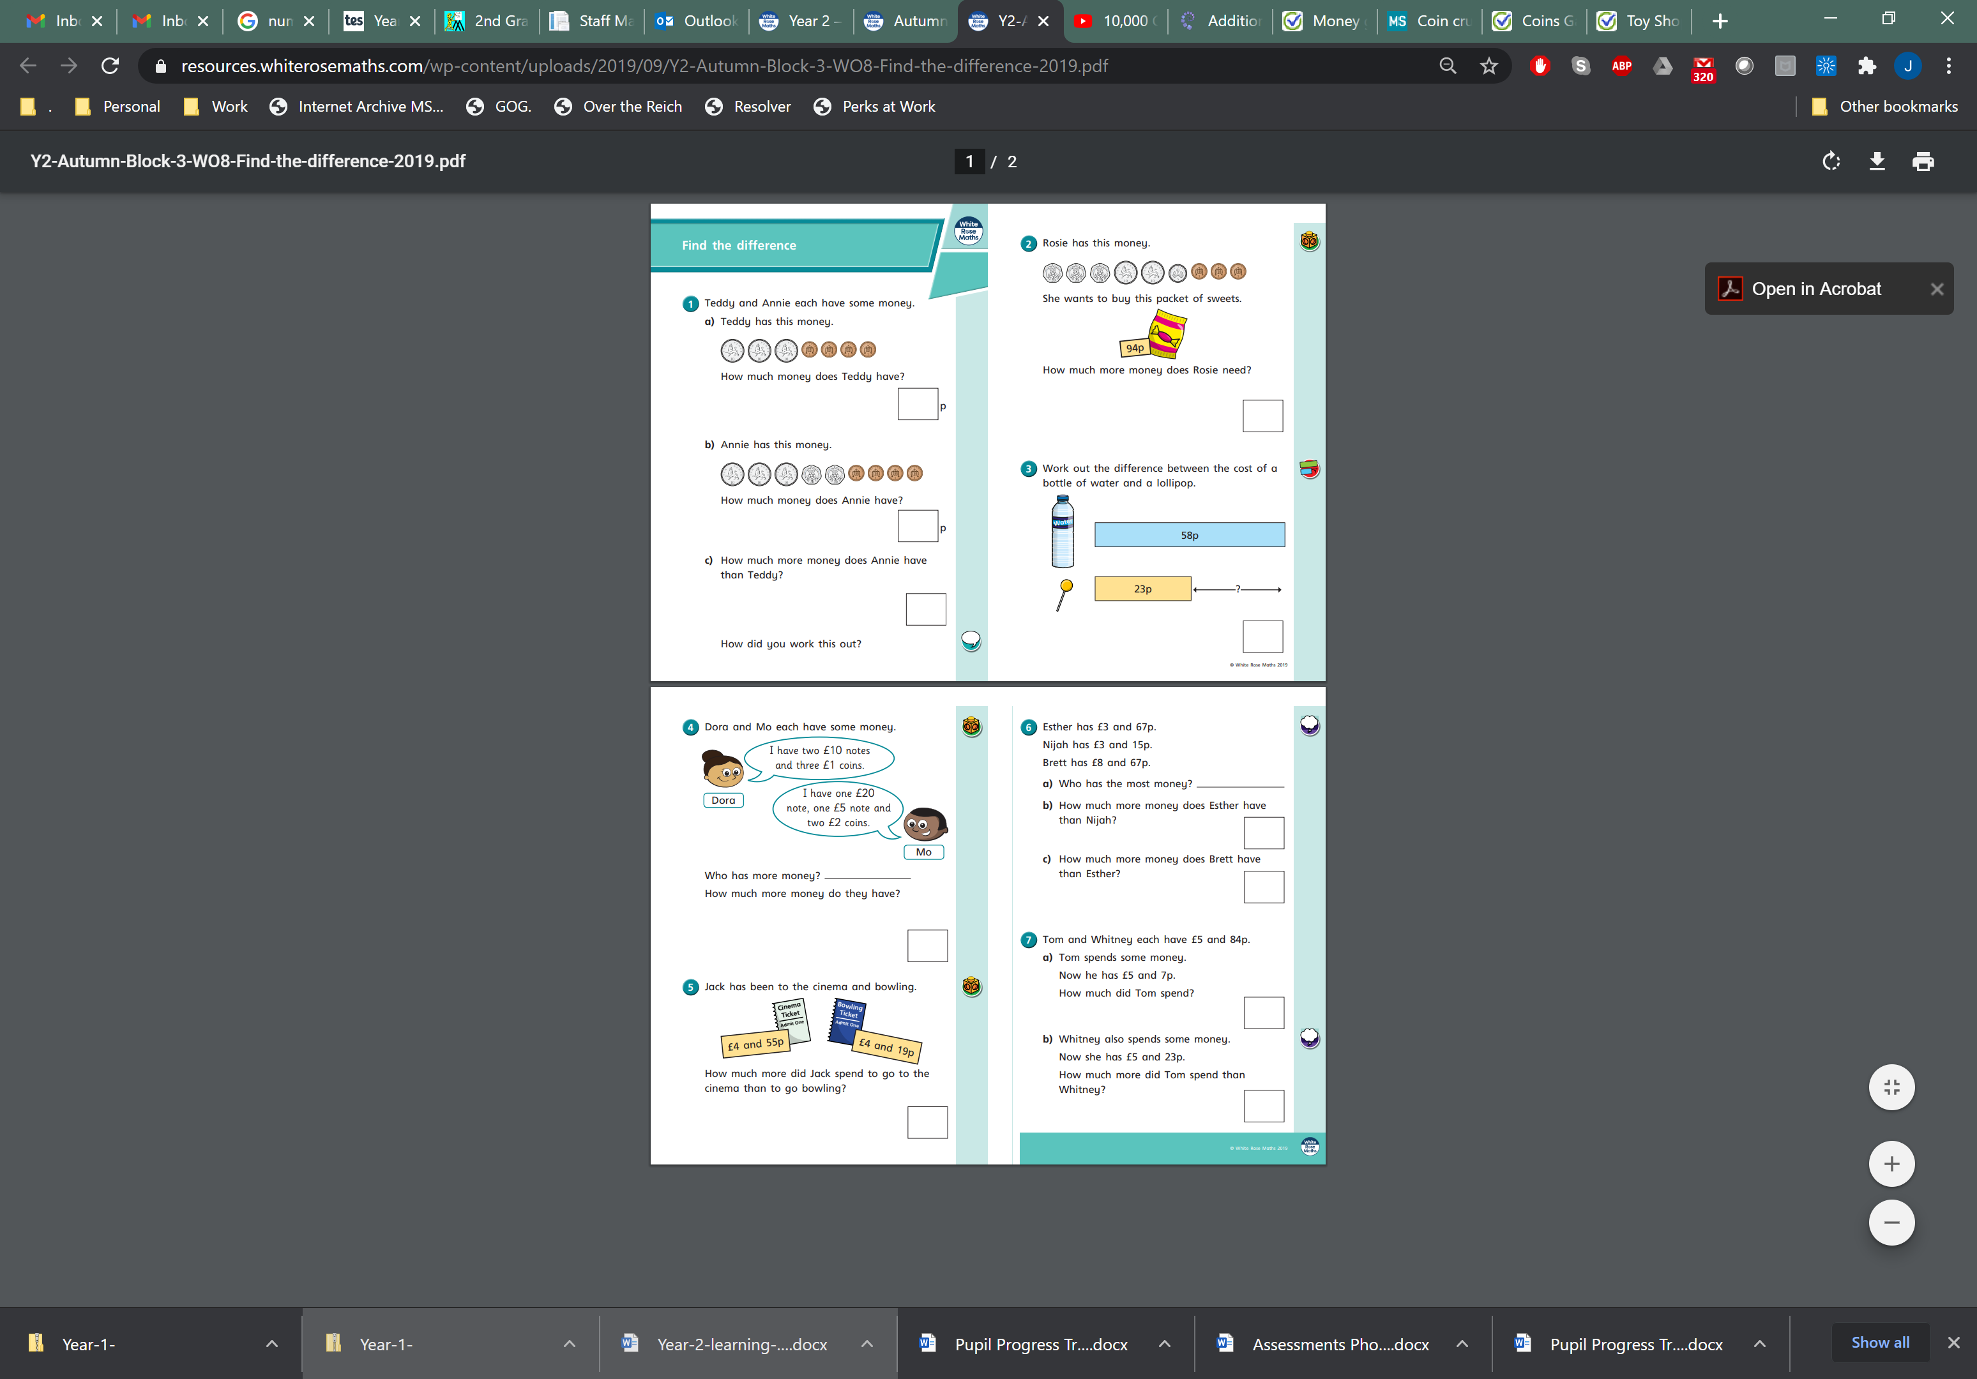

Thursday
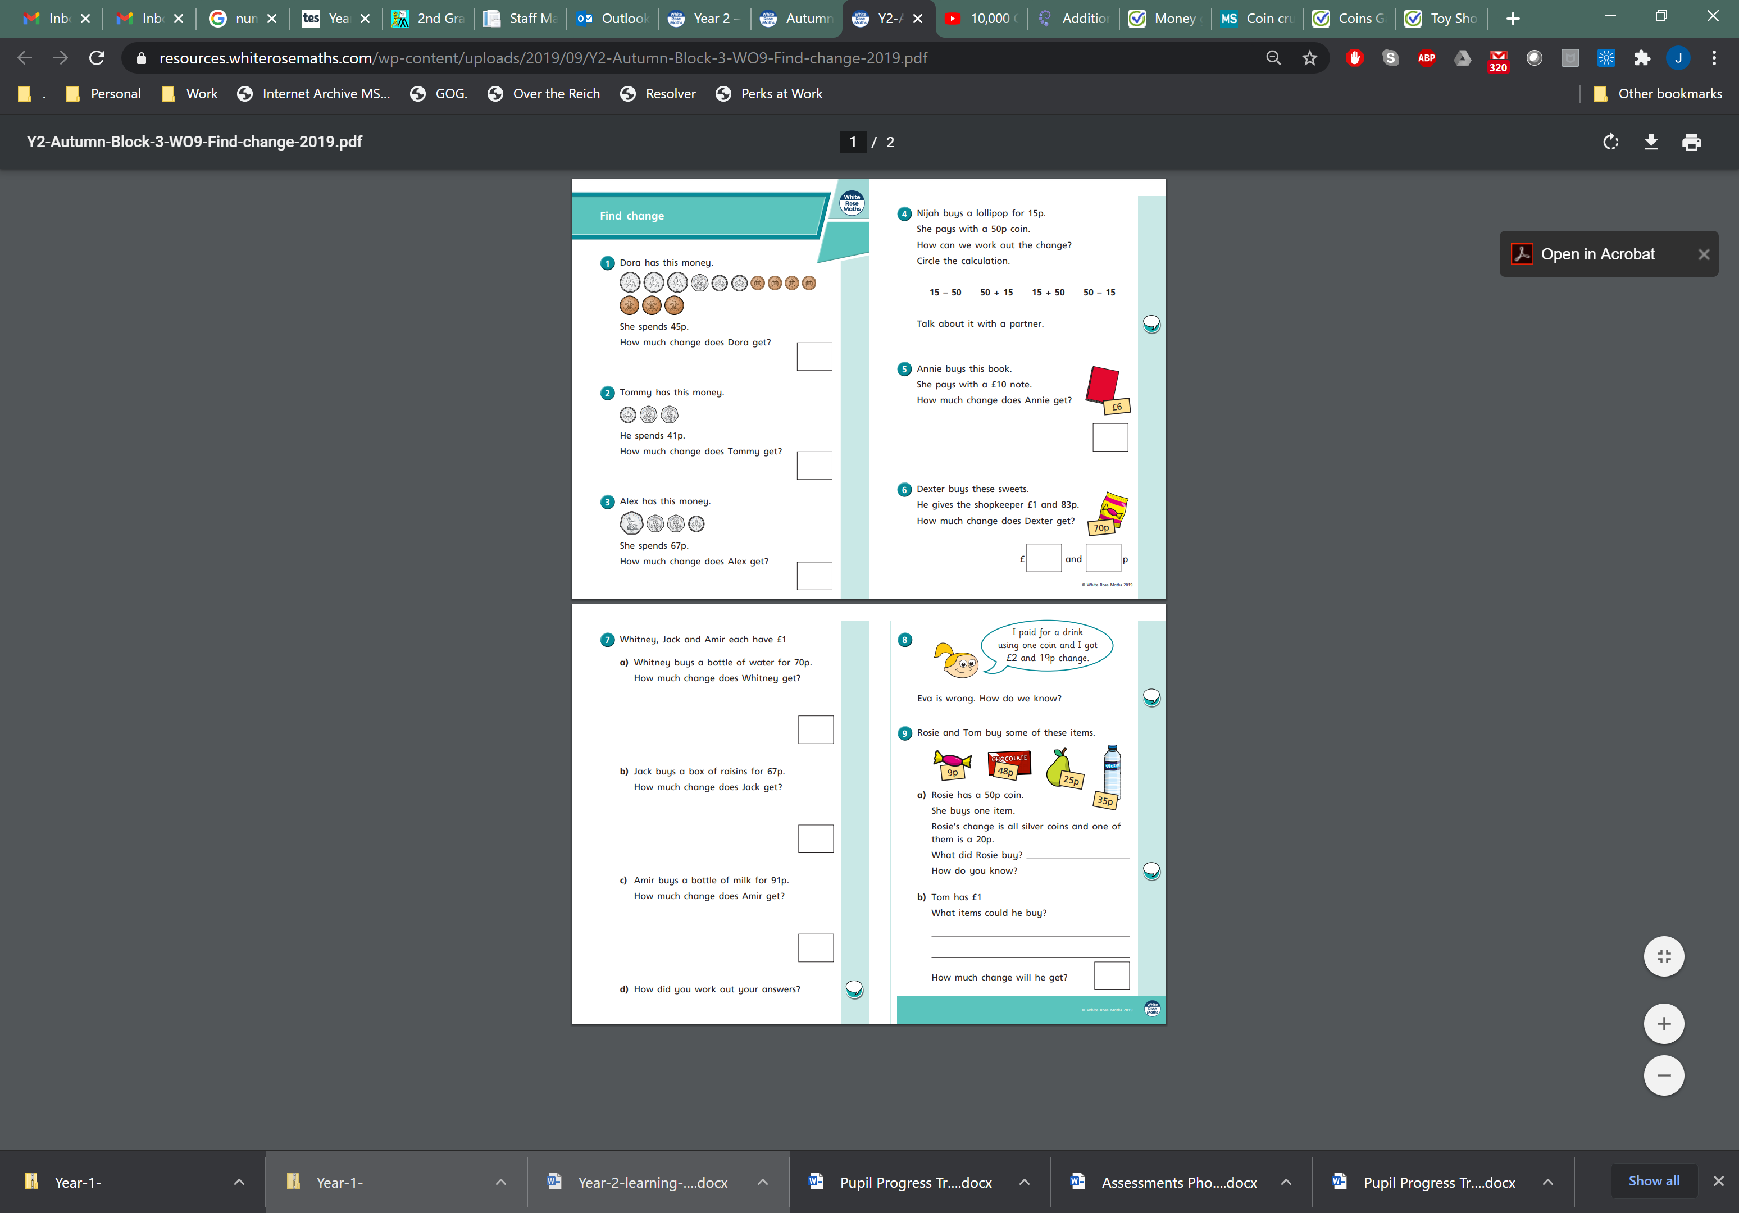
Friday


