Year 2 Literacy
Week beginning 2nd November This week year 2 are learning to innovate a story. https://www.youtube.com/watch?v=1T8-yNxseEQ
Day | Activity | Phonics
Monday | We are learning to change parts of a story. Look at the worksheet below and think of a different setting and character for the story. Fill in the sheet below to innovate your story.  Draw a picture plan of your own version of the story. | ie  https://www.youtube.com/watch?v=OYNoDL0lr84
Tuesday | Write your own version of the story. | i-e  https://www.youtube.com/watch?v=y-6I2ID6KfI
Wednesday | Write your own version of the story. | Y  https://www.youtube.com/watch?v=SMXobblz6uU
Thursday | Write your own version of the story. | i  https://www.youtube.com/watch?v=BPUOhjLnJUU
Friday | Children to practice their spelling and write their own sentences with the spelling words. | revision Identify ‘oa’ words in text.

Monday
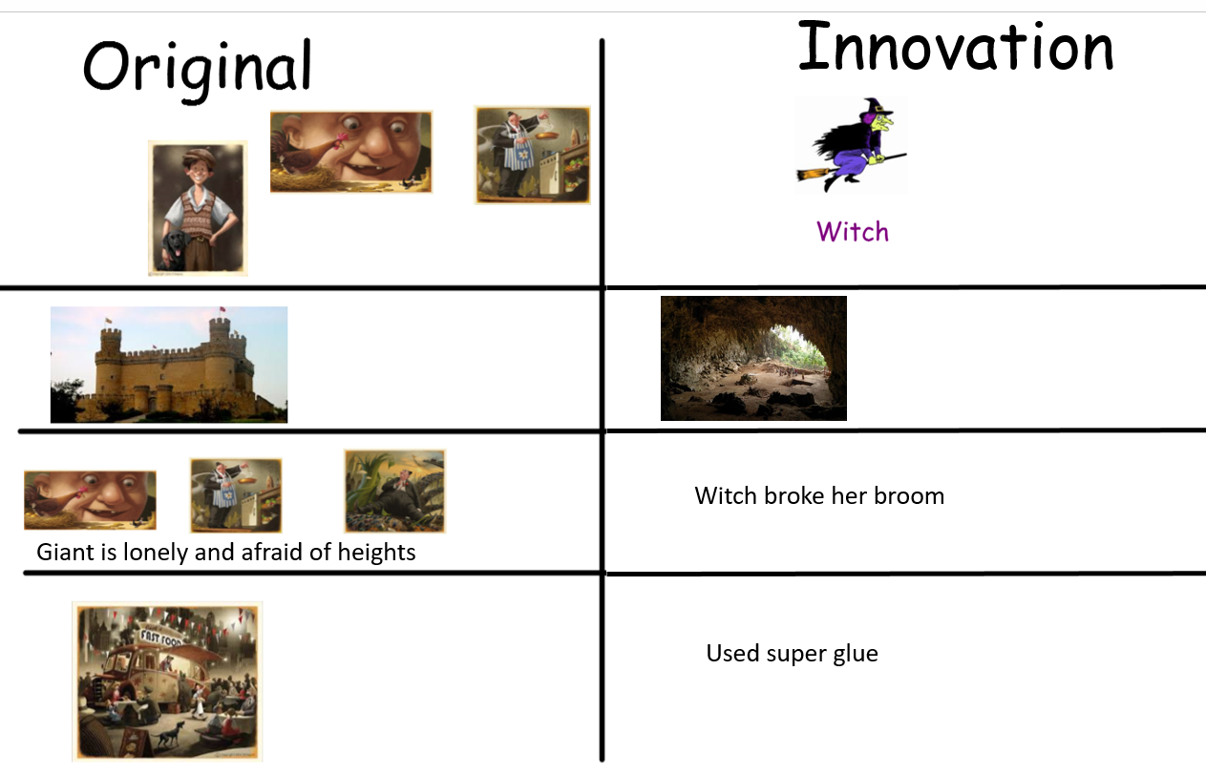

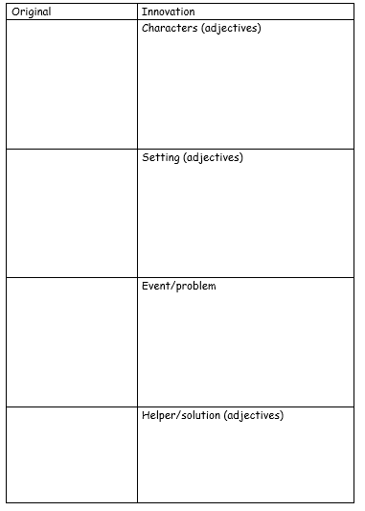

Tues
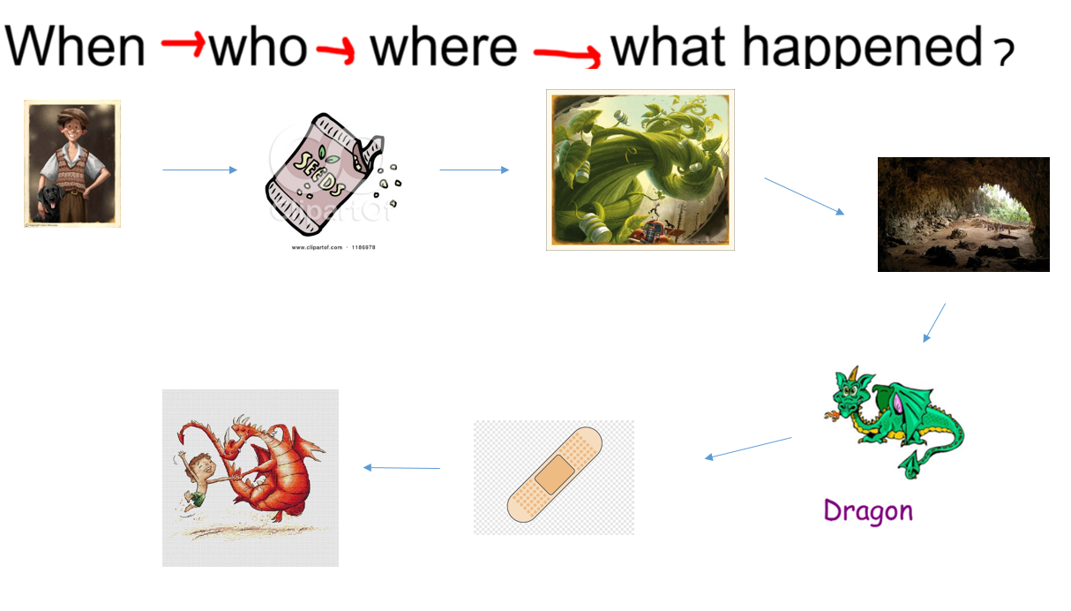
Wed and thurs


