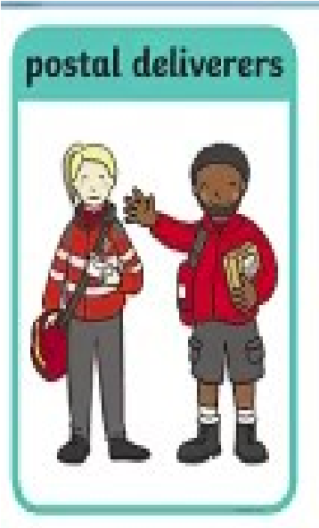
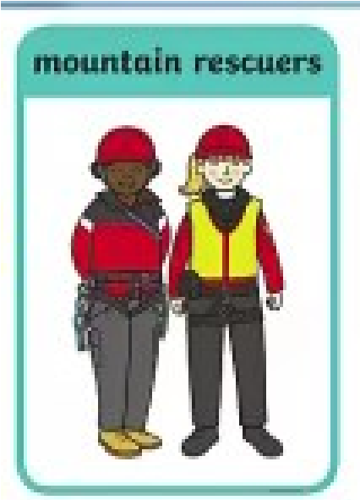
Nursery and Reception Home Learning Project
Autumn 2
Our Local Superheroes
Over this half-term we would like you to help your child to research different local superheroes and make a poster together to showcase all of their hard work.
Your child can choose which heroes they are interested in and can design their poster in any way that suits them.
Things to include: What job do they do?, Who do they help?, How do they help people?, Do they wear a uniform?, Where do they work?, a drawing or photograph.
Your child will need to bring their poster to school by the end of term so that they can share their hard work with their class.


