Year 2 Numeracy
Week beginning 19th October: Addition and subtraction
Day | Video Link  (Copy and paste into your browser) | Learning/Activity | Enrichment/Problem solving/Reasoning
Monday | https://vimeo.com/468561808 | LI: Subtracting 2-digit numbers.  See Monday worksheet | Have a go at the enrichment activity  https://nrich.maths.org/8296
Tuesday | https://vimeo.com/468562834 | LI: Subtracting 2-digit numbers.  See Tuesday worksheet | https://www.topmarks.co.uk/maths-games/hit-the-button
Wednesday | https://vimeo.com/470136728 | LI: Finding and making number bonds.  See Wednesday worksheet | Have a go at the enrichment activity  https://nrich.maths.org/5651/index
Thursday | https://vimeo.com/470138599 | LI: Number bonds to 100.  See Thursday worksheet | https://www.topmarks.co.uk/maths-games/daily10
Friday | https://vimeo.com/470178269 | LI: Adding three 1-digit numbers  See Friday worksheet | https://www.topmarks.co.uk/maths-games/hit-the-button

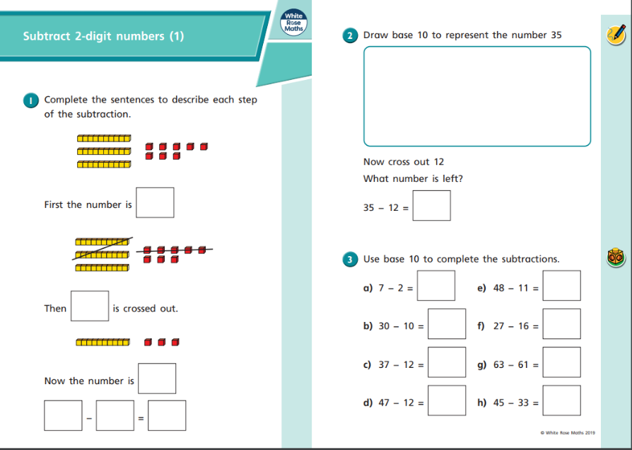
Monday
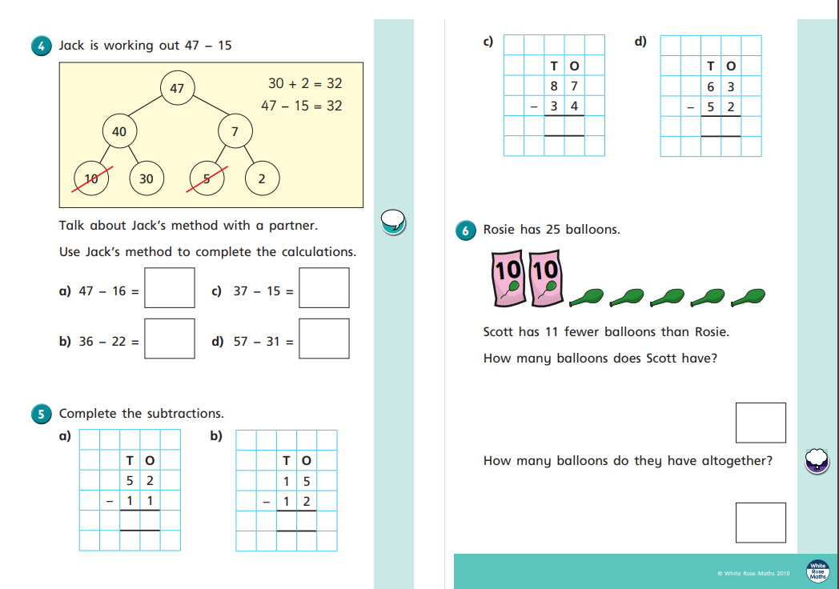
Tuesday
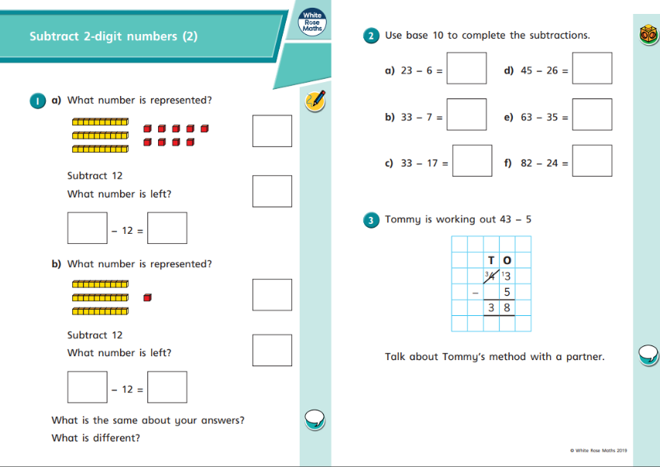

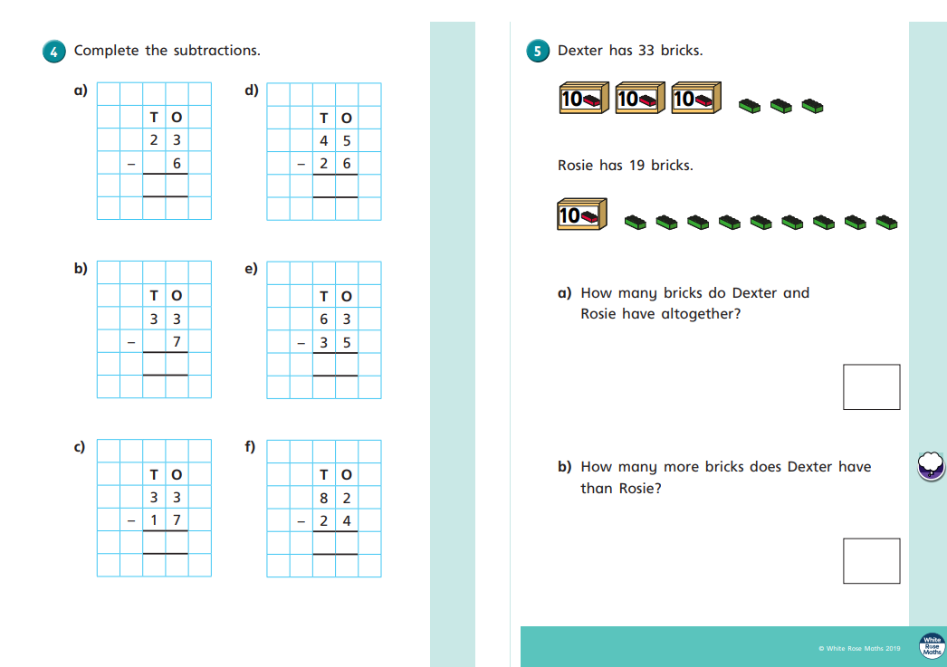Wednesday
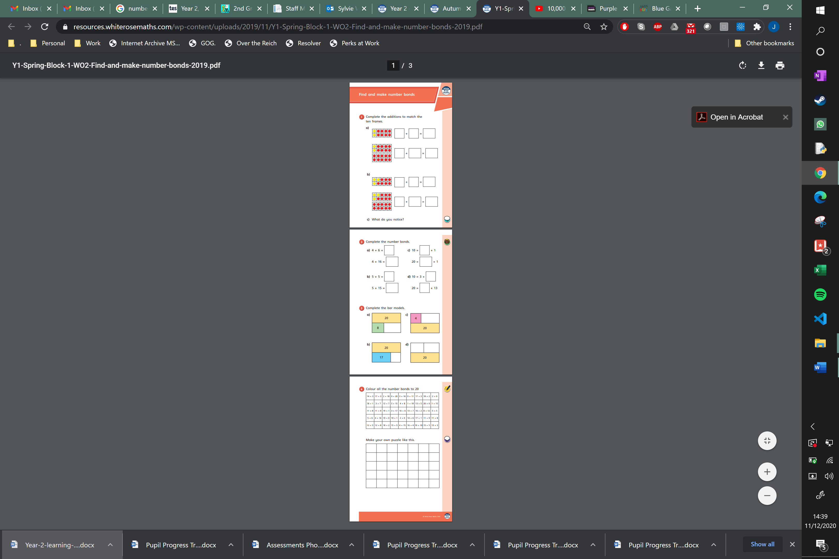

Thursday
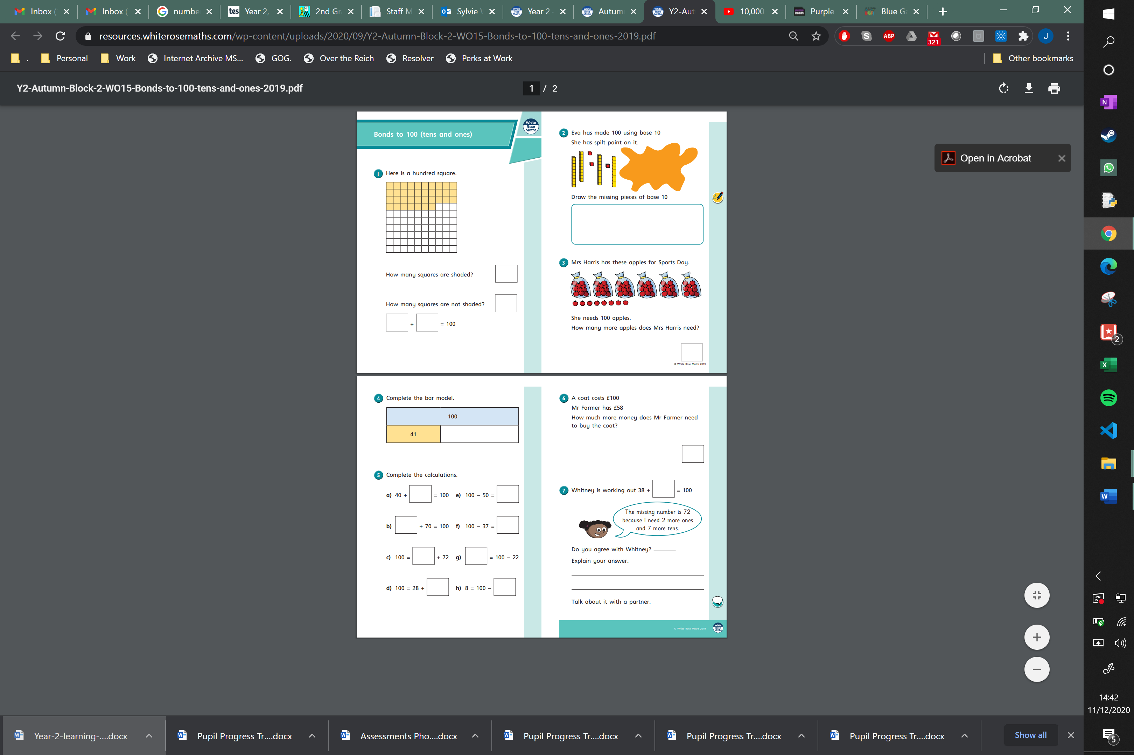
Friday


