Year 2 Numeracy
Week beginning 21 September 2025: Place value
Day | Video Link/PowerPoint | Learning/Activity | Enrichment/Problem solving/Reasoning
Monday | https://vimeo.com/456121633 | LI: Tens and ones using addition  See Monday worksheet | https://www.topmarks.co.uk/maths-games/hit-the-button
Tuesday | https://vimeo.com/456121930 | LI: Using a place value chart  See Tuesday worksheet | https://www.topmarks.co.uk/maths-games/daily10
Wednesday | https://vimeo.com/456122161 | LI: Comparing objects  See Wednesday worksheet | Have a go at the enrichment activity:  https://nrich.maths.org/2404
Thursday | https://vimeo.com/457680528 | LI: Comparing numbers  See Thursday worksheet | Have a go at the enrichment activity:  https://nrich.maths.org/4332
Friday | https://vimeo.com/457681015 | LI: Order objects and numbers | https://www.topmarks.co.uk/learning-to-count/place-value-basketball

Monday
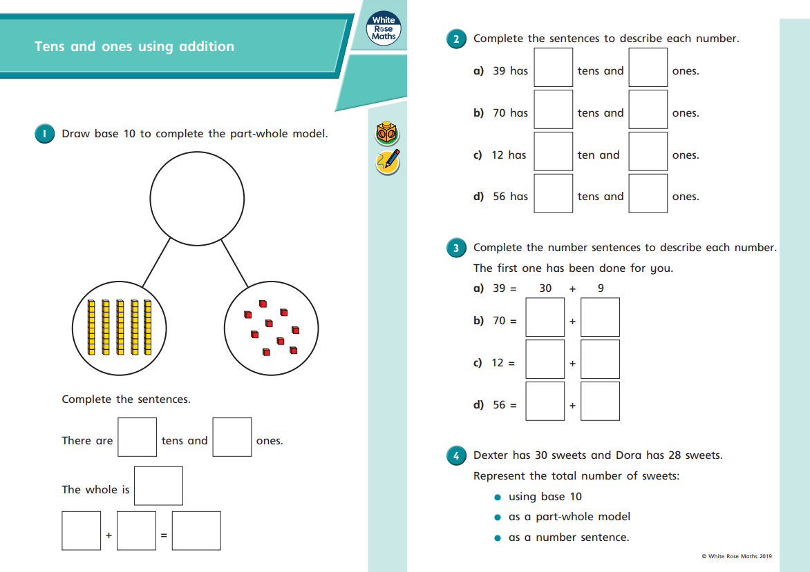

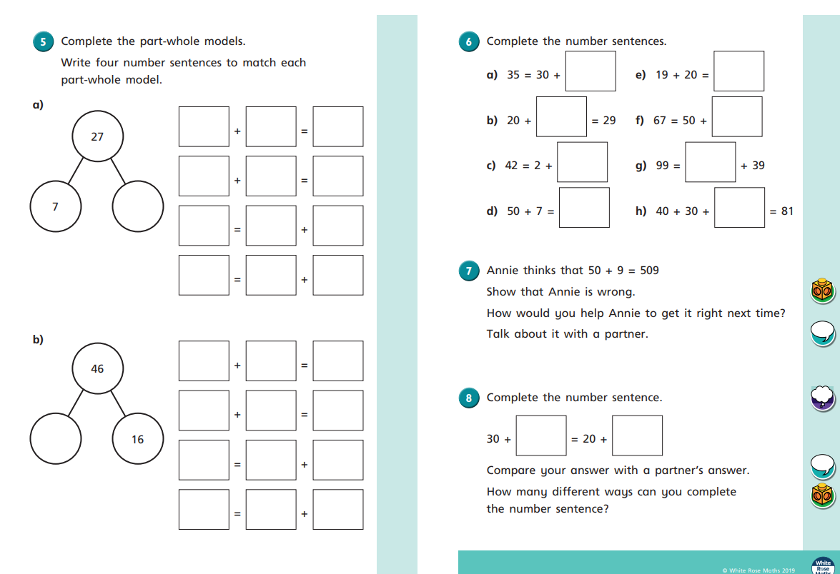
Tuesday
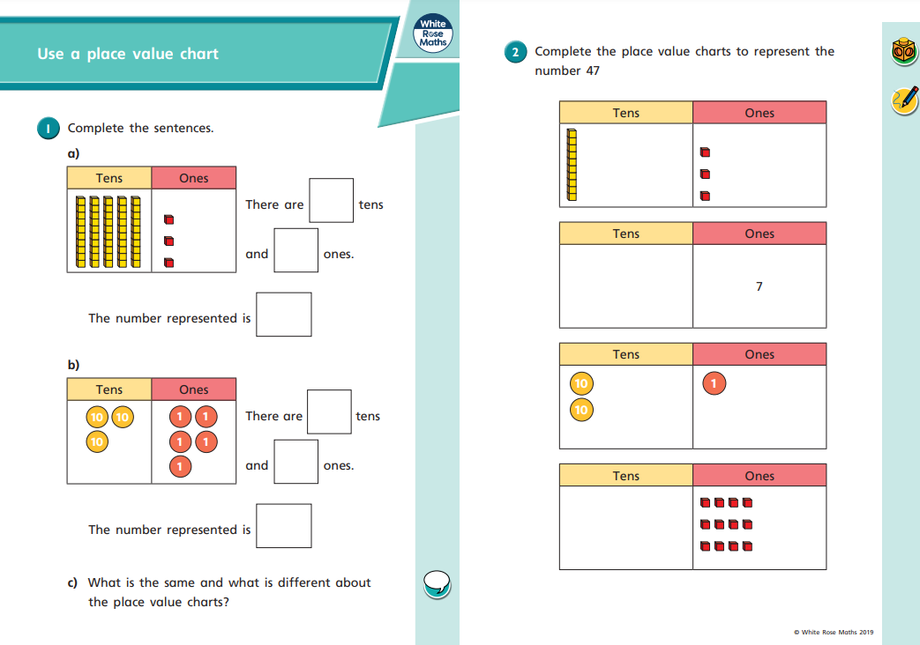
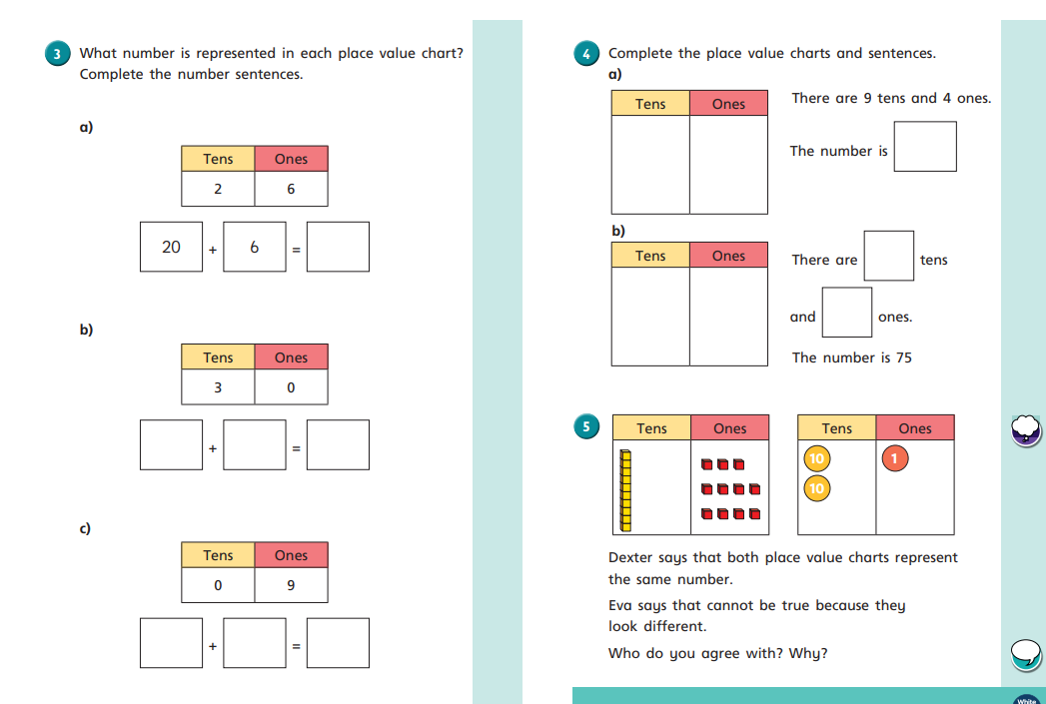
Wednesday
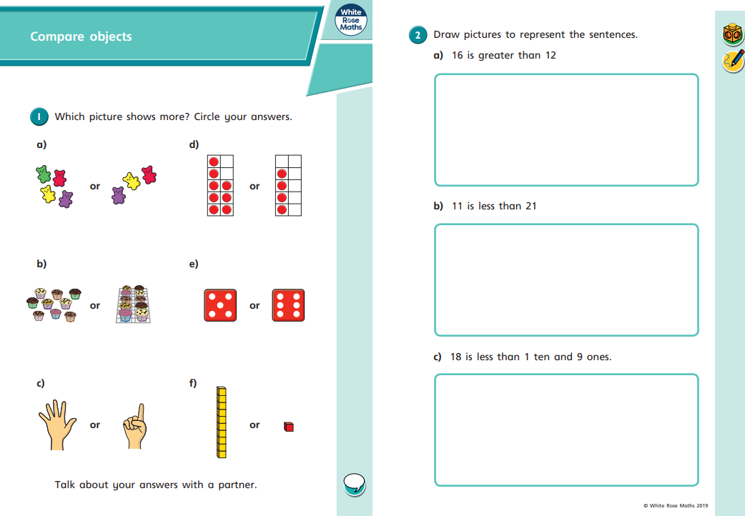

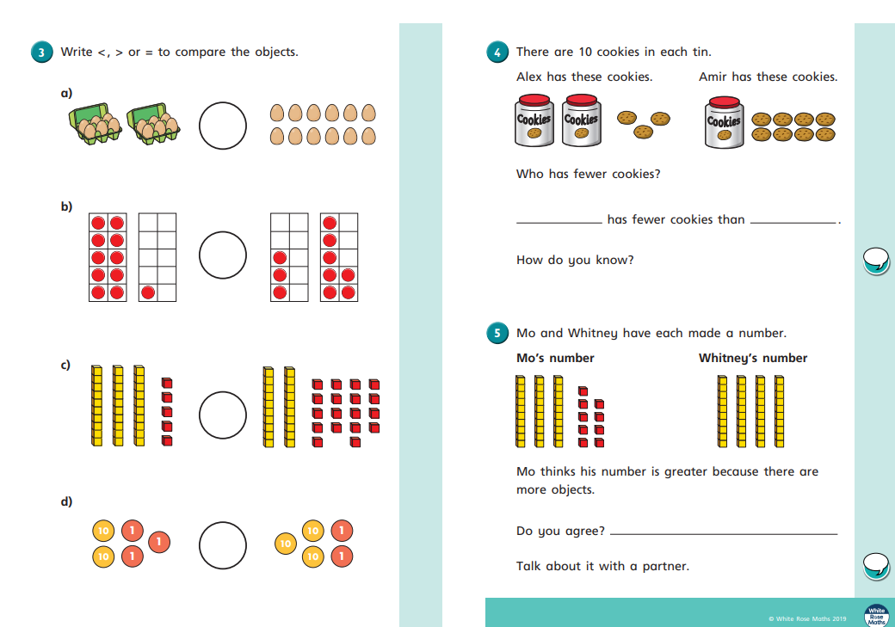
Thursday
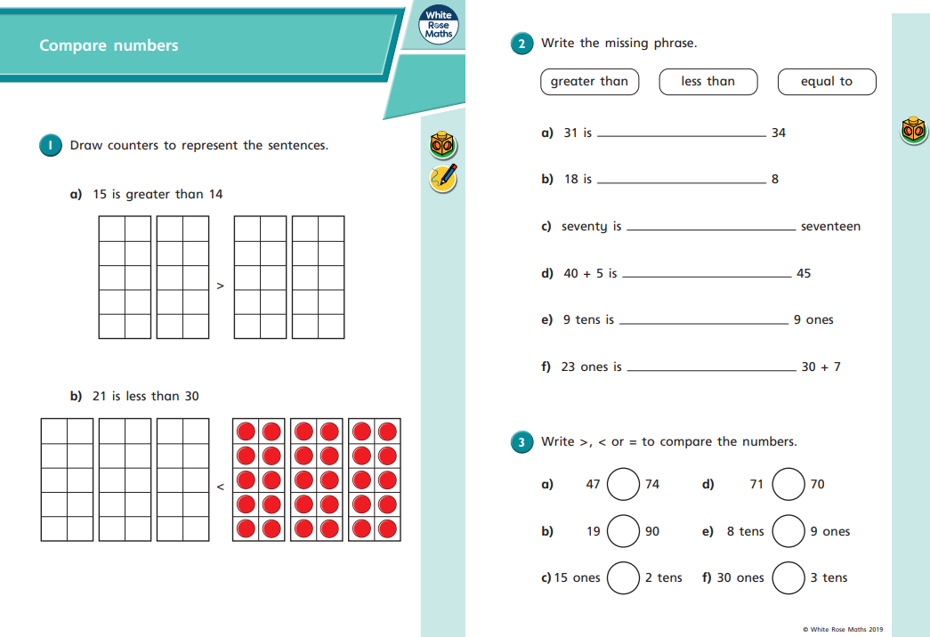
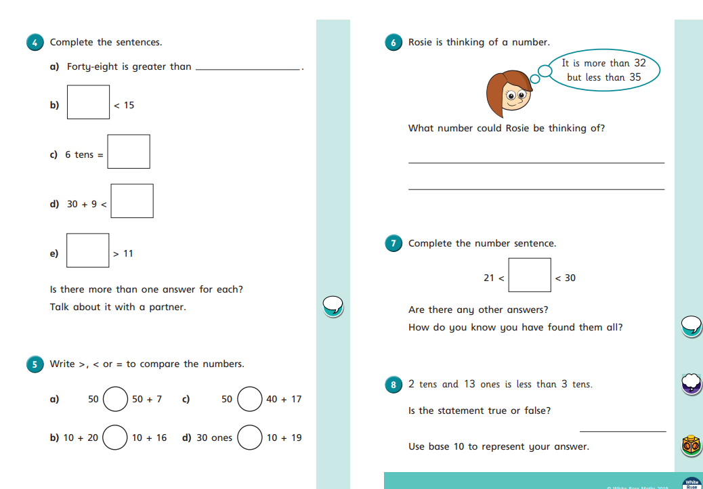
Friday


