Year 1 Numeracy
Week beginning 14th September 2026 SCROLL DOWN FOR ACTIVITIES
Day | Video Link  (Copy and paste into your browser) | Learning/  Activity | Enrichment/Problem solving/Reasoning
Monday | https://vimeo.com/729556981 | Count one more | https://www.ictgames.com/mobilePage/beeMoreOrLess/
Tuesday | https://vimeo.com/729557539 | Count one less | https://www.ictgames.com/mobilePage/beeMoreOrLess/
Wednesday | https://vimeo.com/729557879 | Compare groups by matching | https://uk.splashlearn.com/maths-skills/year-1/numbers-up-to-10-gk/count-forward-up-to-10
Thursday | https://vimeo.com/729558355 | Fewer more same | https://www.topmarks.co.uk/learning-to-count/blast-off
Friday | https://vimeo.com/729558775 | Less than greater than same | http://www.snappymaths.com/counting/counting2/counting2.htm

Monday
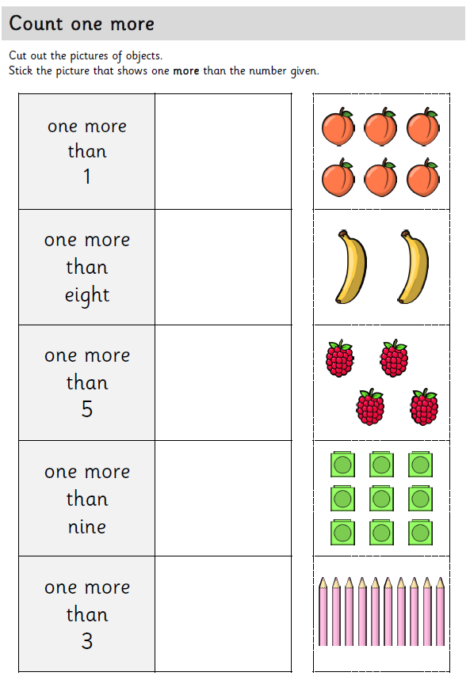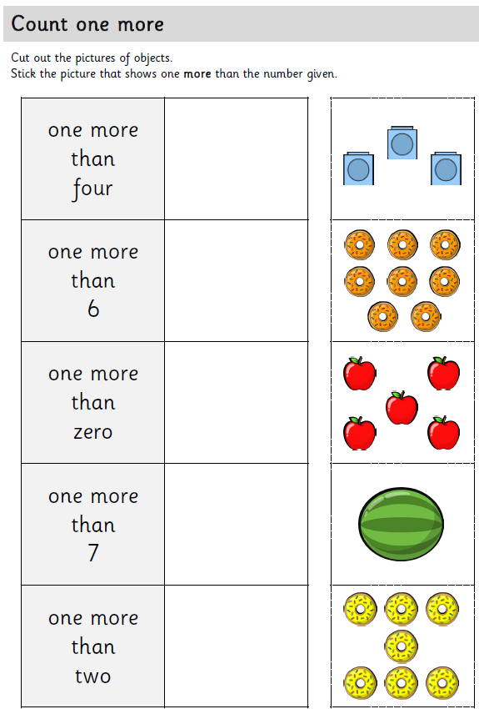

Tuesday
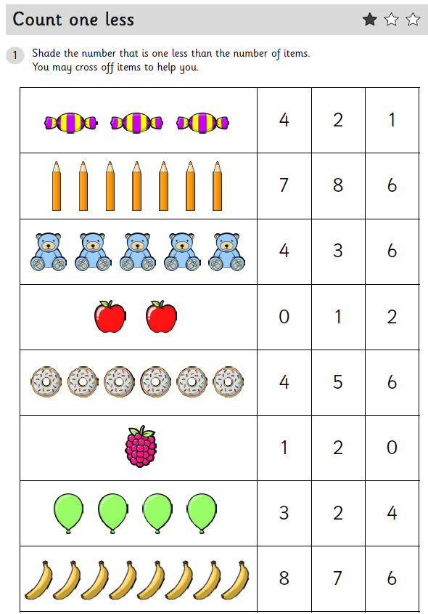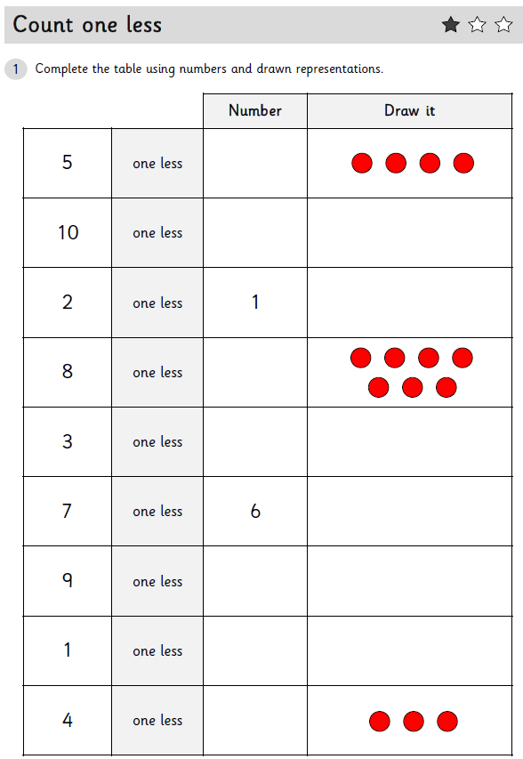

Wednesday
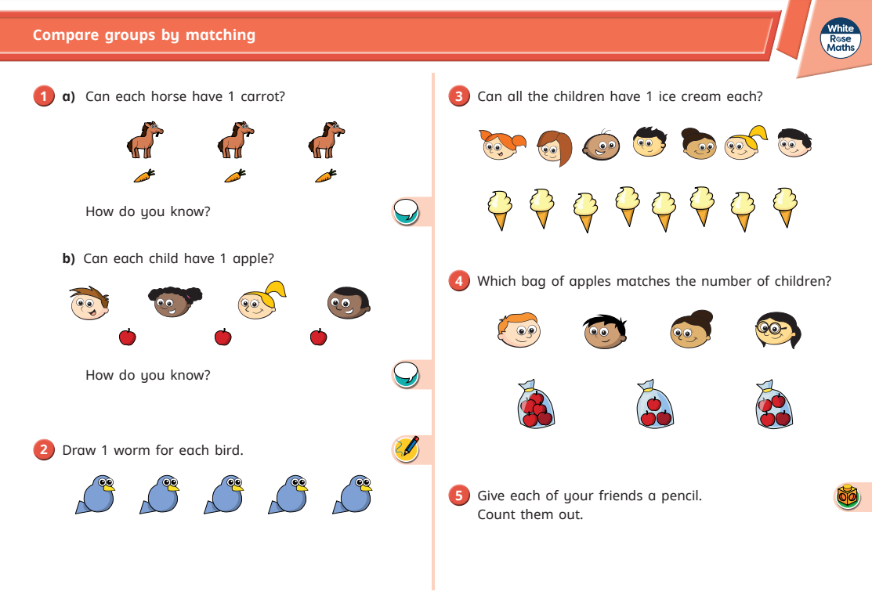

Thursday
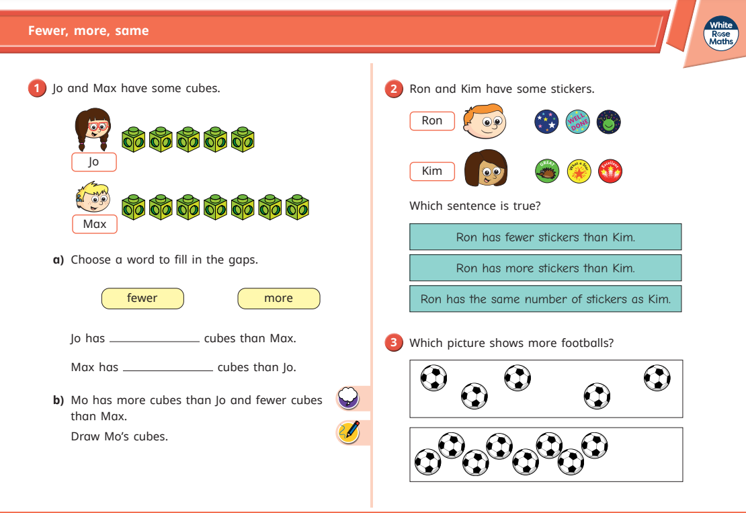

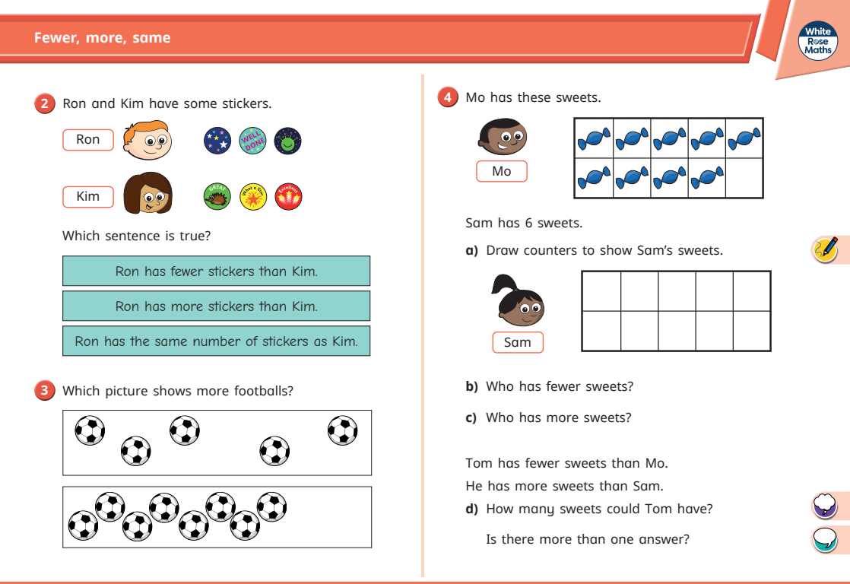

Friday


