Year 2 Literacy
Week beginning 14th September 2026 This week year 2 are learning to retell a familiar story.
Day | Lesson PowerPoint | Activity | Phonics
Monday |  | Listen to the story and orally retell the story to your partner. Remember not to always use the sentence starter ‘then’:  https://www.youtube.com/watch?v=lmrNxvC9bb4 | Digraph ue  https://www.youtube.com/watch?v=DgHINZo3jnM&list=PLuGr6z2H2KNGObda6B-T36vJlZYN06lOh&index=81
Tuesday |  | Draw a picture plan of the story. Use the pictures below to help you. | Digraph u-e  https://www.youtube.com/watch?v=aW-zdYN_z90&list=PLuGr6z2H2KNGObda6B-T36vJlZYN06lOh&index=78
Wednesday and  Thursday |  | On Wednesday write about the first 3 pictures of the story and on Thursday finish your story. Remember to start your sentences with a capital letter and end in a full stop. | revise
Wednesday and  Thursday |  |  | Digraph ew  https://www.youtube.com/watch?v=NEp88NlvxKE&list=PLuGr6z2H2KNGObda6B-T36vJlZYN06lOh&index=79
Friday
Friday |  | Children to practice their spelling and write their own sentences with the spelling words. | Revise: write sentences with words containing the digraphs you have learned this week.
Book: Katie in London. https://www.youtube.com/watch?v=0R7KQALNHrM

    zzzzzz |   Hold on tight! | 
   | 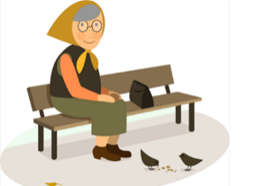  Let’s go! | 

Wed and thurs (draw your pictures in the box and try write your own sentences. (Blue and green group) write paragraphs.
________________ visited ________________  But _______________ fell asleep. | A statue of a __________________  came to life and said “Hold on tight!”. | They saw
They ate | They got back to ________________and they woke up. “Shall we see the sights?” | __________________ was so tired that they fell asleep!

