Year 2 Numeracy
Week beginning 14th September: Place value
Day | Video Link/PowerPoint | Learning/Activity | Enrichment/Problem solving/Reasoning
Monday | https://vimeo.com/454750186 | LI: Counting objects to 100  See Monday worksheet | https://www.topmarks.co.uk/place-value/bead-numbers
Tuesday | https://vimeo.com/454750427 | LI: Counting objects to 100  See Tuesday worksheet | https://www.topmarks.co.uk/learning-to-count/place-value-basketballl
Wednesday | https://vimeo.com/455403280 | LI: Represent numbers to 100  Practical | Have a go at the enrichment activity:  https://nrich.maths.org/6074
Thursday | https://vimeo.com/455403910 | LI: Represent numbers to 100  See Thursday worksheet | Have a go at the enrichment activity:  https://nrich.maths.org/7514
Friday | https://vimeo.com/455404236 | LI: Tens and ones within a part-whole model | https://www.topmarks.co.uk/learning-to-count/place-value-basketball

Monday
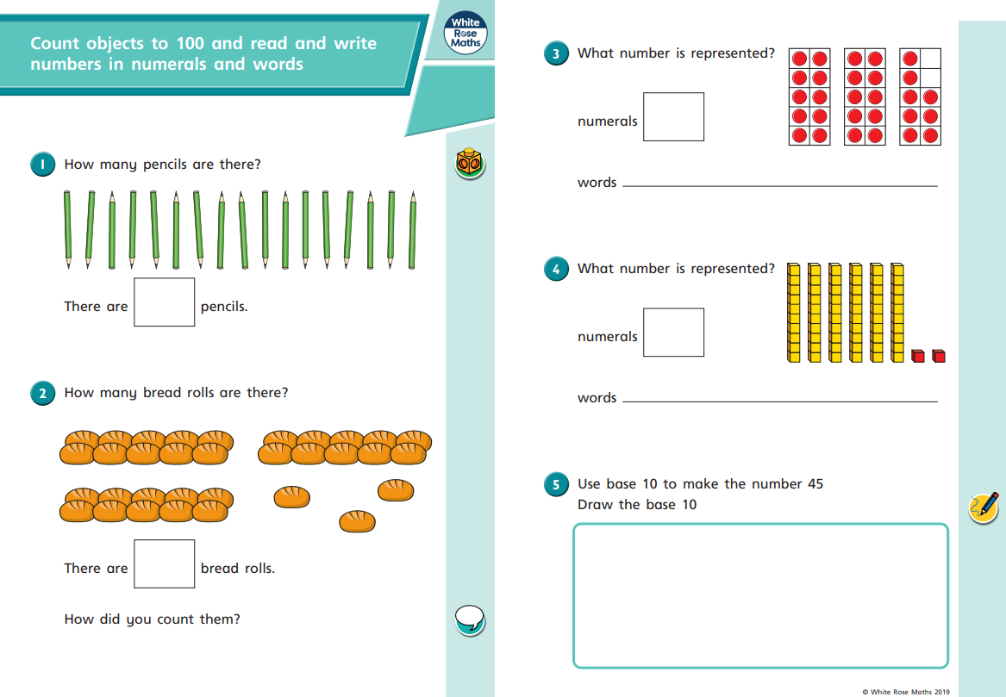
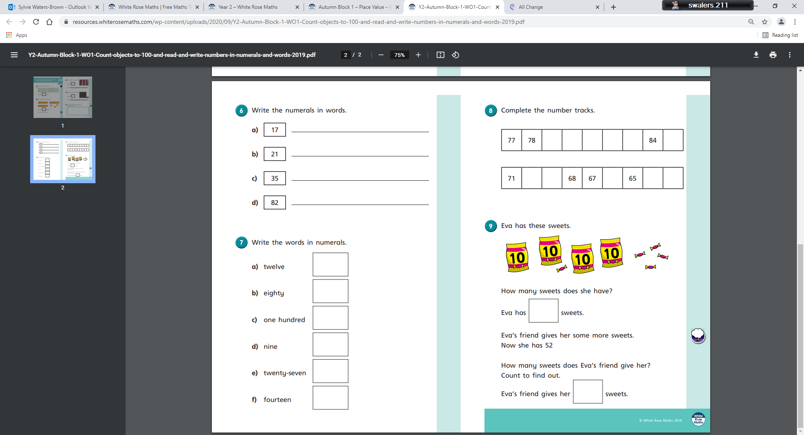Tuesday
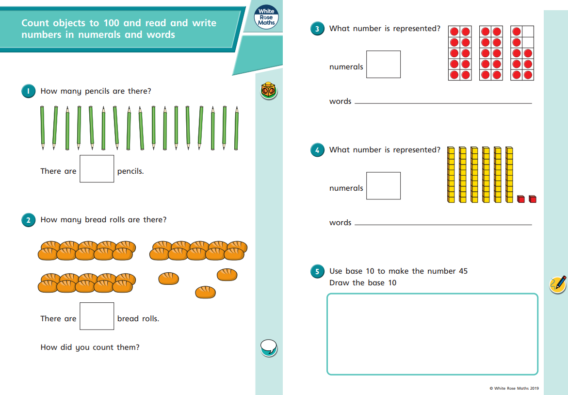
Thursday

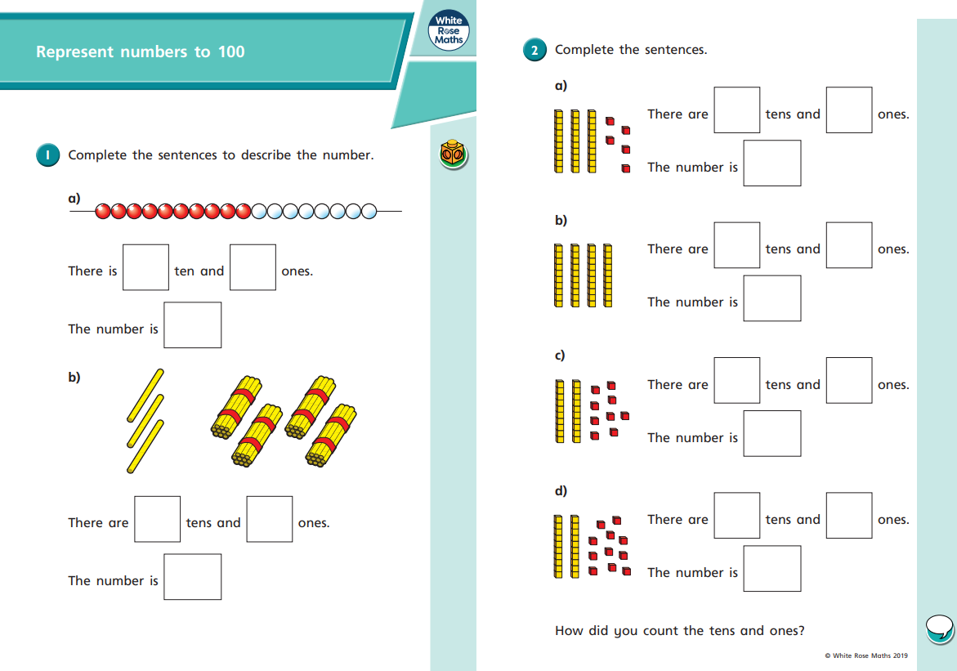
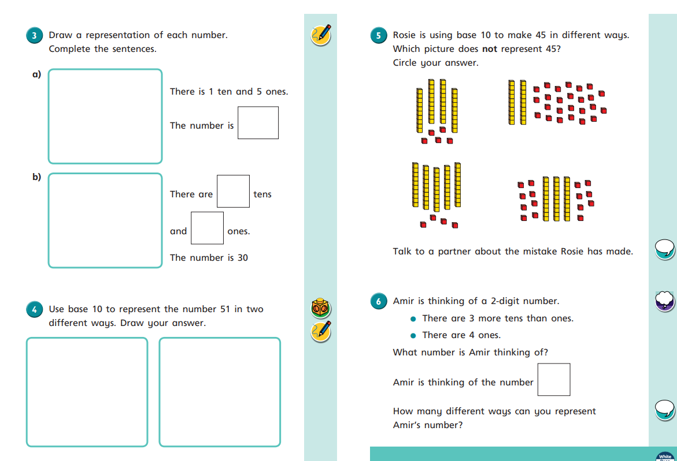
Friday


