Year 2 Literacy
Week beginning 7th September 2026 https://www.youtube.com/watch?v=5jv8RhfDwW0
Day | Activity | Phonics
Monday | Read the story up to where the lion jumps up to take the children on an adventure. Children to predict where they think the lion will take them.  Write a few sentences and remember your describing words. | Diagraph ie  https://www.youtube.com/watch?v=bysxOlWkT08
Tuesday | Children to look at the picture of Katie and describe how she looks like and what type of person she is. Describe her physical and personal traits) | Diagraph i-e  https://www.youtube.com/watch?v=4-swf3Gy_40
Wednesday | Children to add phrases to yesterday’s describing words and similes. Eg. Long curly brown hair, A coat as red as fire. | y  https://www.youtube.com/watch?v=t0C01G_sCsQ
Thursday | Children to write a short description of their chosen character using the adjectives and similes from the previous days. | i  https://www.youtube.com/watch?v=YEVPVf5jptI
Friday | See worksheet below, children to match sentence to the correct sentence type. Children to then write their own examples of a command, statement, question and exclamation. | ie i-e y i (write your own words under these digraphs)
This week year 2 are learning about Katie in London and how to describe a character.

Describe Katie: ( tues, wed, thurs)
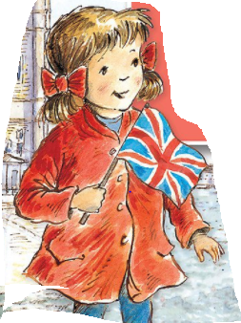

Friday:
statement . | Katie and Jack went on the lion.
command . ! | Get up quick!
exclamation ! | What an amazing ride!
question ? | Where do you want to go?
The lion is very brave. | Hold on tight.
Wow! What a view! | Do you think grandma is still asleep?

