Year 2 Numeracy
Week beginning7th September: Place value
Day | Video Link/PowerPoint | Learning/Activity | Enrichment/Problem solving/Reasoning
Monday | https://vimeo.com/453417031 | LI: Counting forwards and backwards within 20  See Monday worksheet | https://www.topmarks.co.uk/place-value/bead-numbers
Tuesday | https://vimeo.com/453417247 | LI: Tens and ones within 20  See Tuesday worksheet | https://www.topmarks.co.uk/learning-to-count/place-value-basketballl
Wednesday | https://vimeo.com/453417546 | LI: Counting forwards and backwards within 50  See Wednesday worksheet | Have a go at the enrichment activity:  https://nrich.maths.org/7431
Thursday | https://vimeo.com/453417703 | LI: Tens and ones within 50  See Thursday worksheet | Have a go at the enrichment activity:  https://nrich.maths.org/10586
Friday | https://vimeo.com/453561160 | LI: Compare numbers within 50 | https://www.topmarks.co.uk/learning-to-count/place-value-basketball

Monday
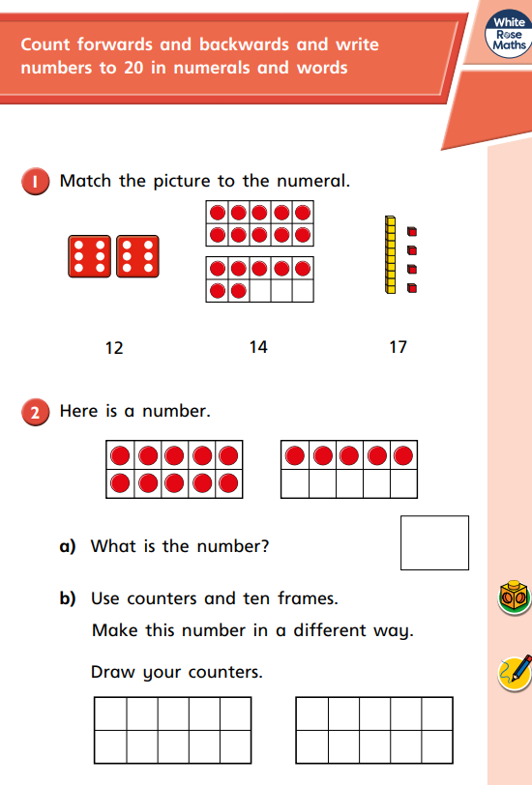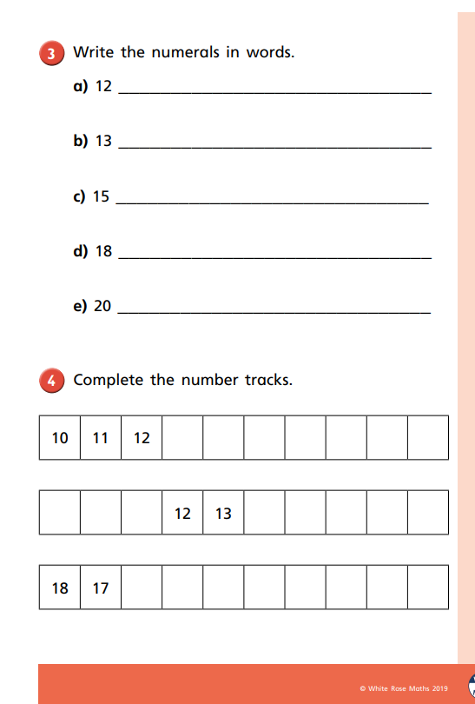
Tuesday

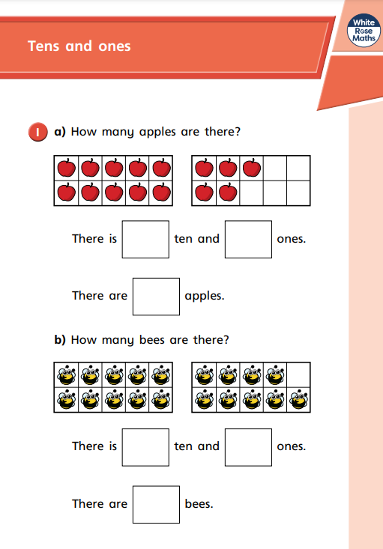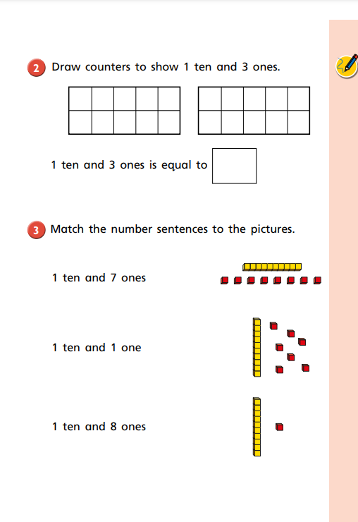
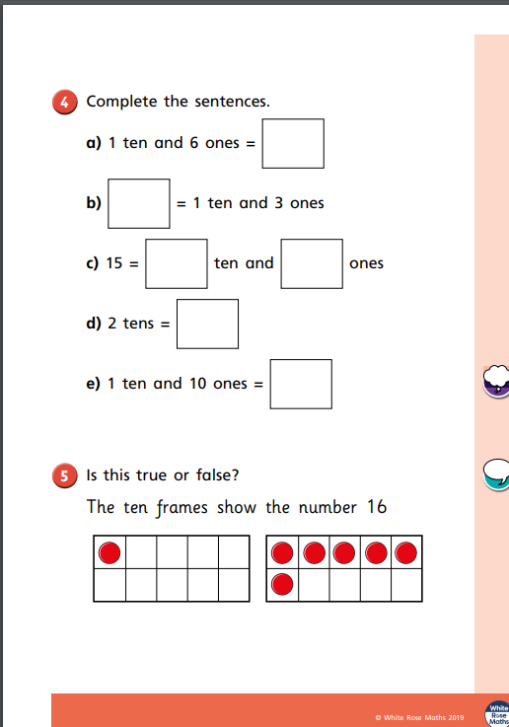
Wednesday
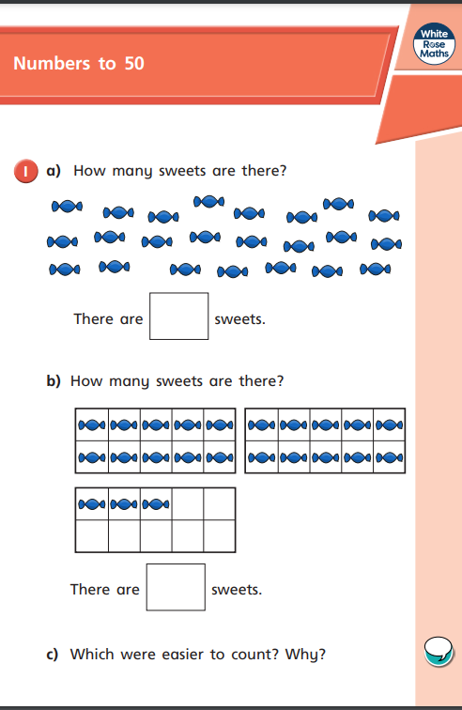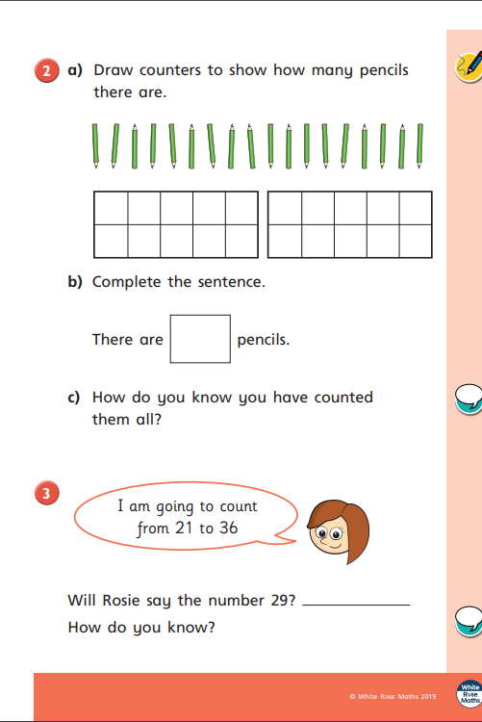
Thursday
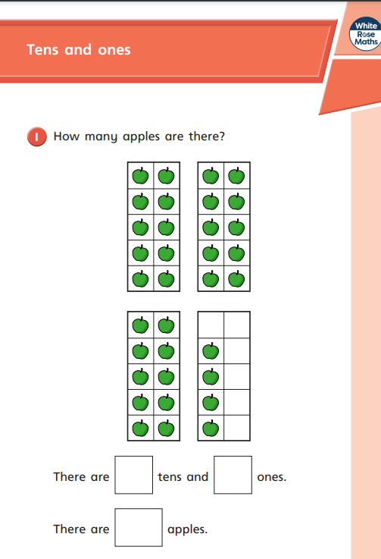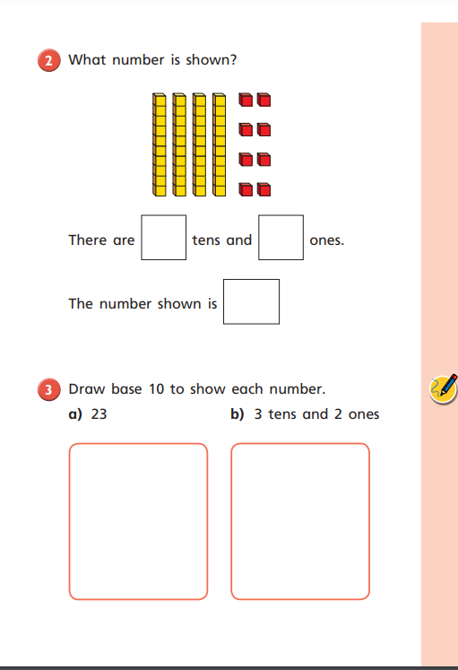

Friday


