Year 1 Numeracy
Week beginning 7th September 2026 SCROLL DOWN FOR ACTIVITIES
Day | Video Link  (Copy and paste into your browser) | Learning/  Activity | Enrichment/Problem solving/Reasoning
Monday | https://vimeo.com/729553478 | We are learning to sort objects | https://uk.splashlearn.com/maths-skills/year-1/numbers-up-to-10-gk/count-forward-up-to-10
Tuesday | https://vimeo.com/729554135 | We are learning to count objects | https://uk.splashlearn.com/maths-skills/year-1/numbers-up-to-10-gk/count-forward-up-to-10
Wednesday | https://vimeo.com/729554811 | We are learning to count objects | https://www.topmarks.co.uk/learning-to-count/todays-number-up-to-20
Thursday | https://vimeo.com/729555639 | We are learning to represent numbers | https://www.topmarks.co.uk/learning-to-count/blast-off
Friday | https://vimeo.com/729556317 | We are learning to write numbers as words | http://www.snappymaths.com/counting/counting2/counting2.htm

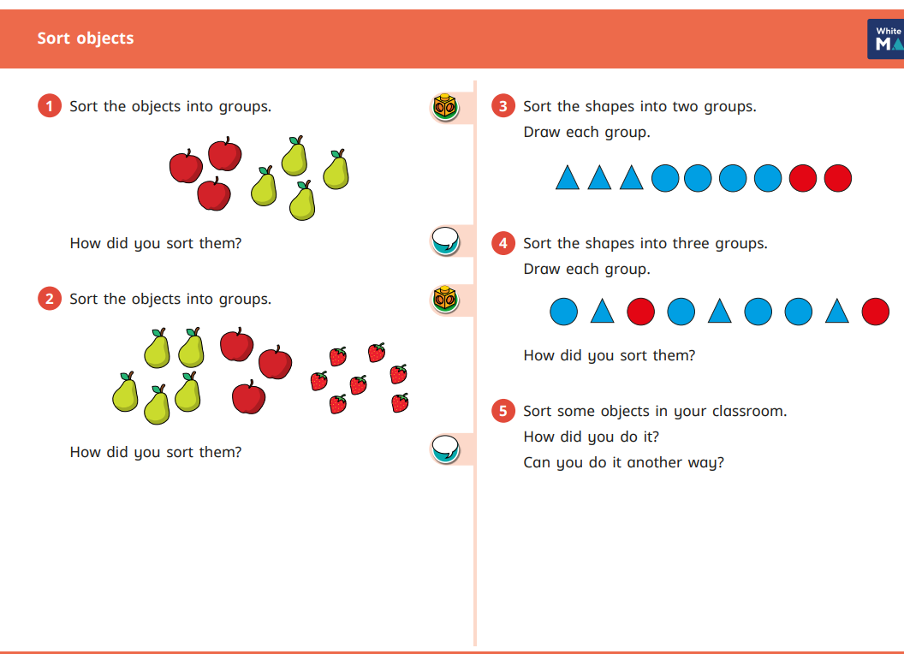
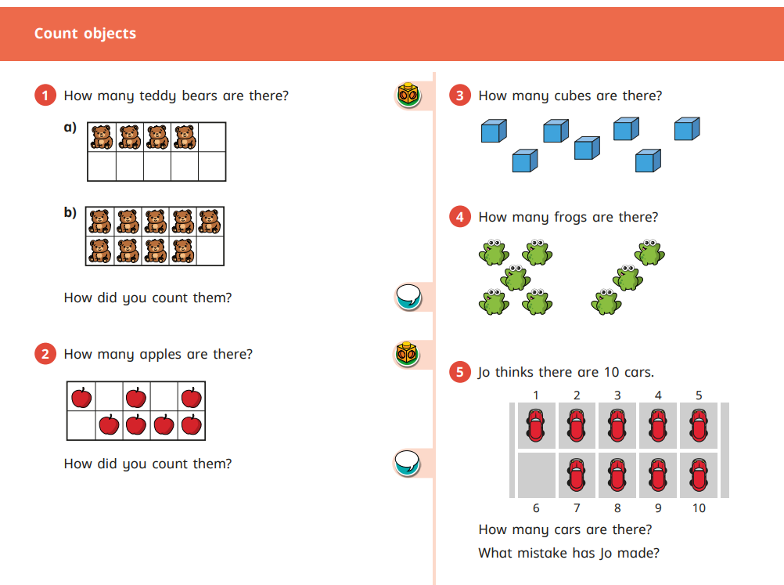
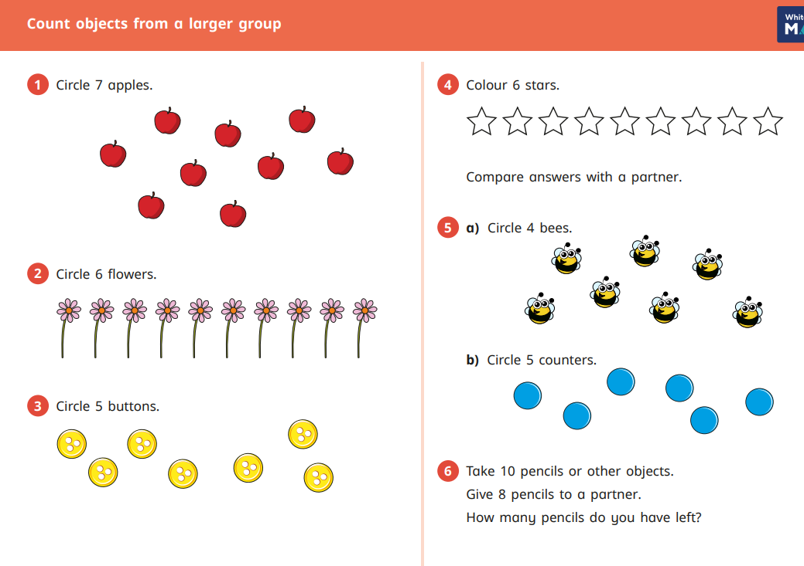
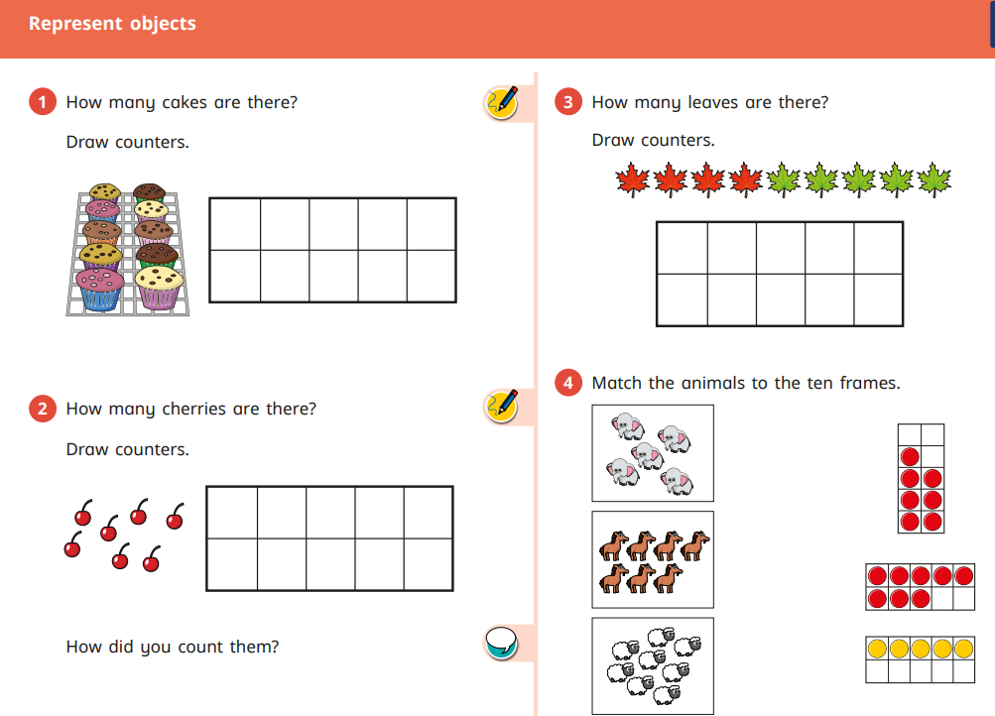
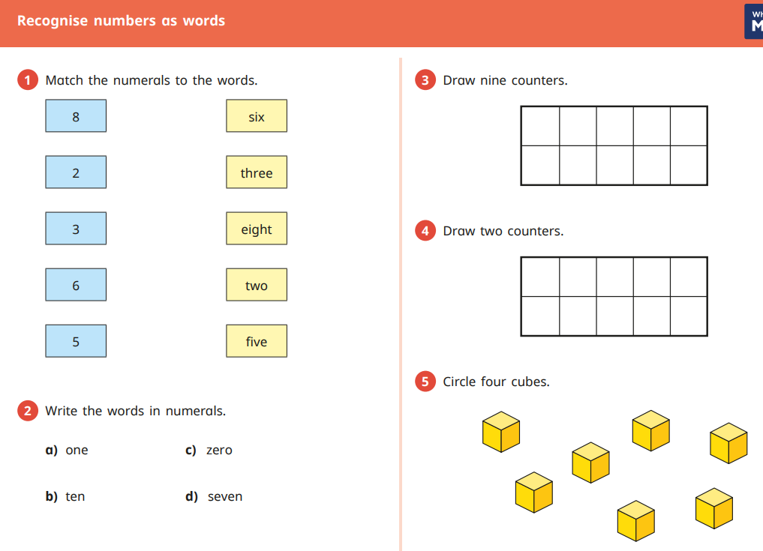
1 | three | 1 | three
2 | nine | 2 | nine
3 | four | 3 | four
4 | one | 4 | one
5 | six | 5 | six
6 | seven | 6 | seven
7 | five | 7 | five
8 | ten | 8 | ten
9 | eight | 9 | eight
10 | two | 10 | two

