Year 1 Autumn 1 Project
Make your own family tree
This term in science we are learning about plants and trees, we will be going on a local walk to Shadwell Park with our class to look at the variety of trees and plants.
Task: Go on a local walk with your family and collect natural materials like twigs and leaves and make your very own family tree. Bring it to school and tell your whole class about your family.
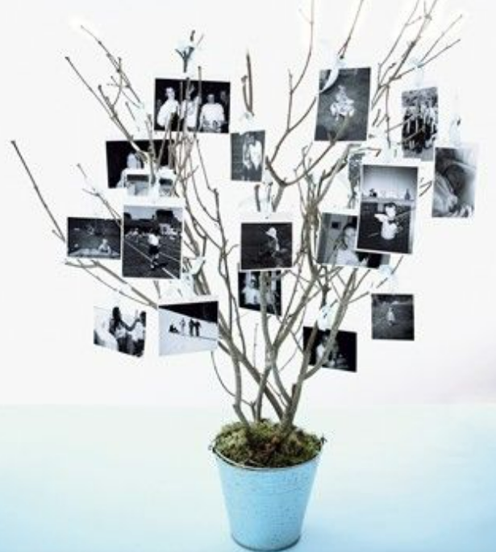
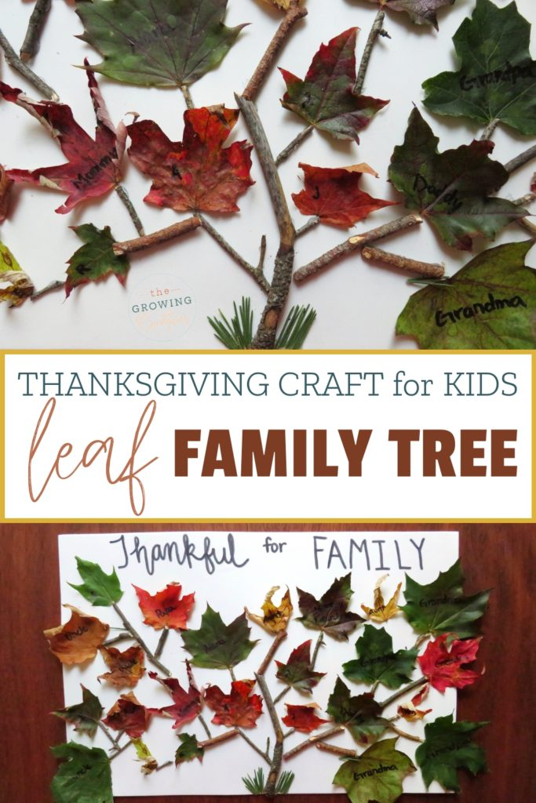
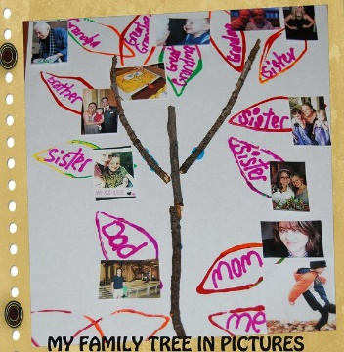
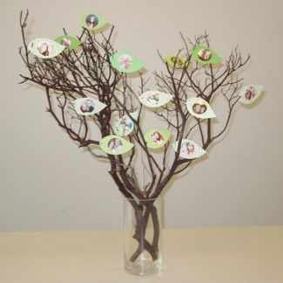
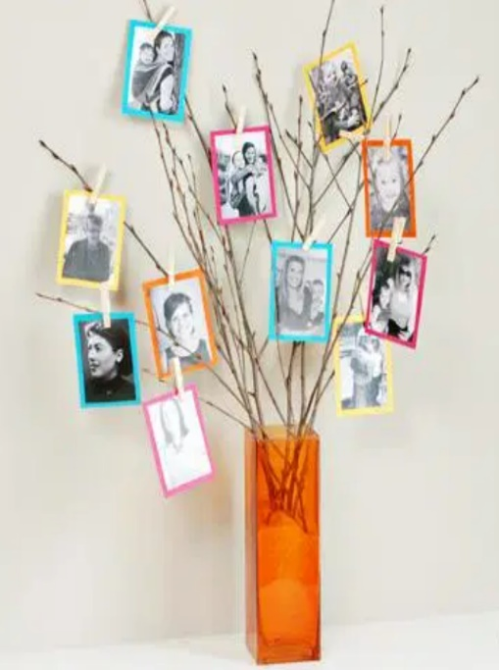
Have a look at these examples for inspiration!

Can you write the names of all the members of your family?
Can you write something special about each person in your family?
Can you find out the name of their favourite plant?

