My home
Can you create your home?
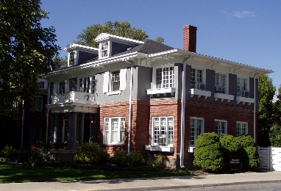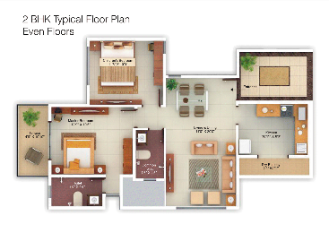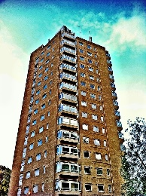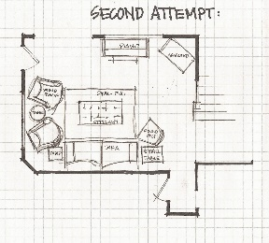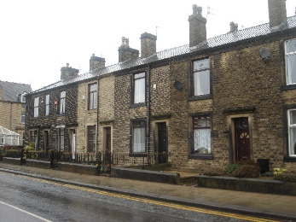
What we would like you to do:
- Think about your home. What does it look like? What is your favourite part of your home?
Choose how you want to create your home and what type of resources you will need. You can use any resources you have at home to create your family e.g. paper, scissors, paint, cardboard etc.

2. Create your home.
Will you draw your home and then tear paper up to glue on?
Will you paint your home?
Will you create a model of home?
Will you create a map of your home?

3. Have fun!
Take photographs of you creating your home.
Once you have created you home bring it to school to share with everyone.

