My family
Can you create a collage of your family?
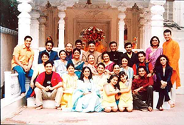
What we would like you to do:
- Think about your family and who is in your family.
Choose how you want to create your family and what type of resources you will need. You can use any resources you have at home to create your family e.g. paper, scissors, paint, cardboard etc.

2. Create your family.
Will you draw your family and then tear paper up to glue on?
Will you paint your family?
Will you make a model for each family member?

3. Have fun!
Take photographs of you creating your family.
Once you have created you family bring it to school to share with everyone.

