Parental Engagement Team
Our Parent Coffee Morning continues to be a welcoming and supportive space where parents can connect, share experiences, and strengthen their wellbeing. Through each activity, parents build confidence, reduce stress, and meet others who understand the challenges and joys of parenting.
Our parents have enjoyed a wonderfully creative and informative Summer Term.
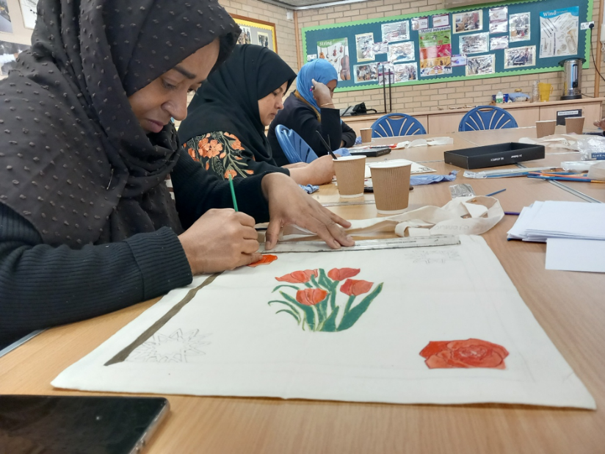
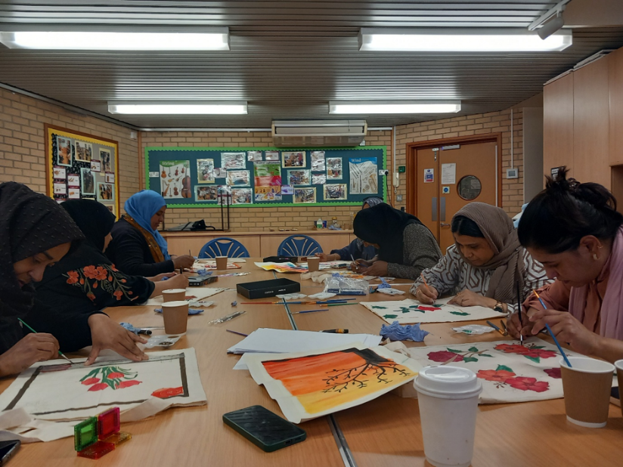
In our bag-decorating workshop, parents explored colour and pattern, learning simple design techniques that encourage creativity and positive self-expression.

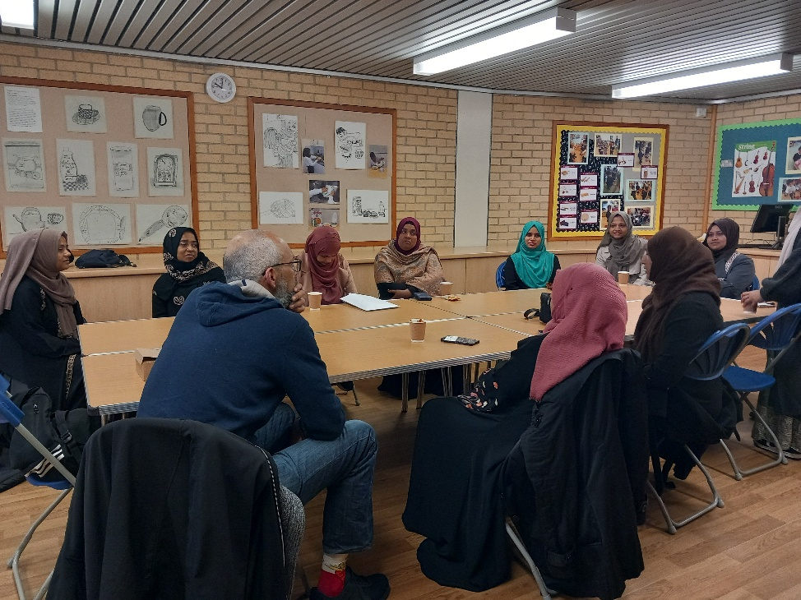
The SEND information session offered clear guidance on support pathways, helping parents feel more informed and empowered in advocating for their children’s needs.

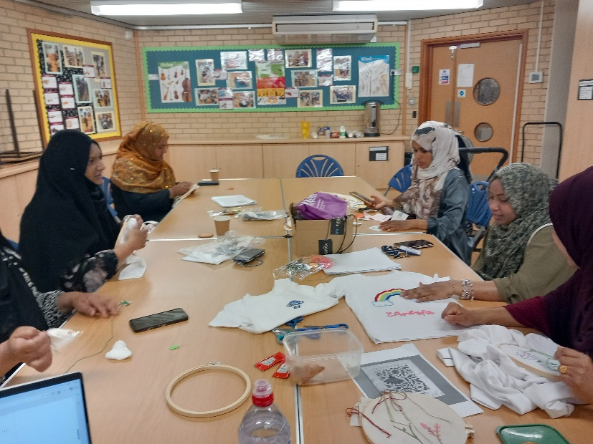
During the upcycling embroidery workshop, participants learnt practical stitching and repair skills while exploring sustainability and mindful crafting — an activity that supports relaxation and boosts confidence.


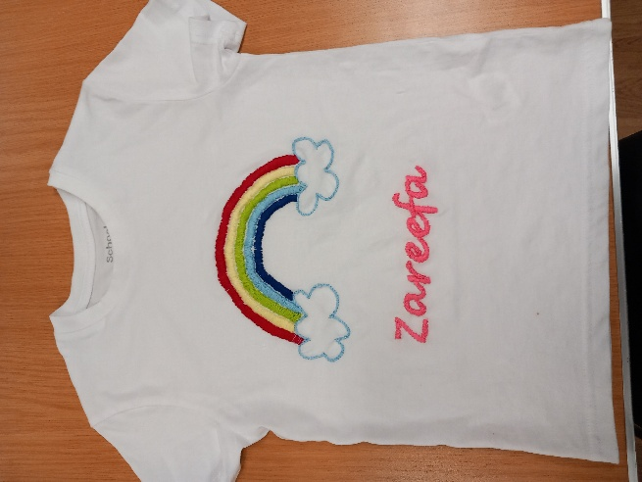
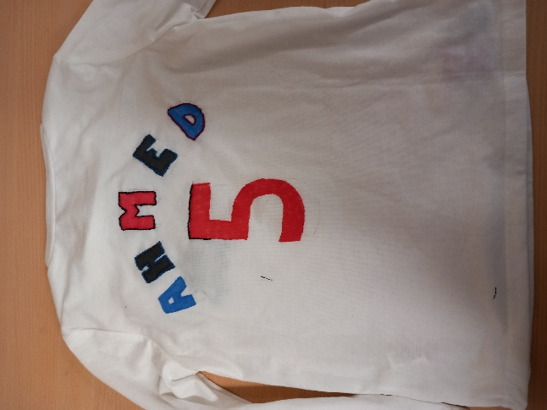

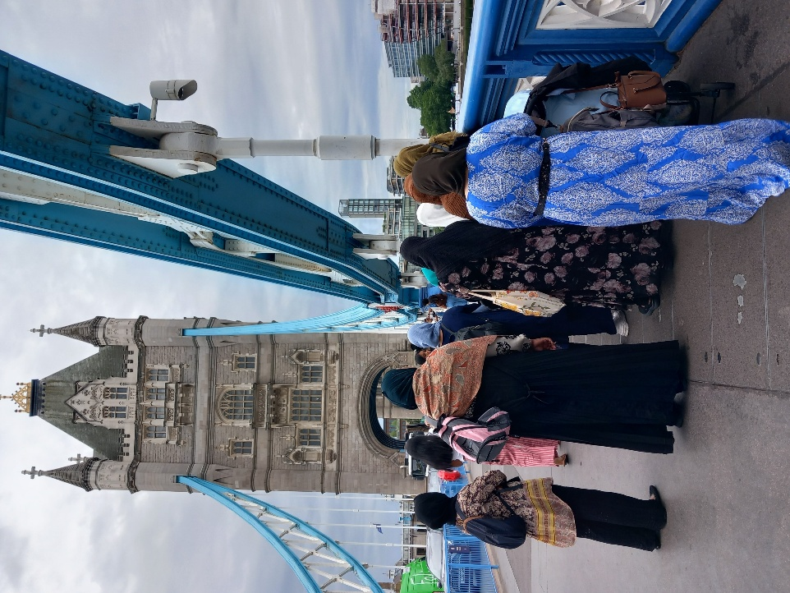
We also enjoyed a fantastic trip to Tower Bridge, visiting inside the historic tower at no cost giving parents the chance to explore one of London’s most iconic landmarks.

These sessions not only bring parents together but also help build supportive networks, enhance parenting skills, and promote positive mental health. Thank you to everyone who joined us and contributed to such a meaningful term.

We have two more trips planned for the Summer Term
Tuesday 7th July-Trip to Holland Park
Wednesday 15th July-Final session, picnic at Thames Barrier Park

If you are interested to take part, please contact Hamida 07543516092

