Year 2 Literacy
Week beginning 13th July This week year 2 are learning to write instructions. https://www.youtube.com/watch?v=0gt65FllIac
When opening web links hold down control key and click link. Story: The worst witch Jill Murphy
Day | Activity | Phonics Phase 5
Monday | LI: To identify features of an instructional text.  SC: I can identify imperative verbs, title and important sub headings in an instructional text. | ay  https://www.youtube.com/watch?v=6AiVFK9SMj0  phase 3 (oa)  https://www.youtube.com/watch?v=rrGadCz2A1o&list=PLuGr6z2H2KNG4XgGr7UylwowIcDLr-T-k&index=91
Tuesday | LI: To explain what a set of instructions need.  SC: I can brainstorm ideas for my own instructional text on how to make a witch’s hat. | a-e  https://www.youtube.com/watch?v=q4jz3U25Xjk&list=PLuGr6z2H2KNGObda6B-T36vJlZYN06lOh&index=90  phase 3 (oo)  https://www.youtube.com/watch?v=VQxqTmiDmIQ&list=PLuGr6z2H2KNG4XgGr7UylwowIcDLr-T-k&index=89 (long)
Wednesday | LI: We are learning to write a set of instructions.  SC: I can write a set of instructions under the correct sub headings and include imperative verbs and time conjunctions. | a  https://www.youtube.com/watch?v=mseNHdo-Al8&list=PLuGr6z2H2KNGObda6B-T36vJlZYN06lOh&index=63  phase 3 (oo)  https://www.youtube.com/watch?v=McxGM5mU0uM&list=PLuGr6z2H2KNG4XgGr7UylwowIcDLr-T-k&index=87 (short)
Thursday
Thursday | LI: We are learning to write a set of instructions.  SC: I can write a set of instructions under the correct sub headings and include imperative verbs and time conjunctions. | Review: ai, ay, a-e, a  https://www.youtube.com/watch?v=G_KDZ6YndSU&list=PLuGr6z2H2KNGObda6B-T36vJlZYN06lOh&index=27  phase 3 ar  https://www.youtube.com/watch?v=yVsmYlNXU-k&list=PLuGr6z2H2KNG4XgGr7UylwowIcDLr-T-k&index=86
Friday | LI: We are learning to follow a set of instructions.  SC: I can follow a set of instructions to make a wand. | Practice spelling words and put them into sentences.

resources below:
Mon: identify features:
Tuesday: brainstorm ideas for your own witch’s hat.
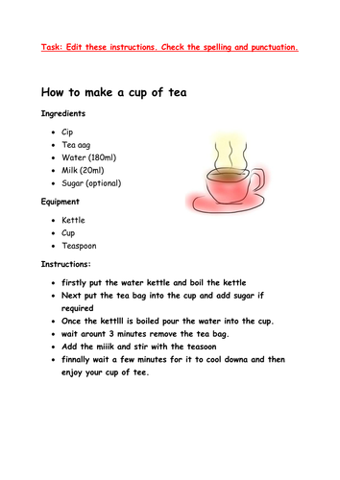
Think about:
What equipment you will need.
What imperative verbs you will use.
What materials you need.
What do you want it to look like?

Friday: follow the instructions to make a witch’s hat.
https://www.youtube.com/watch?v=0gt65FllIac

