Year 2 Numeracy
Week beginning 13th July Division
Day | Video Link/PowerPoint | Learning/Activity | Enrichment/Problem solving/Reasoning
Monday | https://vimeo.com/492603273 | LI: Making equal groups  See Monday worksheet | Have a go at the enrichment activity:  https://nrich.maths.org/12670
Tuesday | https://vimeo.com/492603633 | LI: Making equal groups  See Tuesday worksheet | https://www.ictgames.com/mobilePage/doggyDivision/index.html
Wednesday | https://vimeo.com/492603899 | LI: Making equal groups  See Wednesday worksheet | Have a go at the enrichment activity:  https://nrich.maths.org/7190
Thursday | https://vimeo.com/492603961 | LI: Making equal groups  See Thursday worksheet | http://www.ictgames.com/mobilePage/arrayDisplay/index.html  (Type in a multiplication number sentence to create an array. Rotate the array and see what happens to the number sentence.)
Friday | https://vimeo.com/492604113 | LI: Sharing and grouping  Practical | http://www.ictgames.com/mobilePage/fractions/index.html

Monday
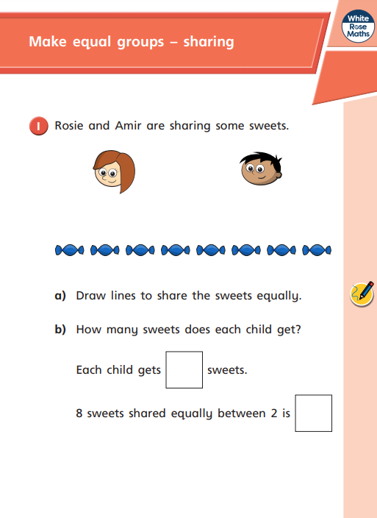
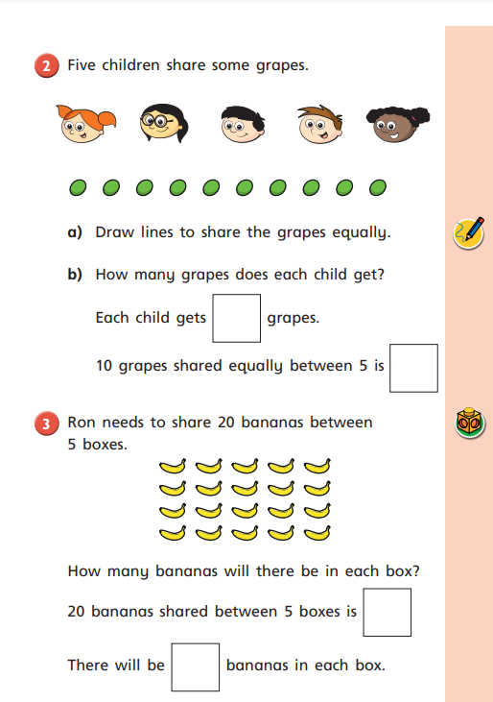
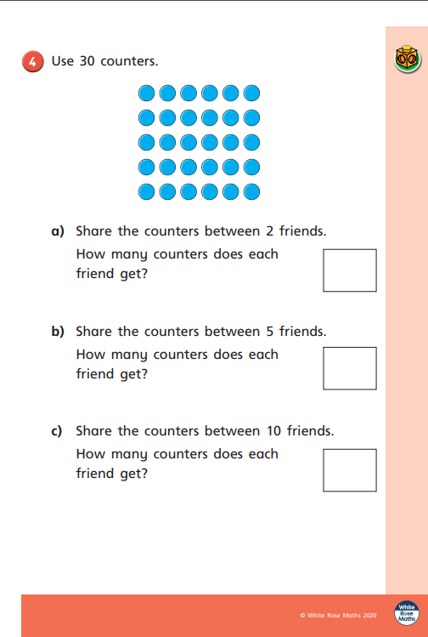
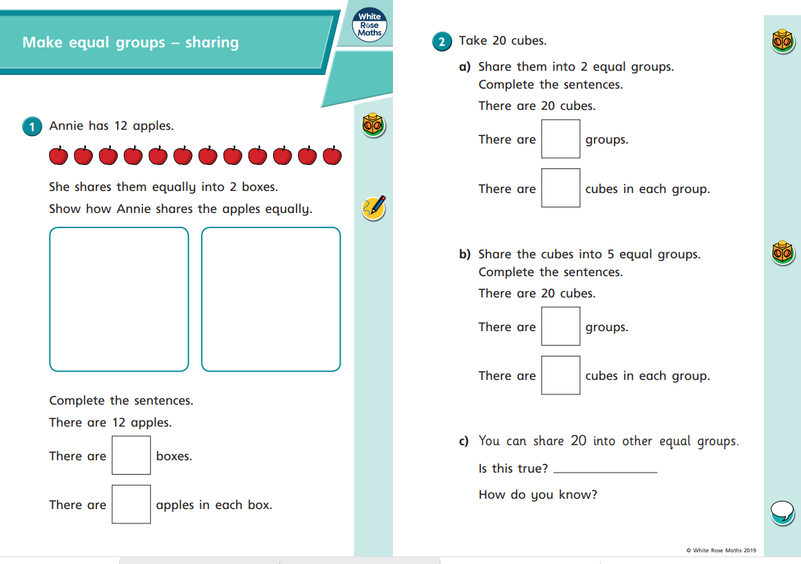
Tuesday

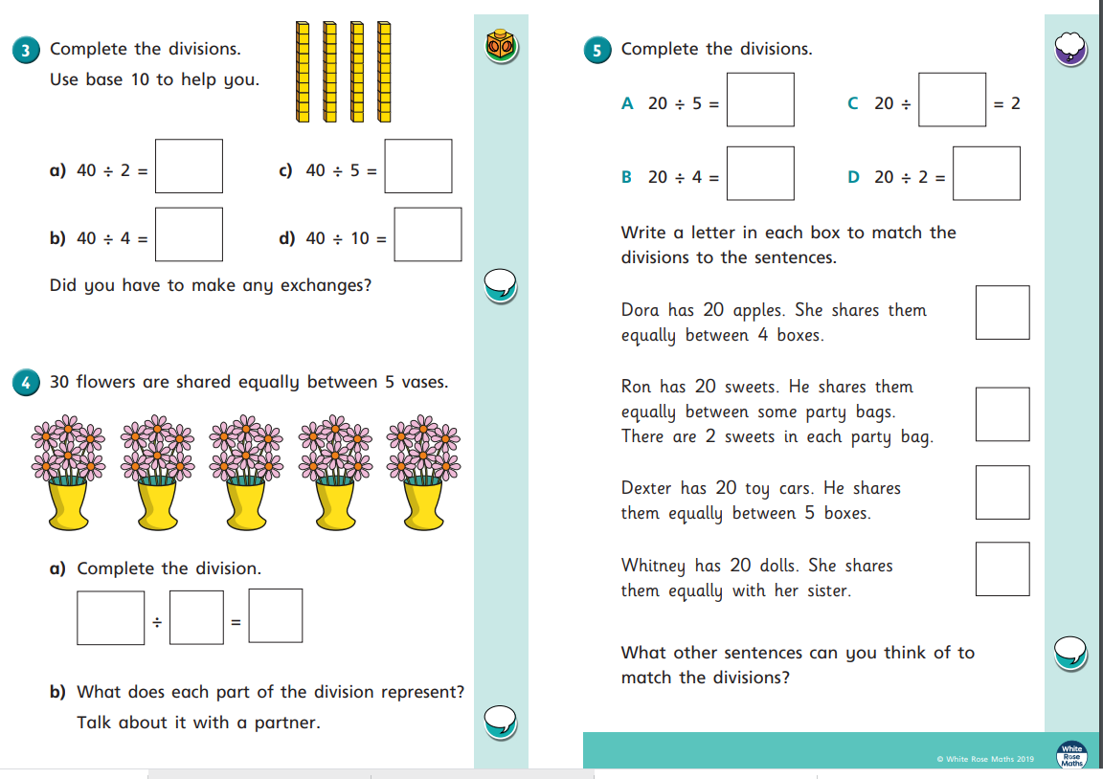
Wednesday

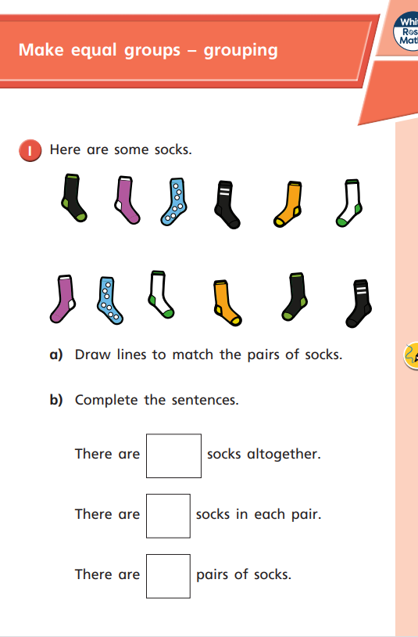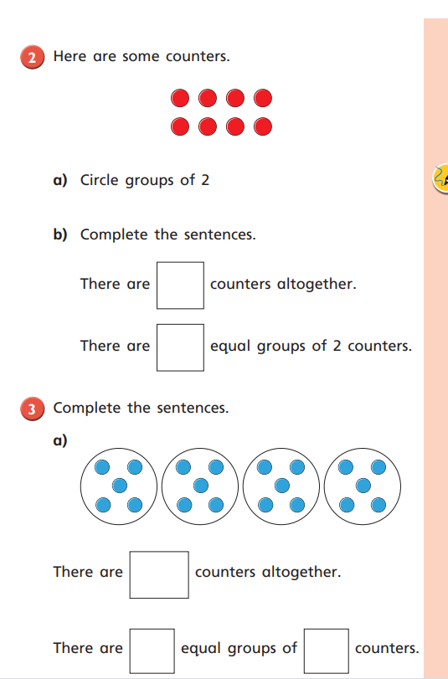
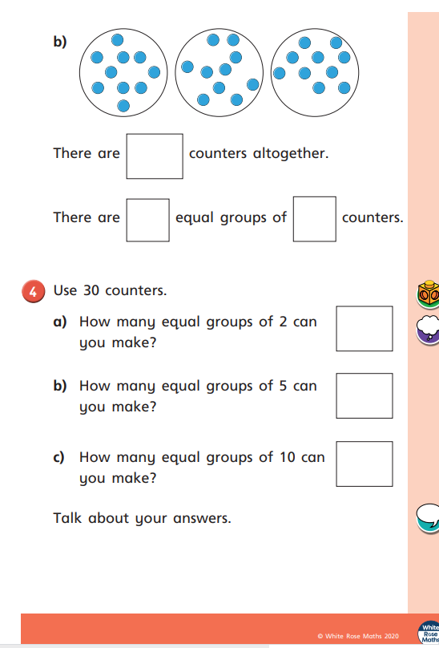
Thursday


