Year 1 Literacy Week beginning 29th June 2026 (If all the world were – Week 1)

Day | Activity https://www.youtube.com/watch?v=nWnBn6sZzXE Book we are reading this week | Phonics
Monday | LI: We are learning to write questions.  SC. I can write questions and use question marks.  Do you know what these words mean?  springtime, space, dreams, feelings, stories,  memories, worlds  Can you write a question about each word? | Phase 5: au  https://www.youtube.com/watch?v=b8cclMWGK7M&list=PLuGr6z2H2KNGObda6B-T36vJlZYN06lOh&index=64
Tuesday | LI: We are learning to infer a character’s feelings.  SC: I can understand and say how a person feels.  Watch above website to access story  Read If all the world were… up to the end of the summer section where they are in space  Ask, what’s the relationship between the two characters? How do you think they feel about each other?  Children to write onto thought bubbles in role as the girl or the grandad at this point in the story | Phase 5: er  https://www.youtube.com/watch?v=Ffjnh3muZow&list=PLuGr6z2H2KNGObda6B-T36vJlZYN06lOh&index=60
Wednesday | LI: We are learning to write commands.  SC: I can use verbs to write commands.  Falling out phrases:  Re-read from the beginning up to the ‘deep space’ that you reached in session 2  Children to create their own ‘Top Tips for Dealing with Feelings’ guide. Examples:  Think of the budding springtime  Share your feelings  Mix the bright feelings to paint over sad  ones  Paint and draw your memories | Phase 5: ou  https://www.youtube.com/watch?v=9mPiMevwOUU&list=PLuGr6z2H2KNGObda6B-T36vJlZYN06lOh&index=71
Thursday | LI: To write statements and commands.  SC: I can use imperative language/verbs.  Read the page with the empty chair and the single sentence but some tales are silent  Write a letter to a friend giving them tips on how to deal with emotions. | Phase 5: oy  https://www.youtube.com/watch?v=d-5QYq382lo&list=PLuGr6z2H2KNGObda6B-T36vJlZYN06lOh&index=70
Friday | LI: We are learning to begin to plan own poem  SC: I can plan ideas for my own writing  Then, go back and look at the objects that the girl found that bring back memories of her grandad.  Ask the children to think of 3/4 objects that are special to them | Phase 5: are  https://www.youtube.com/watch?v=h03ObEoFmac&list=PLuGr6z2H2KNGObda6B-T36vJlZYN06lOh&index=33

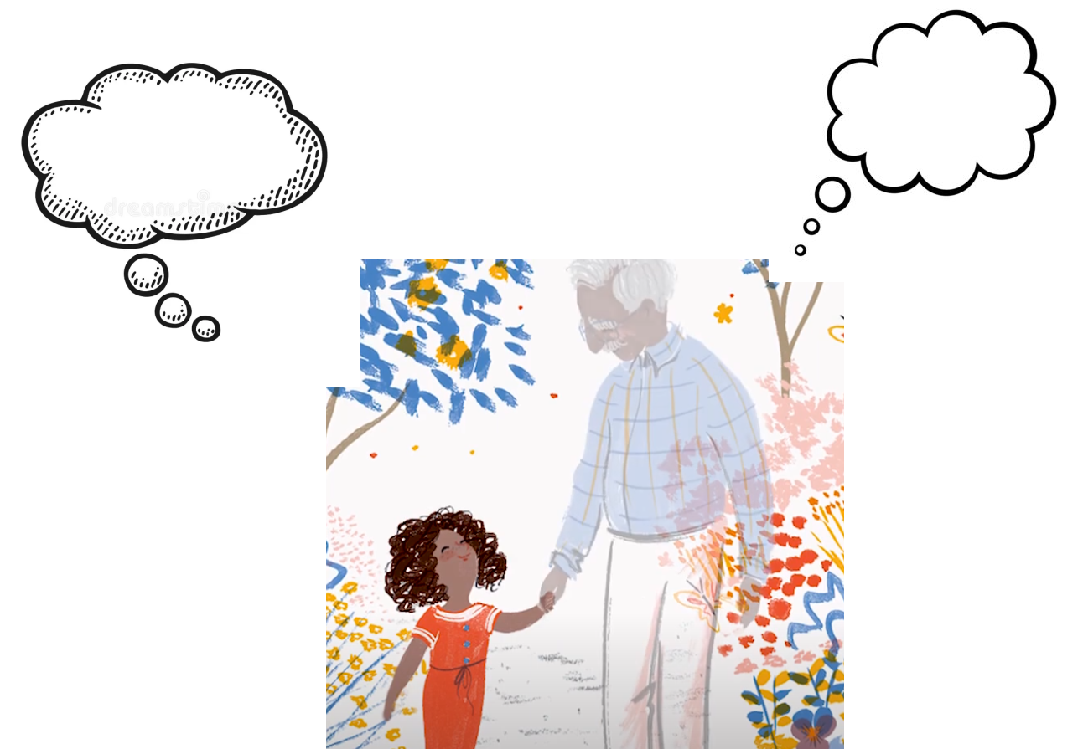

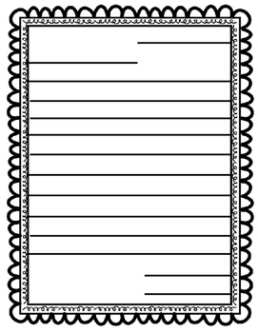

Objects that are special to me

