Year 1 Literacy Week beginning 22nd June 2026

Day | Activity | Phonics
Monday | LI: We are learning to write a recount.  Look at the pictures below and discuss our Sports Day. What activities did we do? Which one was your favourite one? Cut the pictures out and put them in the correct order. What did we do first/next/after/at the end? | Phase 5: ear  https://www.youtube.com/watch?v=kS5ee1T3yfw&list=PLuGr6z2H2KNGObda6B-T36vJlZYN06lOh&index=32
Tuesday | LI: We are learning to write a recount.  Look at the grid below and draw pictures of what we did at our Sports day. | Phase 5: ch  https://www.youtube.com/watch?v=tZtMkodXm0Y&list=PLuGr6z2H2KNGObda6B-T36vJlZYN06lOh&index=41
Wednesday | LI: We are learning to write a recount.  Using the grid from yesterday write about our Sports day. Include time words and adjectives: because so but and | Phase 5: c  https://www.youtube.com/watch?v=1pN_0caLakI&list=PLuGr6z2H2KNGObda6B-T36vJlZYN06lOh&index=45
Thursday | L.I: We are learning to edit our work.  Look at your writing from yesterday. Use a coloured pencil to edit and improve your work. Have you missed any capital letters or full stops? Can you add some adjectives? | Phase 5: se  https://www.youtube.com/watch?v=DZWycZlvJXE&list=PLuGr6z2H2KNGObda6B-T36vJlZYN06lOh&index=17
Friday | L.I: We are learning about punctuation.  S.C: I can use an exclamation mark, question mark and full stops.  Look at the worksheet below and use punctuation to complete the sentences correctly. | Phase 5: Review of set  https://www.youtube.com/watch?v=6tC31vimqJ0&list=PLuGr6z2H2KNGObda6B-T36vJlZYN06lOh&index=23

Monday
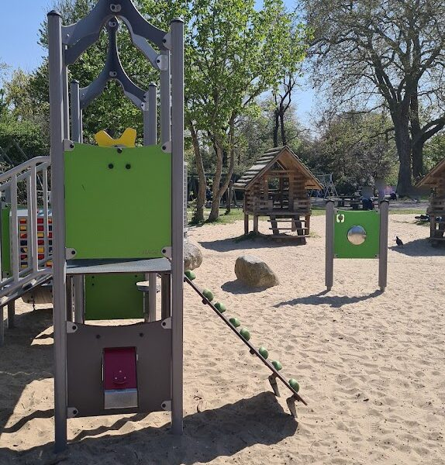
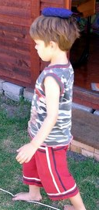
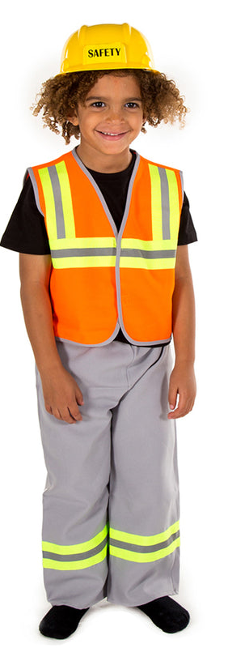
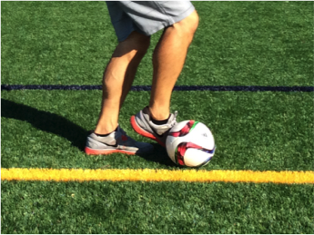

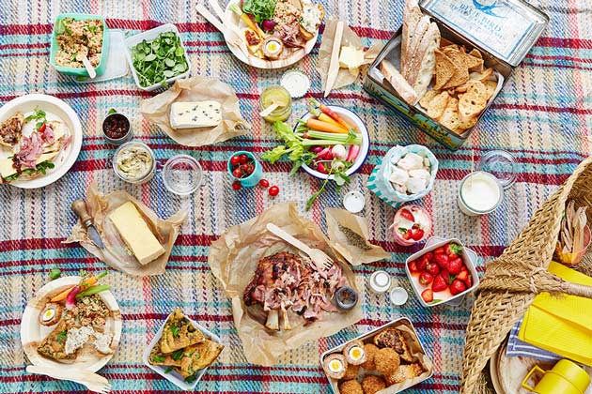
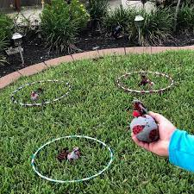
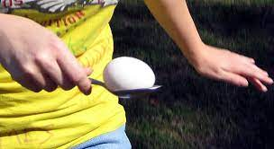
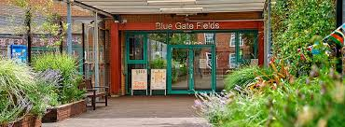
Balancing
Builder dress up
Picnic
Dribbling
Target throwing
Playground
Race
Egg and spoon
First | Next | Then | After | Subsequently
Then | Soon | Later | Next | Finally
Tuesday

Friday

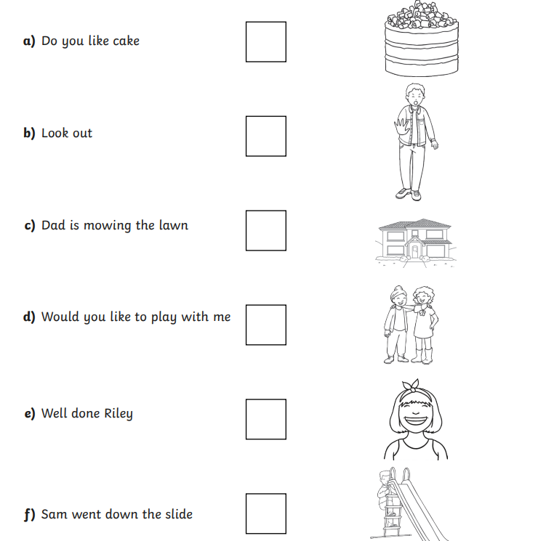
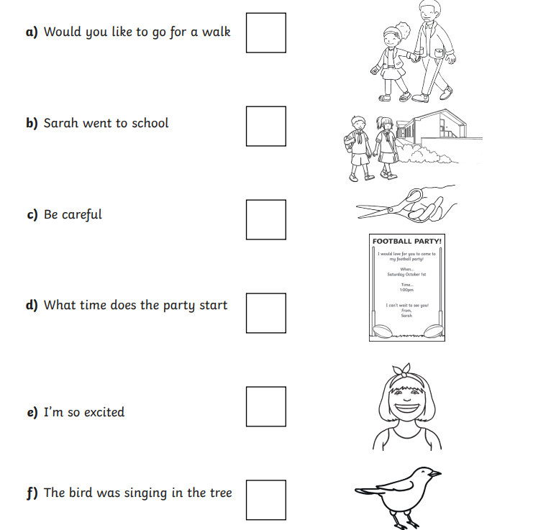
Put an exclamation mark (!), questions mark (?) or full stop (.) to complete the sentences correctly.



