Year 2 Numeracy
Week beginning 29th June Measurement: Money
Day | Video Link  (Copy and paste into your browser) | Learning/Activity | Enrichment/Problem solving/Reasoning
Monday | https://vimeo.com/470140979 | LI: Counting money-pence  See Monday worksheet | Have a go at the enrichment activity  https://nrich.maths.org/6589/index
Tuesday | https://vimeo.com/471307411 | LI: Counting money-pounds  See Tuesday worksheet | https://www.topmarks.co.uk/money/toy-shop-money
Wednesday | https://vimeo.com/471307831 | LI: Counting money-notes and coins  See Wednesday worksheet | Have a go at the enrichment activity  https://nrich.maths.org/7819
Thursday | https://vimeo.com/473051856 | LI: Selecting money  See Thursday worksheet | https://www.topmarks.co.uk/money/coins-game
Friday | https://vimeo.com/471402395 | LI: Making the same amount  See Friday worksheet | https://natwest.mymoneysense.com/students/students-5-8/coin-cruncher/

Monday
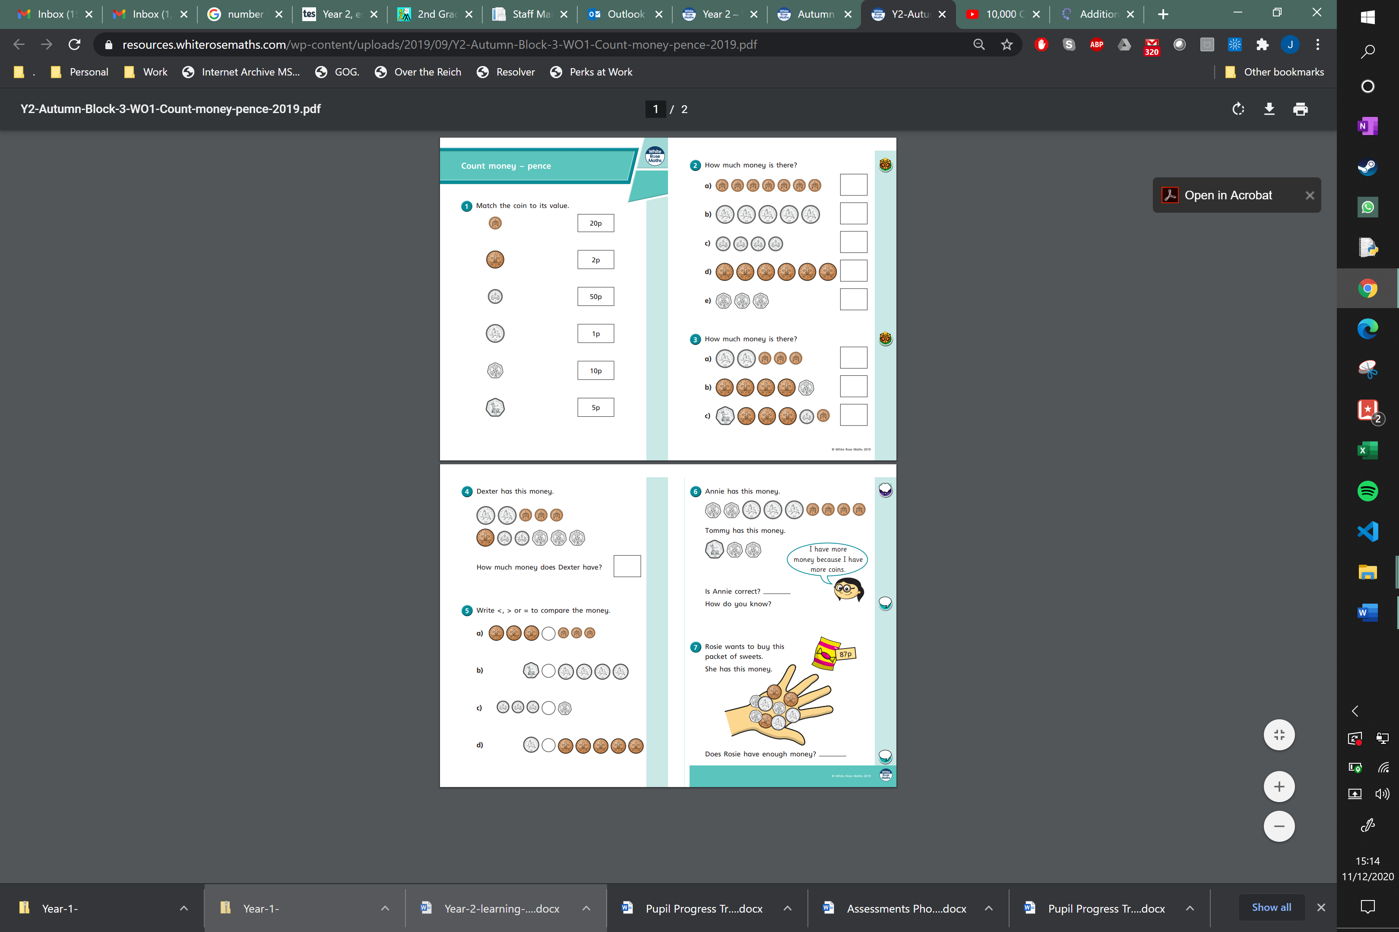
Tuesday
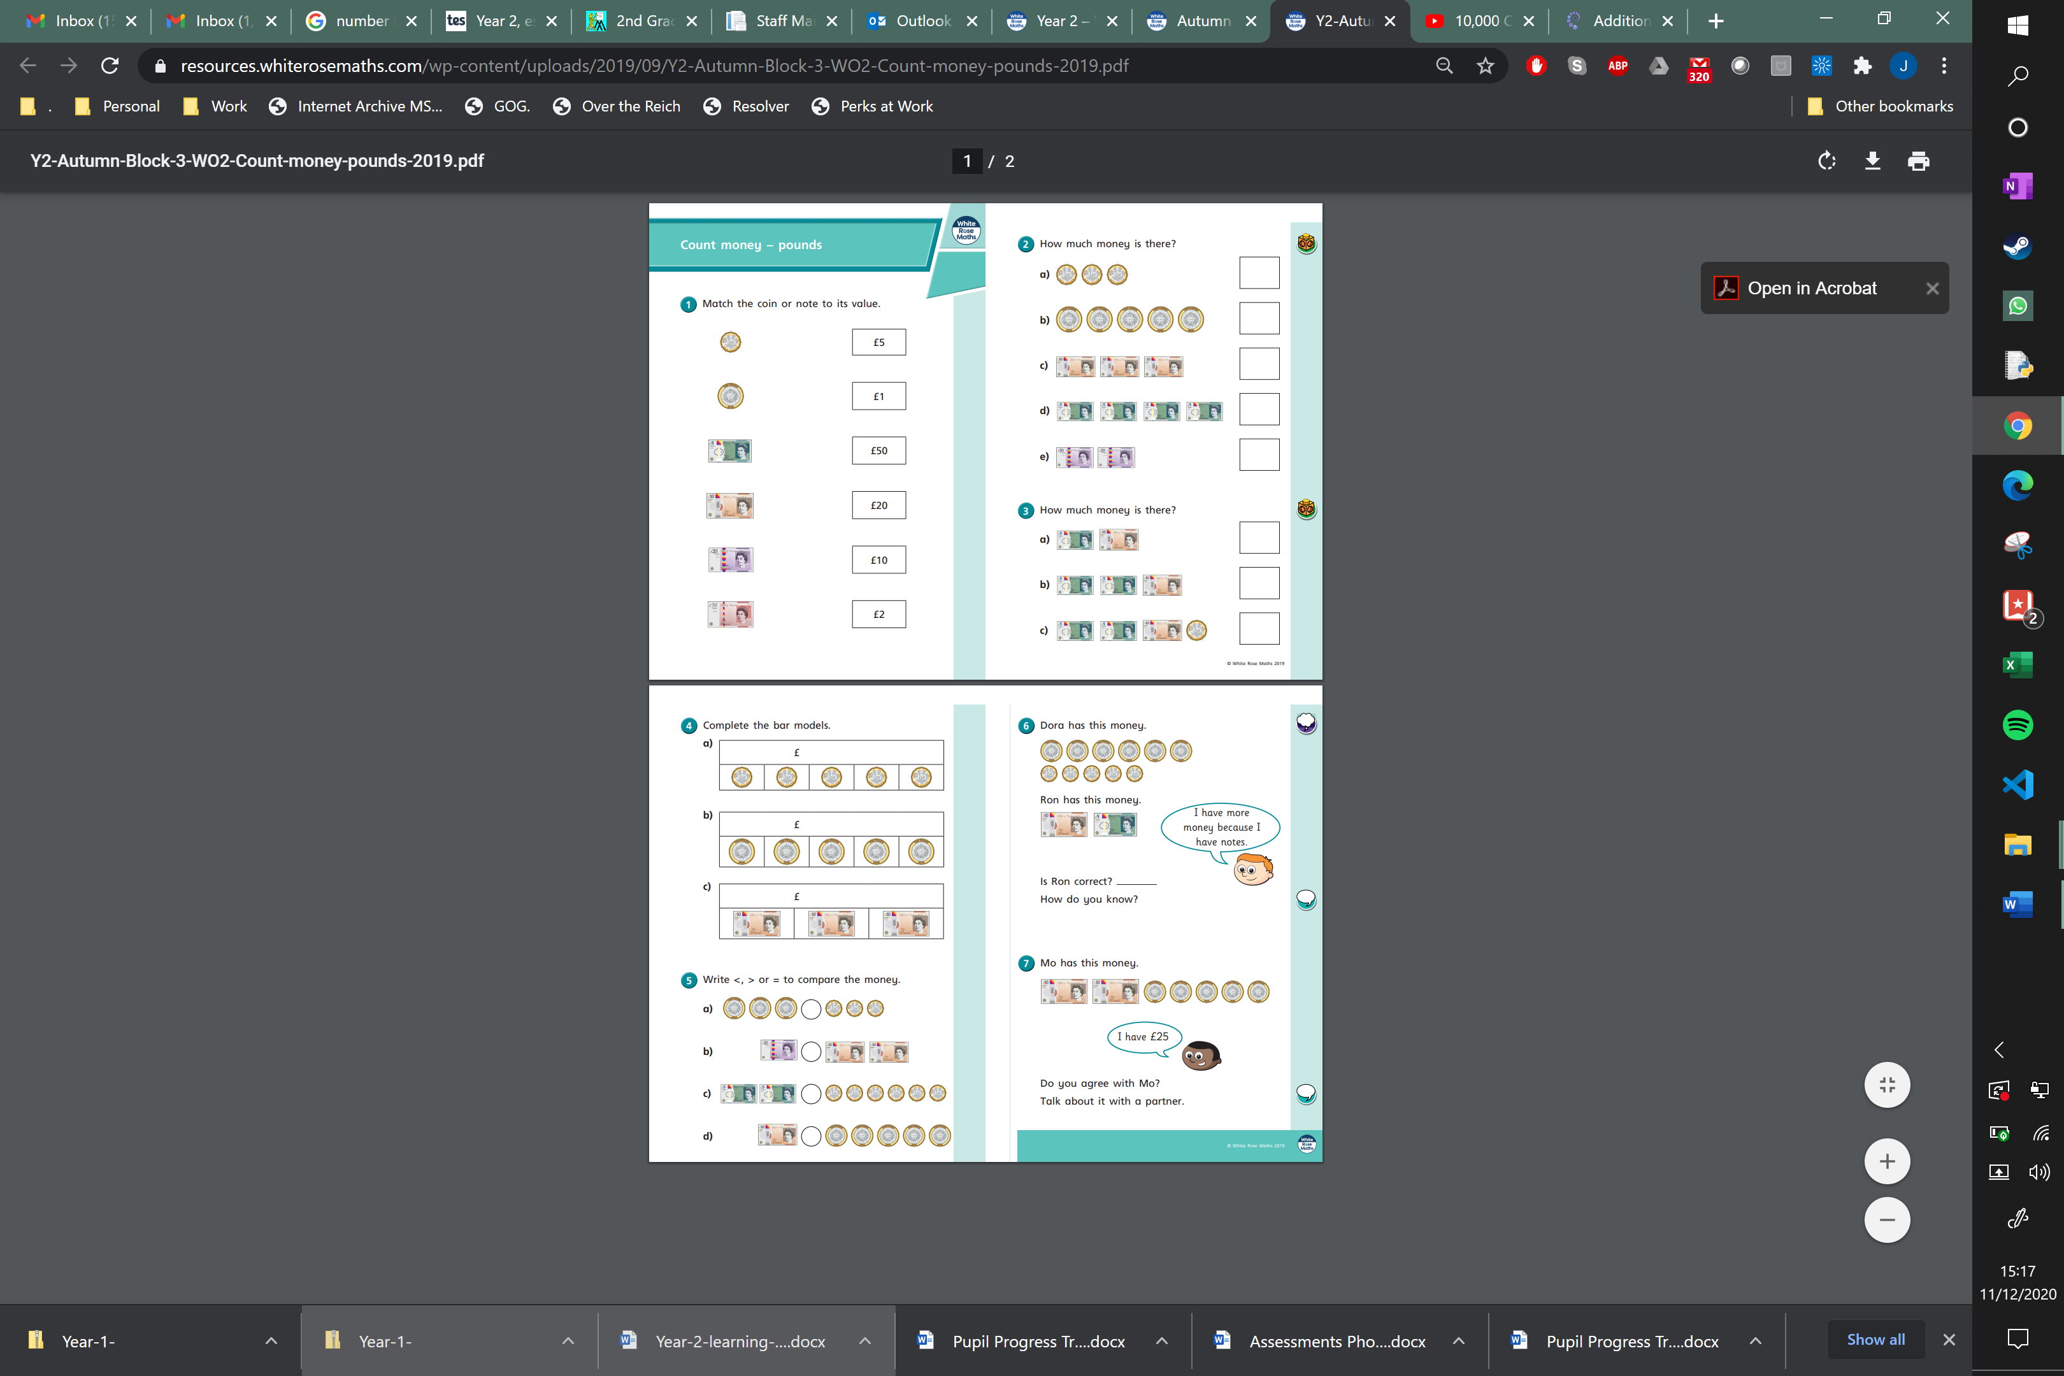
Wednesday
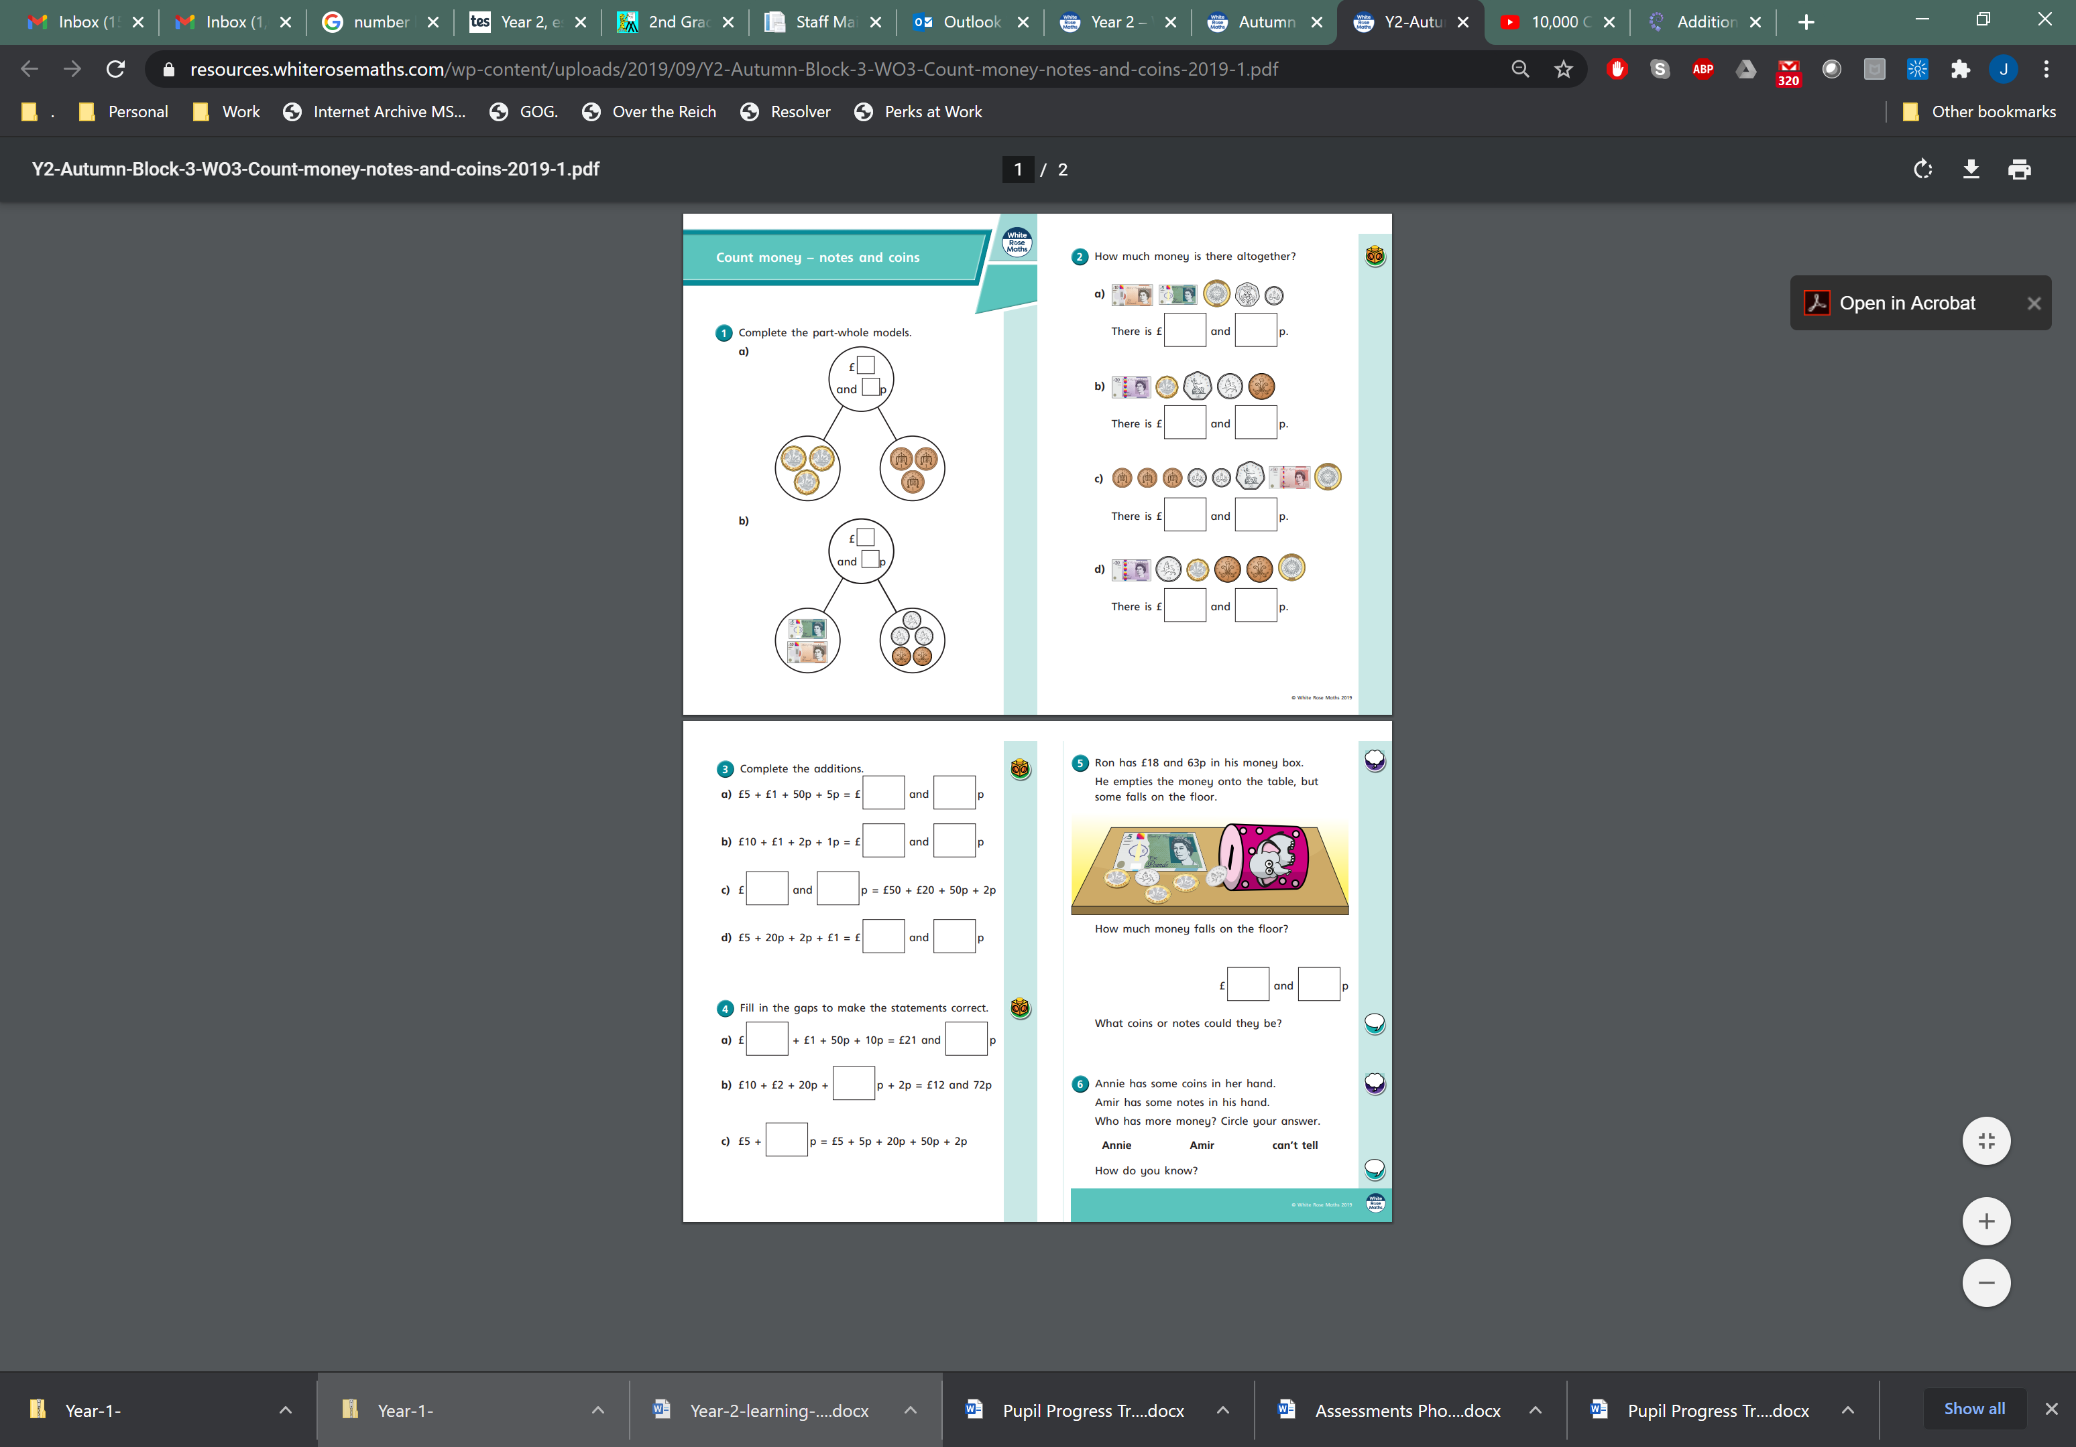
Thursday
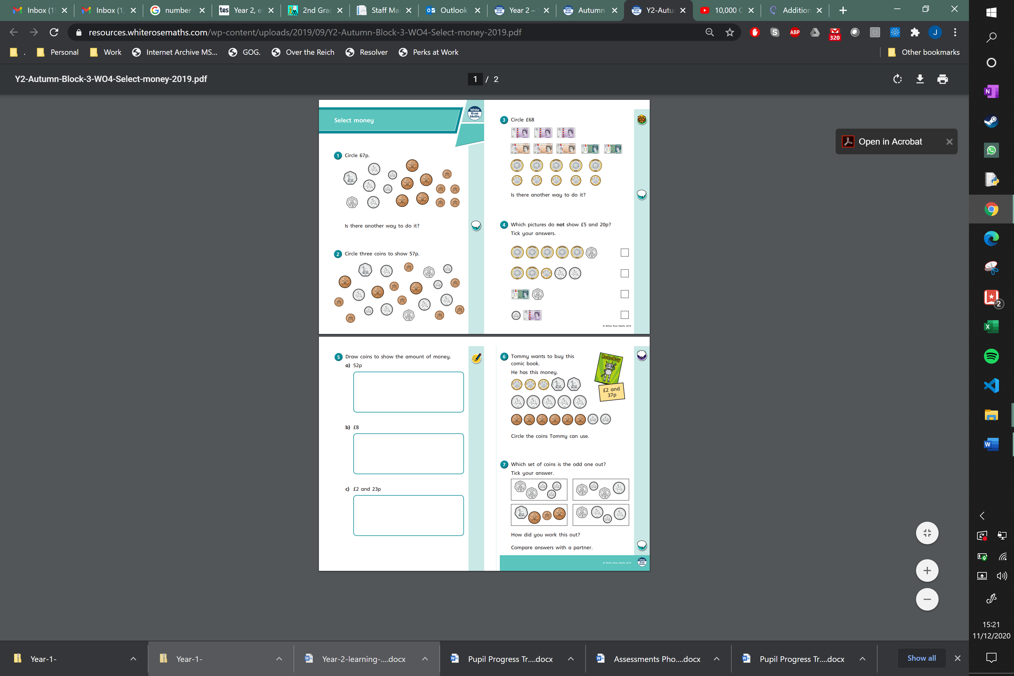
Friday


