Year 2 Literacy
Week beginning 15th June This week year 2 are learning to compare two characters.
When opening web links hold down control key and click link. Story: The worst witch Jill Murphy
Day | Activity | Phonics Phase 5
Monday | LI: To compare two characters from a story.  SC: I can use comparative language  brainstorm | Review: mb, wr  https://www.youtube.com/watch?v=_BQSgmIHTys&list=PLuGr6z2H2KNGObda6B-T36vJlZYN06lOh&index=5  phase 3 (ai)  https://www.youtube.com/watch?v=siVkXoEQDNc&list=PLuGr6z2H2KNG4XgGr7UylwowIcDLr-T-k&index=94
Tuesday | LI: To compare two characters from a story.  SC: I can use comparative language.  See resources. | Review: gn, kn  https://www.youtube.com/watch?v=IOto5XEwclE&list=PLuGr6z2H2KNGObda6B-T36vJlZYN06lOh&index=8  phase 3 (ee)  https://www.youtube.com/watch?v=hBFFUCraDt8&list=PLuGr6z2H2KNG4XgGr7UylwowIcDLr-T-k&index=93
Wednesday | LI: We are learning to discuss favourite part of a story.  SC: I can give reasons from text for my opinion. | tch  https://www.youtube.com/watch?v=ot3eJNkXgwE&list=PLuGr6z2H2KNGObda6B-T36vJlZYN06lOh&index=19  phase 3 (igh)  https://www.youtube.com/watch?v=7anrdHnwGbs&list=PLuGr6z2H2KNG4XgGr7UylwowIcDLr-T-k&index=92
Thursday
Thursday | LI: I am learning to write a letter.  SC: I can use language of opinion.  See resources. | ssion  https://www.youtube.com/watch?v=OSzpBS6HIMY&list=PLuGr6z2H2KNGObda6B-T36vJlZYN06lOh&index=12  phase 3 Review of ai, ee, igh:  https://www.youtube.com/watch?v=WOGmKeYoUNU&list=PLuGr6z2H2KNHY2HITC9jV0a65ED0aD2Ry&index=20
Friday | Spelling practice | Practice spelling words and put them into sentences.

resources below:
Mon: brainstorm
Wednesday: write about your favourite part of the story with reasons.
Tues: write a comparison text.
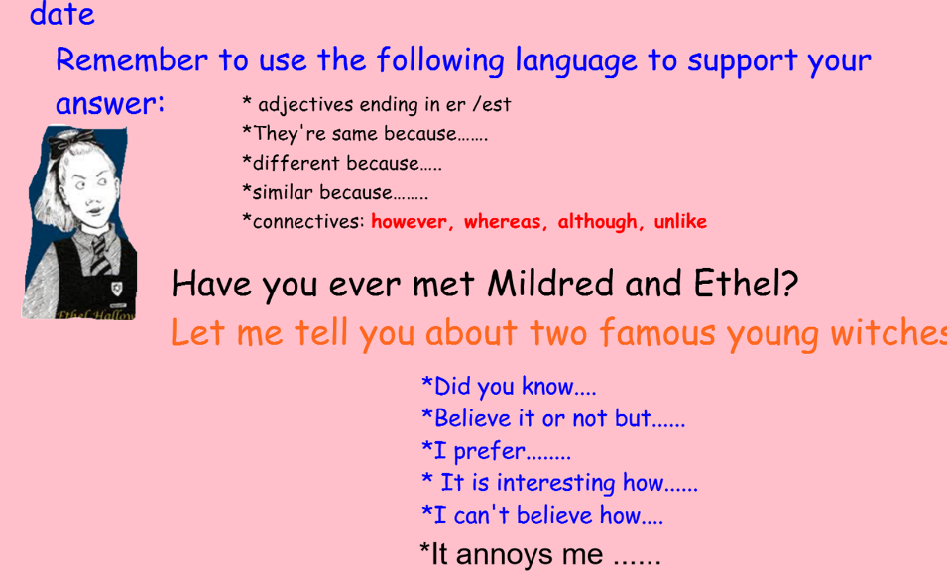

Thurs: writing a letter to Jill Murphy
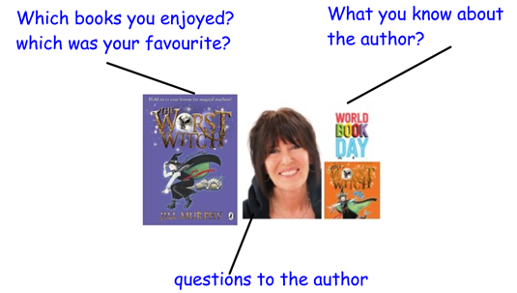
Friday:



