Year 2 Numeracy
Week beginning 15th June: Measure
Day | Video Link/PowerPoint | Learning/Activity | Enrichment/Problem solving/Reasoning
Monday | https://vimeo.com/562671164 | LI: Four operations with mass  See Monday worksheet | https://www.bbc.co.uk/bitesize/topics/zt9k7ty/articles/z428wty
Tuesday | https://vimeo.com/562671601 | LI: Four operations with volume  See Tuesday worksheet | https://www.topmarks.co.uk/maths-games/daily10
Wednesday | https://vimeo.com/563564811 | LI: Understanding temperature  Practical activity | Have a go at the enrichment activity:  https://nrich.maths.org/14727
Thursday | https://vimeo.com/562671854 | LI: Understanding temperature  See Thursday worksheet | Have a go at the enrichment activity:  https://nrich.maths.org/5590
Friday |  | LI: Assessment  See Friday worksheet | https://www.topmarks.co.uk/learning-to-count/place-value-basketball

Monday
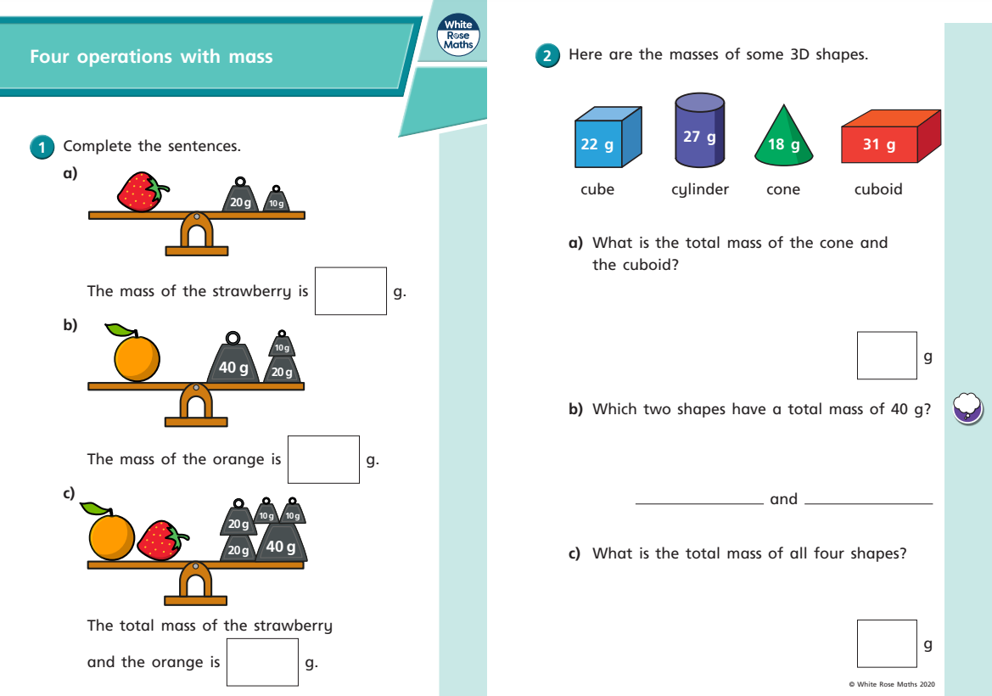
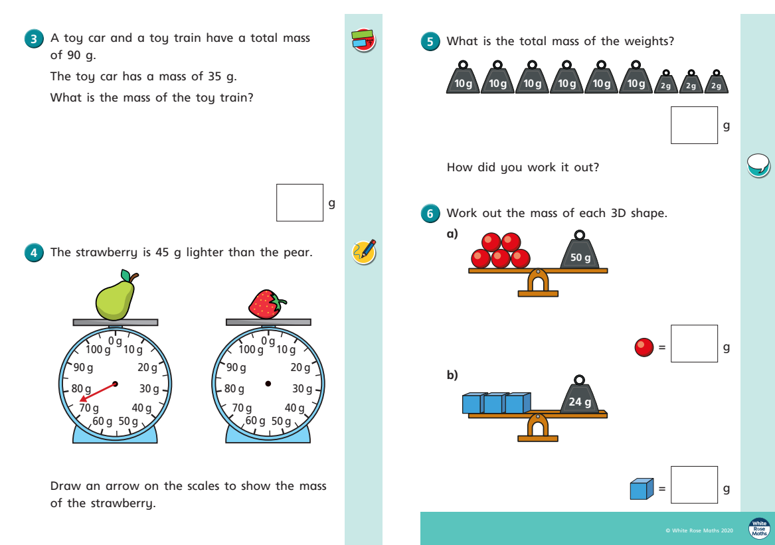

Tuesday
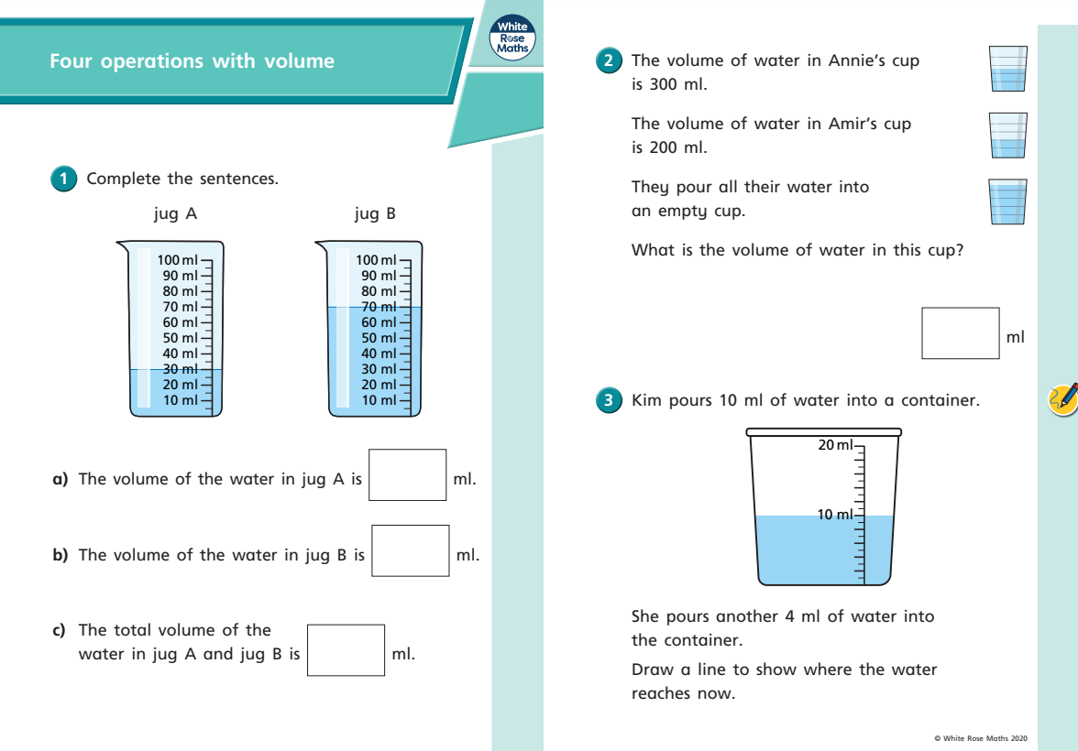
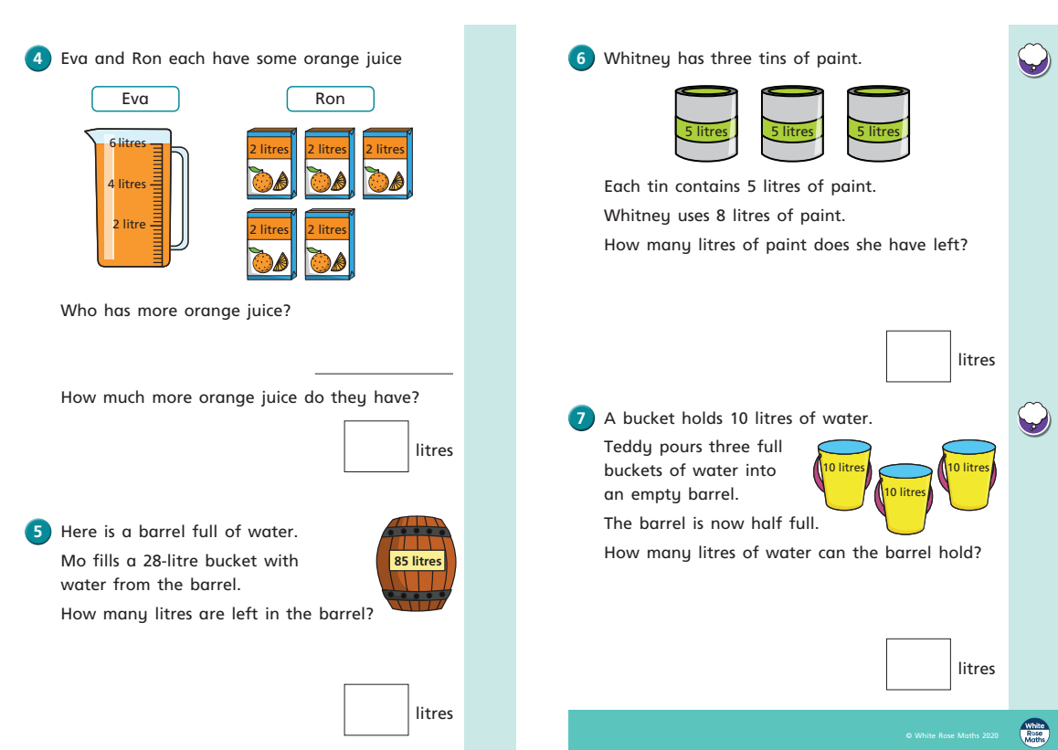
Thursday
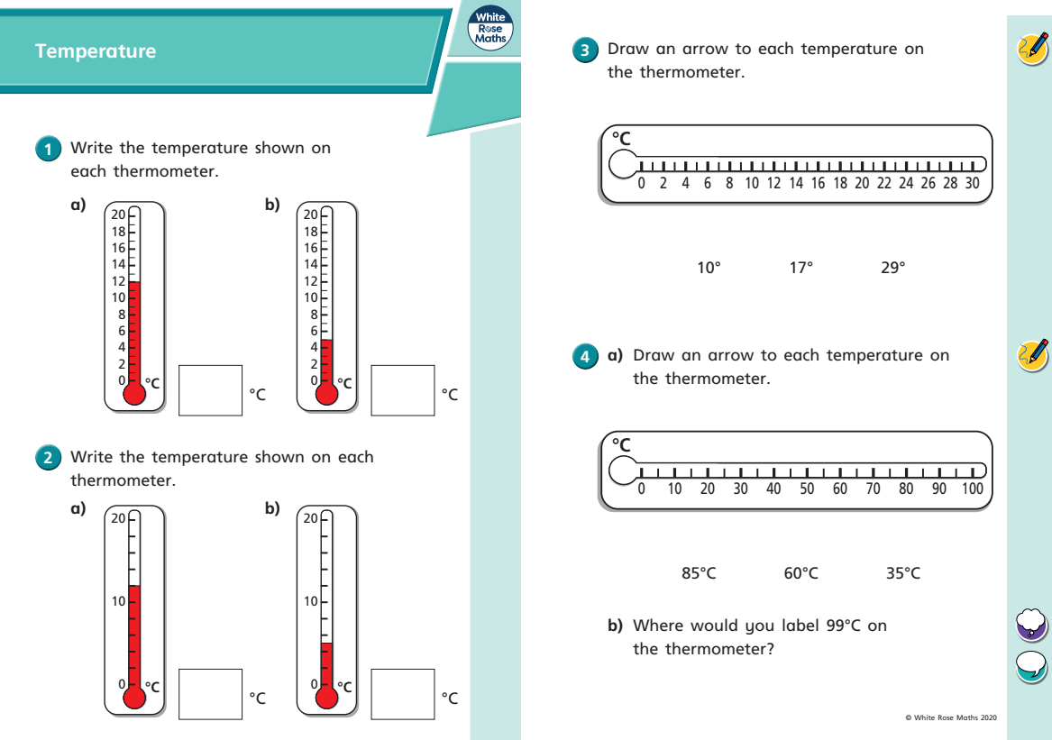
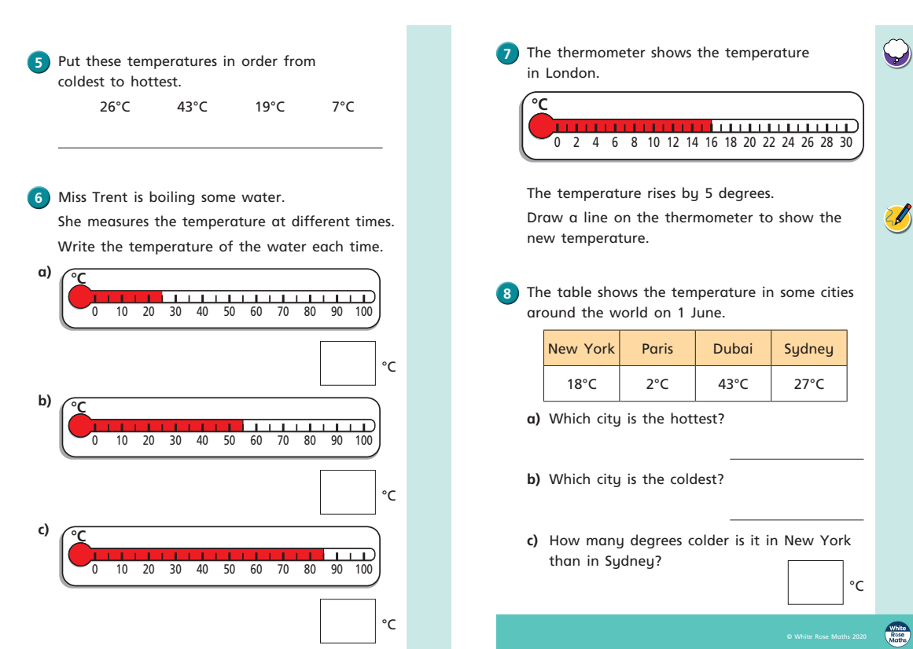
Friday


