Year 2 Literacy
Week beginning 8th June This week year 2 are learning to describe a character and make predictions.
When opening web links hold down control key and click link. Story: The worst witch Jill Murphy
Day | Activity | Phonics Phase 5
Monday | LI: To predict what a story is about and give reasons.  SC: I can use predictive language: I think, I believe…because…, My reason for thinking that is……… | tch phase 5  https://www.youtube.com/watch?v=ot3eJNkXgwE&list=PLuGr6z2H2KNGObda6B-T36vJlZYN06lOh&index=1  Phase 3  Review session of set 6 video:  https://www.youtube.com/watch?v=OQ1AnMCGTzg
Tuesday | LI: We are learning to write a character description.  SC: I can use interesting adjectives and give reasons for my opinion when describing a character.  See resources. Brainstorm. | ssion phase 5  https://www.youtube.com/watch?v=OSzpBS6HIMY&list=PLuGr6z2H2KNGObda6B-T36vJlZYN06lOh&index=12  Phase 3  https://www.youtube.com/watch?v=OQ1AnMCGTzg
Wednesday | LI: We are learning to write a character description.  SC: I can use interesting adjectives and give reasons for my opinion when describing a character. | tion phase 5  https://www.youtube.com/watch?v=ySMwEseAOjE&list=PLuGr6z2H2KNGObda6B-T36vJlZYN06lOh&index=13  Phase 3  Learn to read words:  https://www.youtube.com/watch?v=N2PZ_RO9pYs
Thursday
Thursday | LI: I am learning to describe a setting.  SC: I can describe and compare two settings.  See resources. (practical) | cial phase 5  https://www.youtube.com/watch?v=xis9zXVTjiw&list=PLuGr6z2H2KNGObda6B-T36vJlZYN06lOh&index=11  Phase 3  https://www.youtube.com/watch?v=N2PZ_RO9pYs
Friday | LI: I am learning to describe a setting.  SC: I can describe and compare two settings.  See resources.  Write a letter to Mildred , comparing the two settings. | tch phase 5  https://www.youtube.com/watch?v=ot3eJNkXgwE&list=PLuGr6z2H2KNGObda6B-T36vJlZYN06lOh&index=1  Phase 3  Review session of set 6 video:  https://www.youtube.com/watch?v=OQ1AnMCGTzg

resources below:
Mon:
Tues Brainstorm

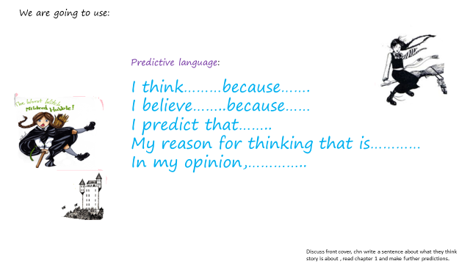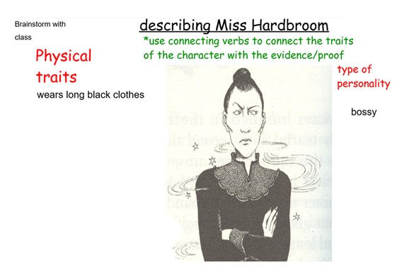
Wed : write a description
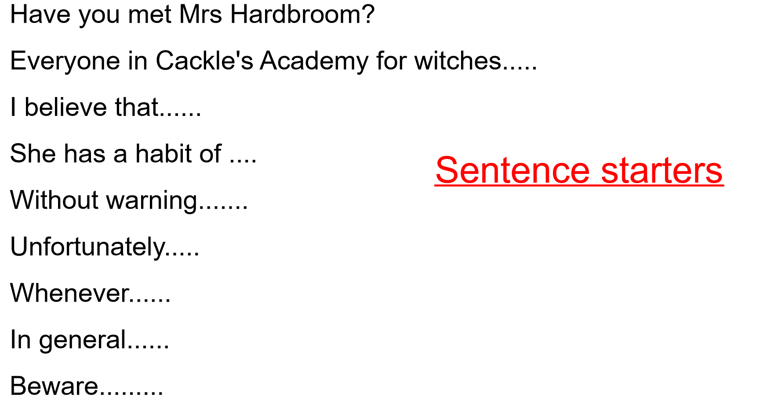

Thurs and Friday: describe settings( the academy and our school)



