Year 2 Numeracy

Week beginning ^{8th} June : Position & direction

Day | Video Link  (Copy and paste into your browser) | Learning/Activity | Enrichment/Problem solving/Reasoning
Monday | https://vimeo.com/544473778 | LI: Describe turns  See Monday worksheet | Pattern sequencing game  https://www.topmarks.co.uk/ordering-and-sequencing/shape-patterns
Tuesday | https://vimeo.com/545379383 | LI: Describe movement and turns Practical: Direct a friend through a maze, using quarter and half turn as well as clockwise and anti-clockwise. | Practise make turns and rotations  https://www.ictgames.com/mobilePage/deadlyDoors/index.html
Wednesday | https://vimeo.com/545004596 | LI: Describe movement and turns  See Wednesday worksheet | Have a go at the enrichment activity  https://nrich.maths.org/8084
Thursday | https://vimeo.com/545005594 | LI: Making patterns with shapes  See Thursday worksheet | How many times you could press the "turn" button to make the man look the same as in each of the picture  https://nrich.maths.org/5560
Friday |  | LI: Problem solving  See Friday worksheet | Pattern sequencing game  https://www.topmarks.co.uk/ordering-and-sequencing/shape-patterns

Monday
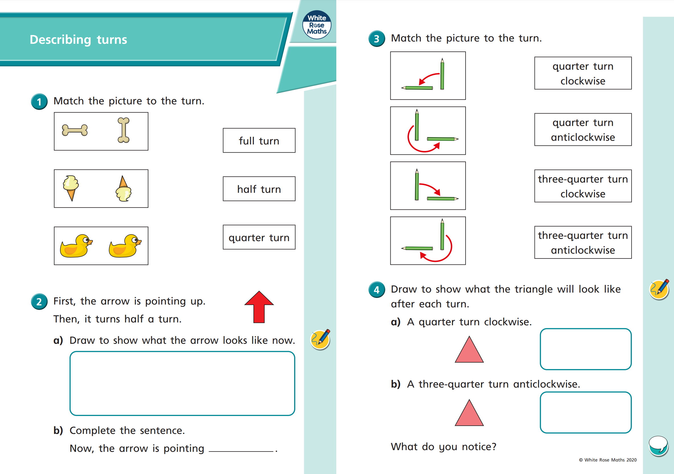
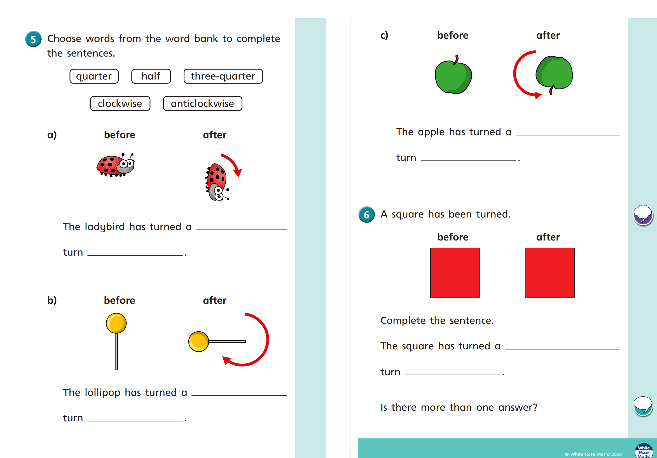
Wednesday
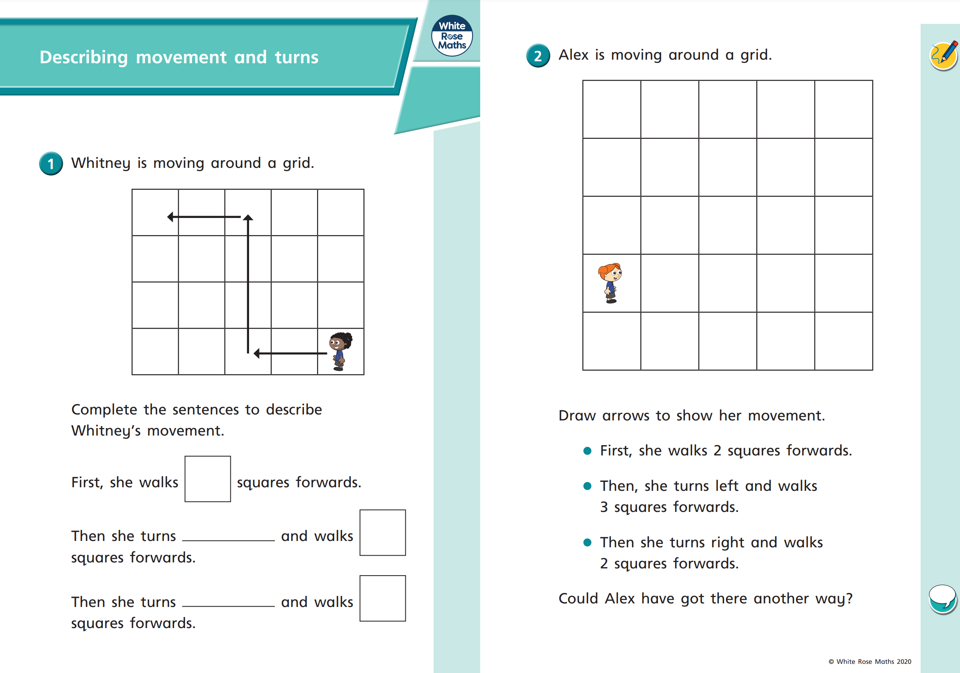
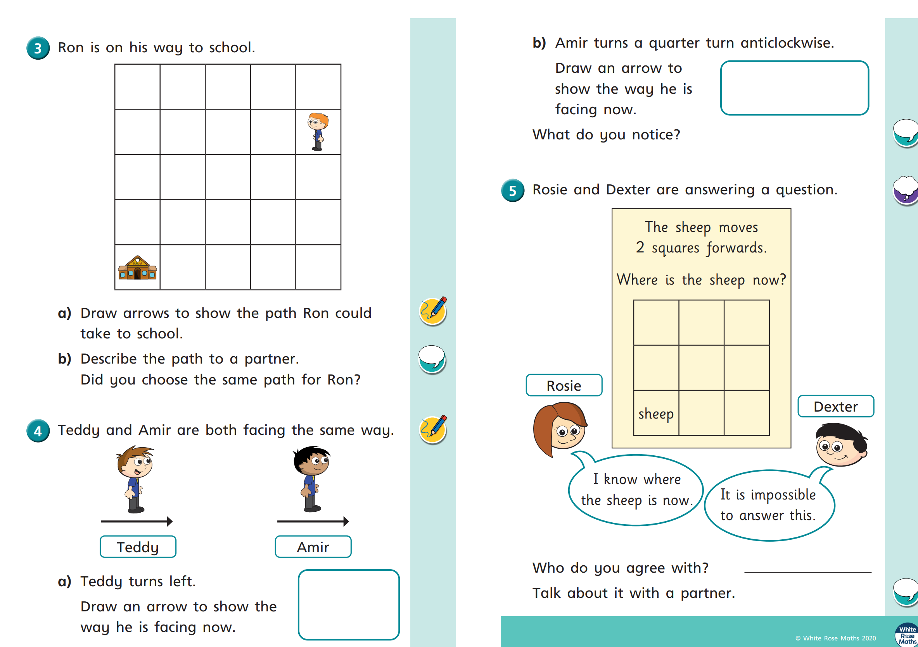
Thursday
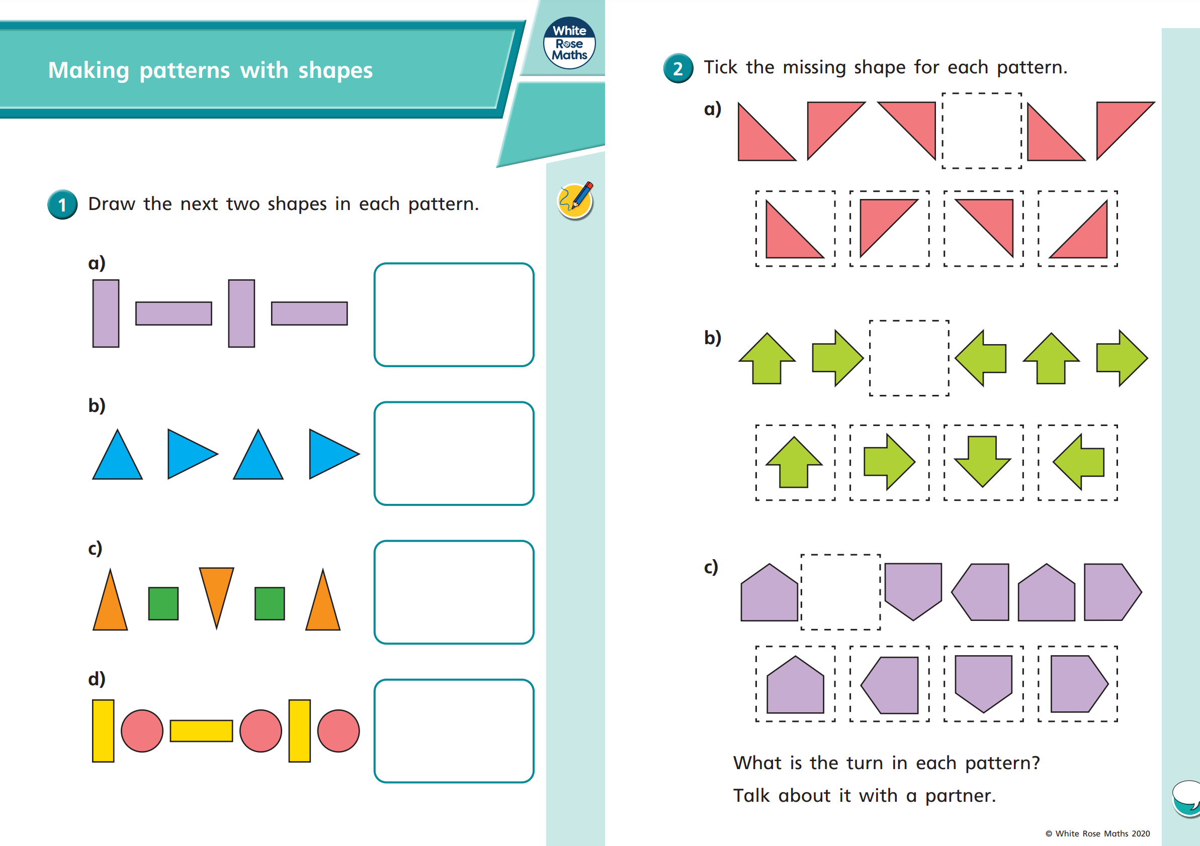
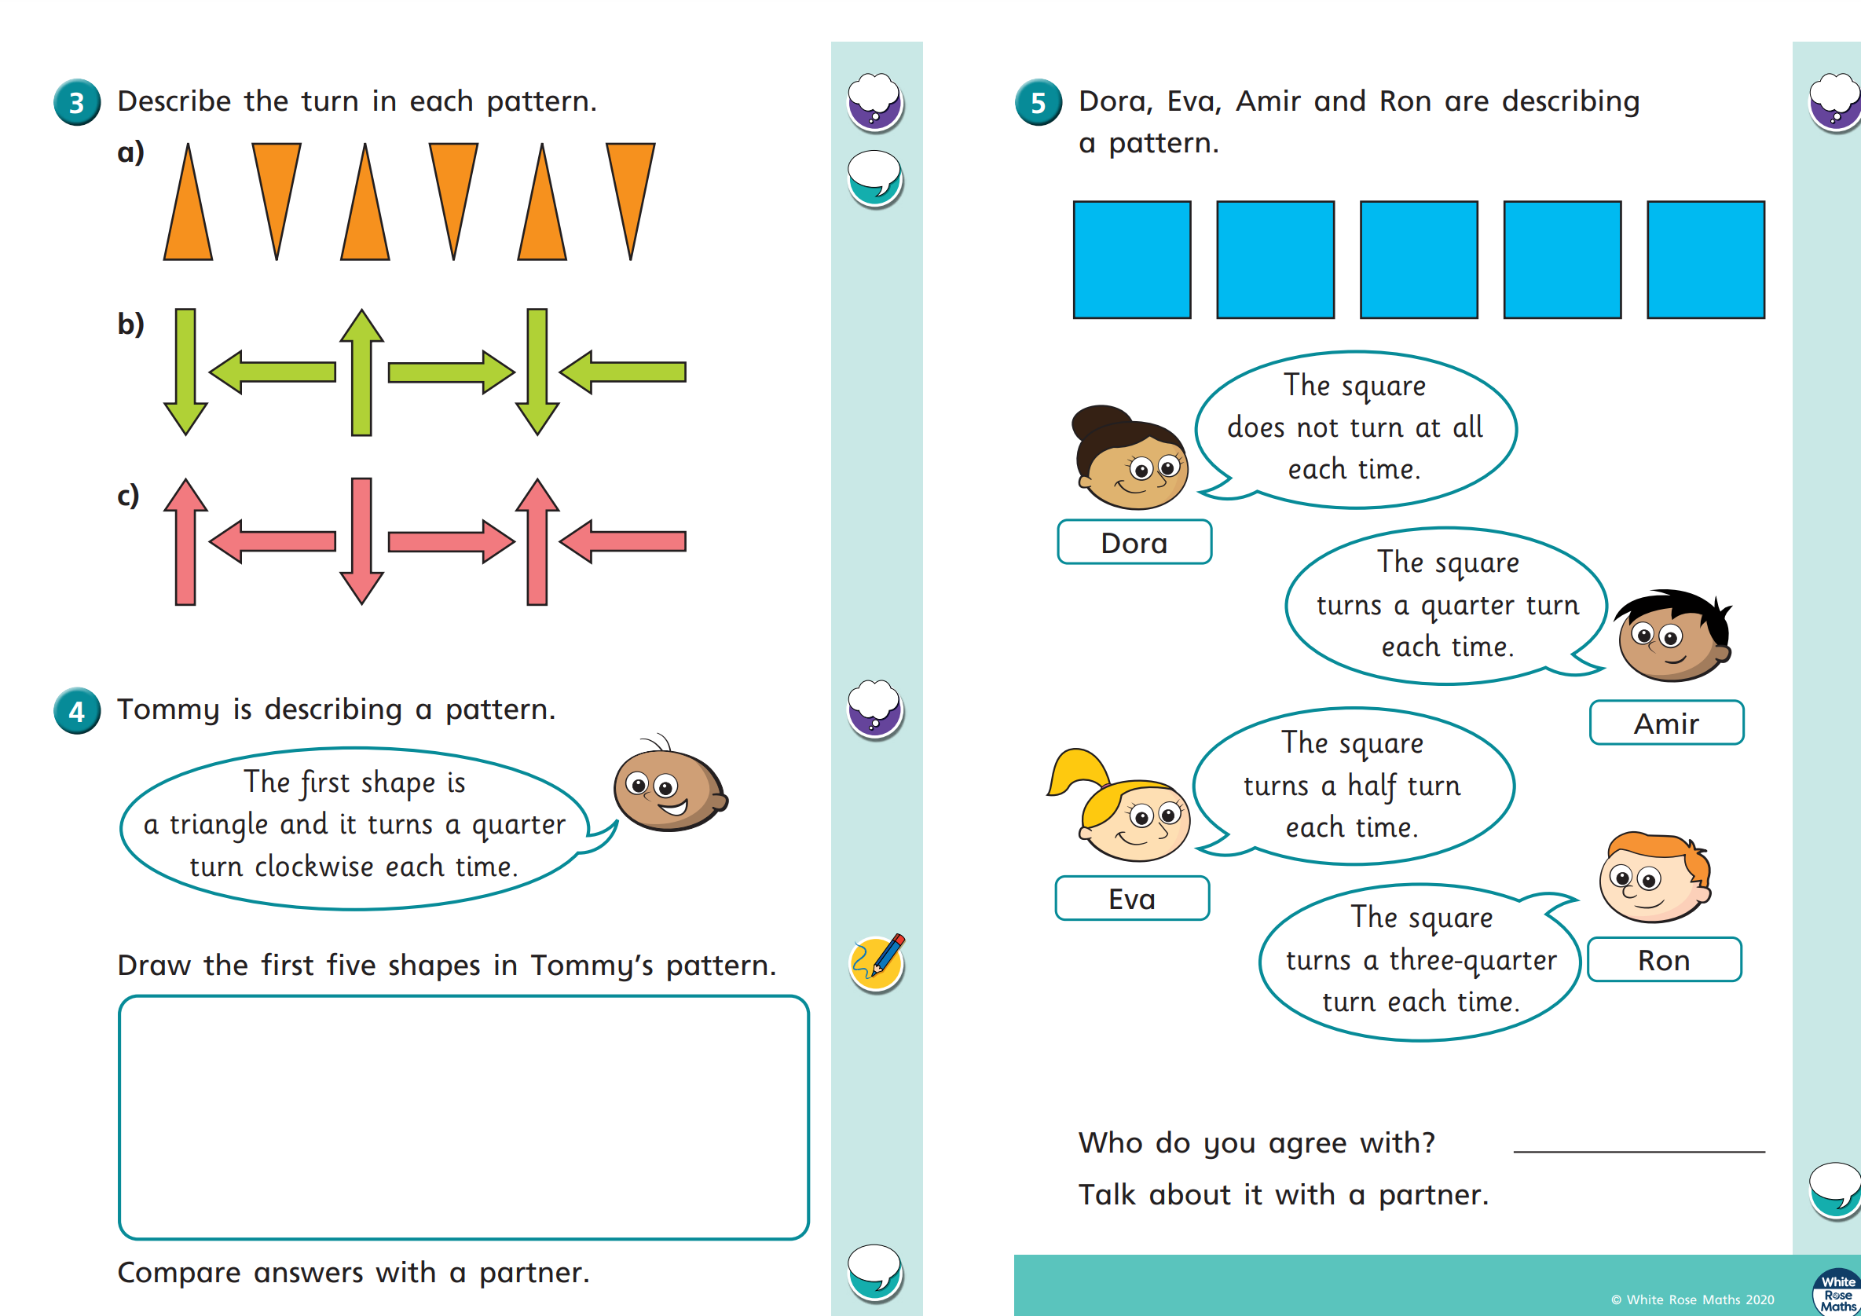
Friday


