Year 1 Numeracy
Week beginning 18th May 2026 SCROLL DOWN FOR ACTIVITIES
Day | Video Link  (Copy and paste into your browser) | Learning/  Activity | Enrichment/Problem solving/Reasoning
Monday | https://vimeo.com/797347954 | Find and name a quarter of a shape | https://www.topmarks.co.uk/Search.aspx?q=quarters
Tuesday | https://vimeo.com/797348348 | Find and name a quarter of a shape | https://uk.ixl.com/maths/year-1/make-quarters
Wednesday | https://vimeo.com/797348704 | Find and name a quarter of a quantity | https://www.turacogames.com/games/fractions-half-quarter-math-game-for-kids/
Thursday | https://vimeo.com/797349074 | Find and name a quarter of a quantity | https://ictgames.com/mobilePage/firepitFractions/index.html
Friday |  | End of block assessment

.
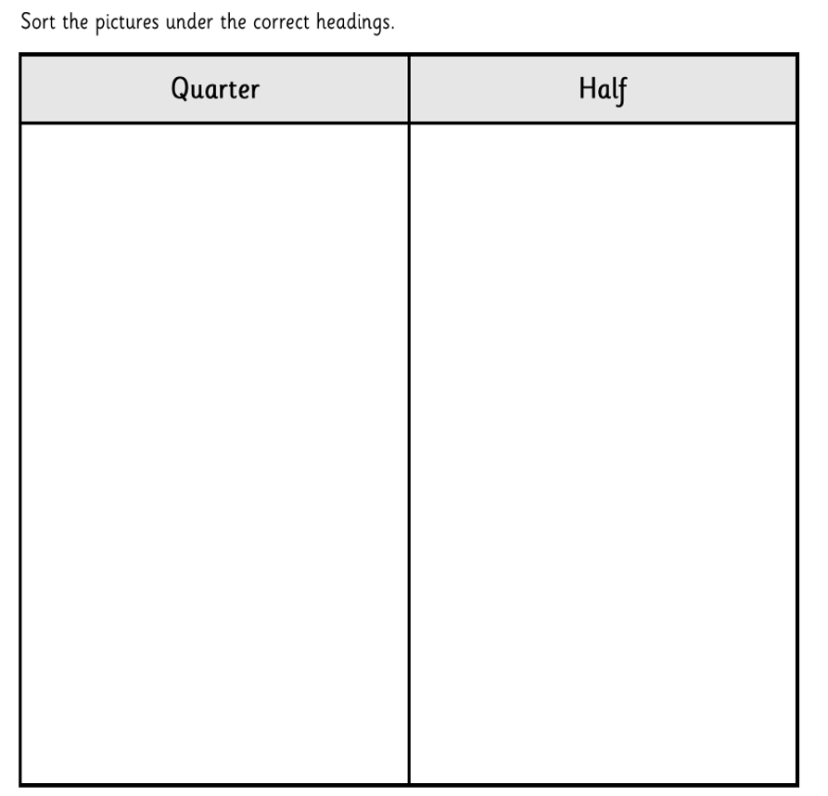

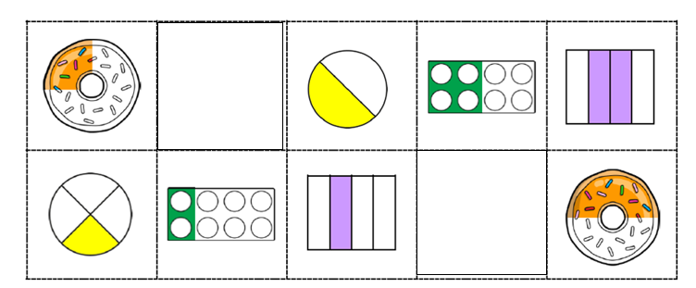

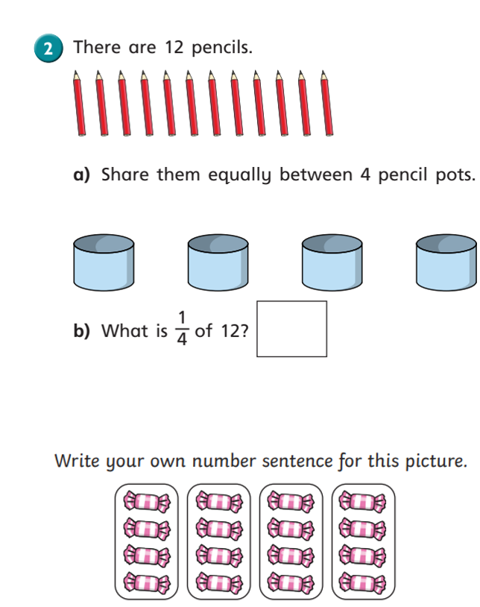
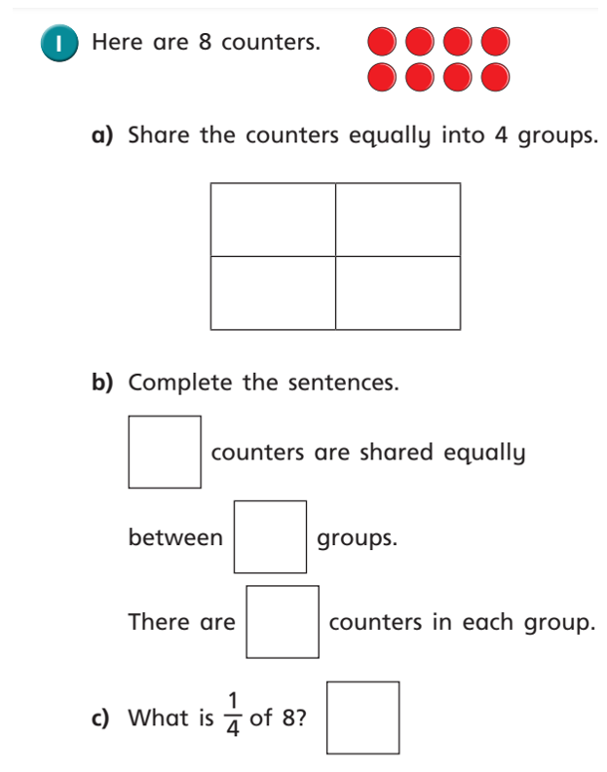
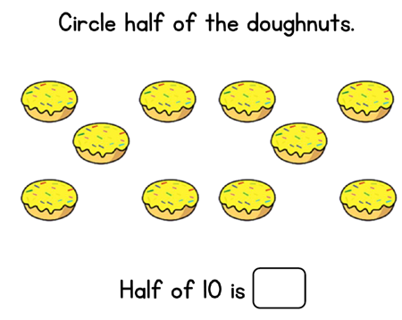
END OF BLOCK ASSESSMENT



