Dear parents
Below is Year 2 home project for this half term. The children will be able to complete as many of the tasks as they wish and bring them into school.
The activities are designed to complement and build knowledge in some of the work that your child will be doing during out topic and literacy about The Isle of Struay.
As a reward for completing the different activities your child will earn stickers which will be exchanged for a prize.
The more activities you do the more stickers you will earn and if you get 5 stickers or more then you will get a prize!
You can do as many activities as you like from the list to complete over the half term and then bring it to school when it’s open again. Some of the activities can be done on purple mash. Remember to save your work so that your class teacher can see it and print it out.
All of the activities on purple mash can be accessed from the 2dos box when you log on.

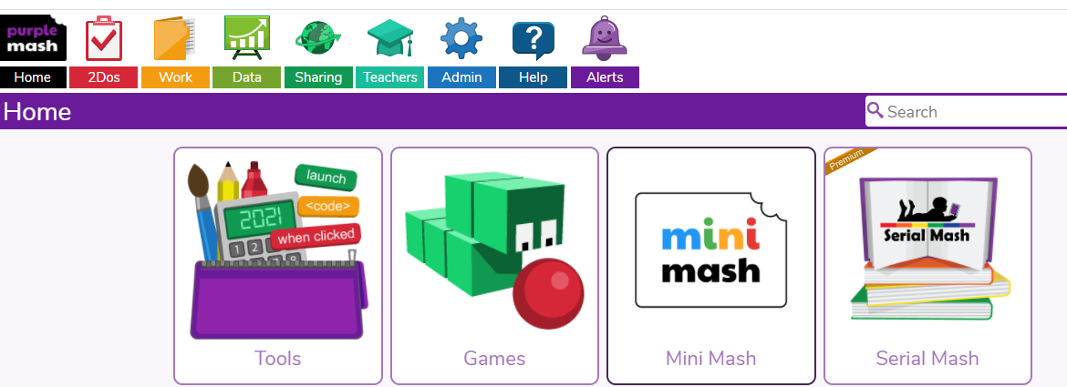

Activity | Tick what you have done.

Research: Katie Morag’s fictional Isle of Struay is based on the real Isle of Coll. Do your own research about the Island of Coll and bring it in to share with the class.

https://www.wildaboutargyll.co.uk/whats-new/blogs/how-coll-inspired-katie-morag/
http://www.bbc.co.uk/naturescalendar/summer/islands/coll/coll.shtml
https://kids.kiddle.co/Coll,_Lewis
https://visitcoll.co.uk/about/
Purple Mash: Make an Isle of Struay Map with a key

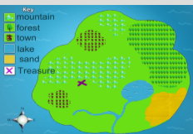

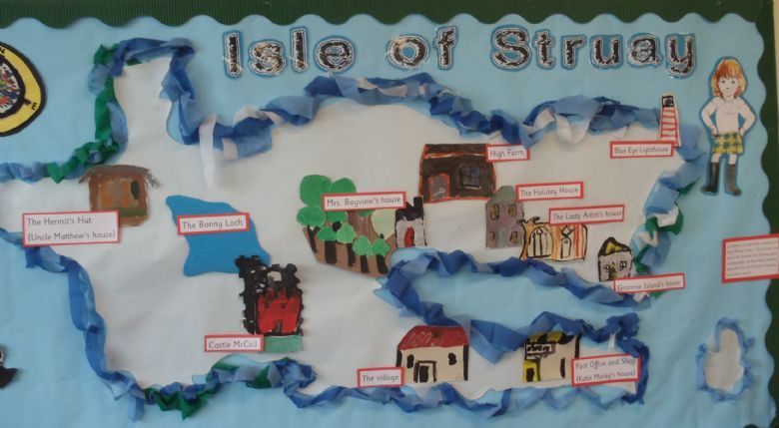
Create a map or a model of the Isle of Struay OR the Isle of Coll. Can you label the main features?

The Great BGFI bake off: Can you make some Isle of Struay themed snacks?

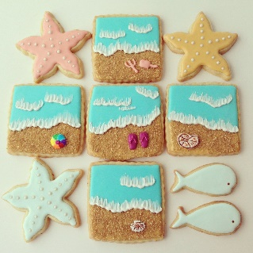

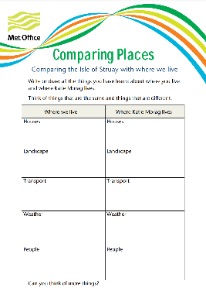
Comparing places: Using the worksheet in this pack, compare the Isle of Struay with where you live in London. Write or draw all the things you have learnt about where you live and where Katie Morag lives. What is the same and what is different?

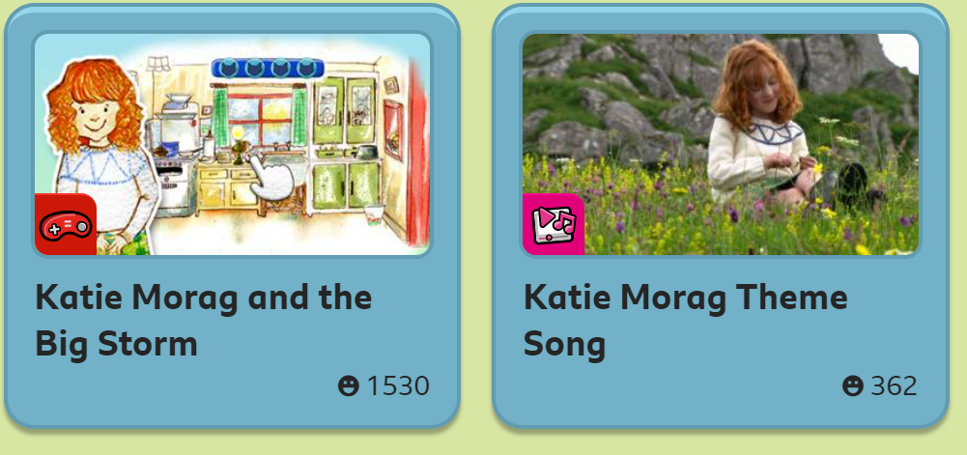
Play the Katie Morag game and watch clips:
https://www.bbc.co.uk/cbeebies/shows/katie-morag
Purple Mash: Write a post card: Imagine that you have been on holiday on the Isle of Struay or Coll. Write a post card to your friend or teacher describing what the island is like and what you have been up to.
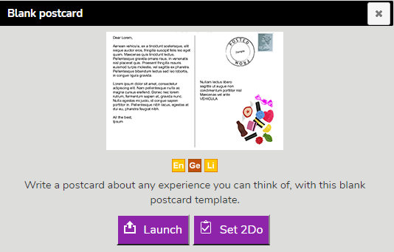

Some ideas


