Year 1
Summer 2 Project
This term in science we are learning about weather.

Task: Keep a weather diary and choose an activity of your choice.
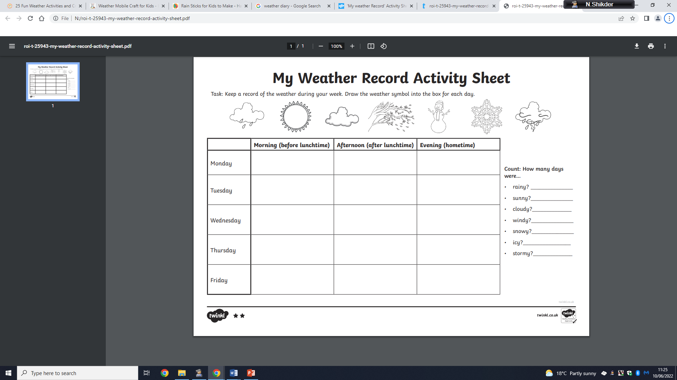
Weather diary:

Activity number 1:
Create a Weather Mobile Craft
For this you will need:
- Paper
- Colouring pens
- Scissors
- String
- Tape
- Small branch/ hanger

Instructions:
Draw some weather symbols on your paper using colouring pens. Cut them out and tape a piece of string to the back of each symbol. Tie these onto a branch or hanger to create your very own weather mobile.
Here are some examples for inspiration!
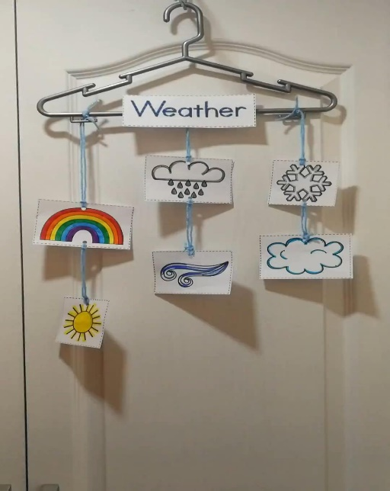
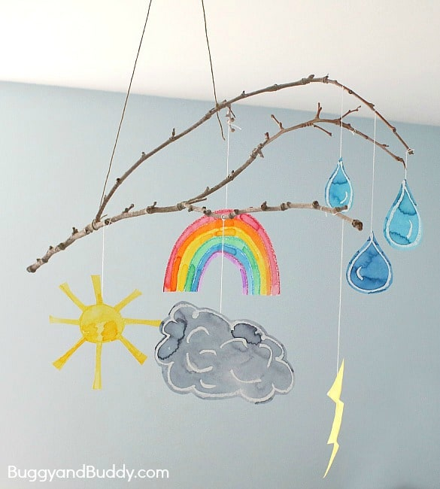
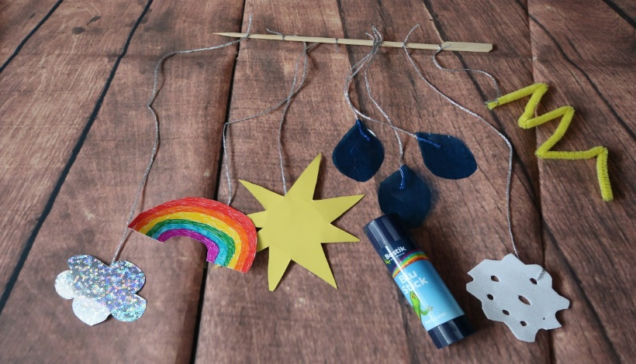
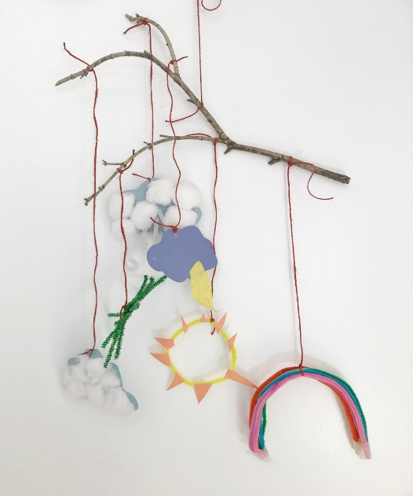

How many weather symbols are there and can you draw them all? Can you tell the temperature of each weather? What’s your favourite weather and why?
Activity number 2:
Make a rain stick
For this you will need:
- Cardboard tube
- Aluminium Foil
- Glue
- Coloured tissue paper/ Coloured card/ Sticker
- Nails or drawing pins
- Filler: rice, corn kernels, small buttons, beads etc
Instructions:
Get your cardboard tube and push some nails or drawing pins into it. Then roll your tube up in aluminium foil and stuff the extra into one end of the tube to ensure none of your filling will fall out. Next pour your filler items into the open end of the tube. Decorate it however you like and you’ll end up with your magical rain stick that makes the sound of falling rain.
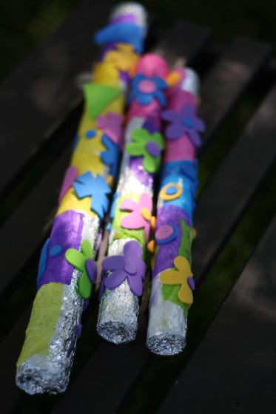
Here are some examples for inspiration!
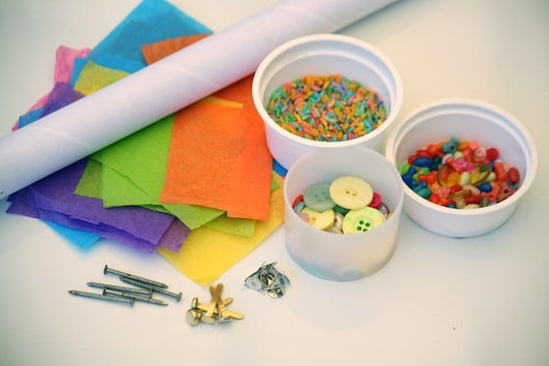

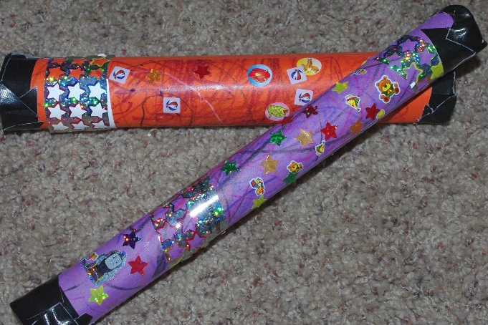
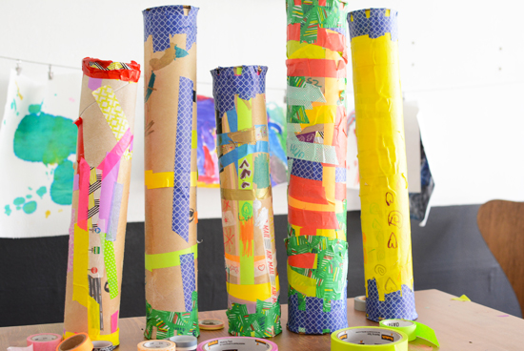

What can you use to make the sound of falling rain? Do you like the rain and why? What’s your favourite thing to do when it rains?

