Around the world
Can you create a map showing where you live?
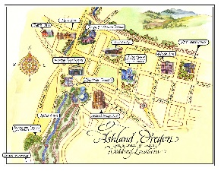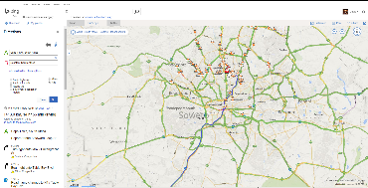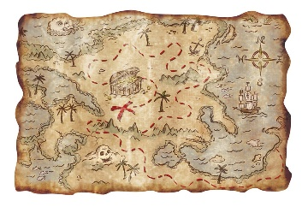

What we would like you to do:
- Find out where you live.
Look your area up on a map or online and look at the map details.
Where are the roads? The homes? Are there any parks? Etc.

3. Have fun!
Take photographs of you making your map and add them to Tapestry.
Bring them to school so that we can celebrate all of your hard work!
2. Make your map.
You can make your map using any media you have at home.
You could paint it, draw and colour it or collage it using magazines and newspapers.



