Year 1 Literacy Week beginning 11th May 2026 (Non-chronological report – Walter Tull)

 | Activity | Phonics
Monday | LI: We are learning to write a non-chronological report.  SC: I can identify features of a non-chronological report.  Look through the example of a non-chronological report. Discuss with an adult the different features including: heading, subheading, introduction, written in the present tense unless it is historical, written in chronological order (in correct time order), facts and pictures. Highlight the features in the report. | Phase 5 – e /ee/:  https://youtu.be/8Wr2V0P2VUg
Tuesday | LI: We are learning to write a non-chronological report.  SC: I can organise information.  Recap the information on Walter Tull (https://www.bbc.co.uk/bitesize/articles/zbgxbdm#zk4ccmn). Think about what he did in his life and what happened in his early life. Cut up the sentences and arrange them into his early life and solider facts. | Phase 5 – ie /igh/:  https://youtu.be/GPjyrObPQlk
Wednesday | LI: We are learning to write a non-chronological report.  SC: I can plan my report.  Draw Walter Tull on the grid and write some facts about him in the introduction (e.g. he was a solider and a footballer). Write some facts about his early life (e.g. where was he born, his date of birth, mum and dad died went to an orphanage). | Phase 5 – i-e /igh/ :  https://youtu.be/y-6I2ID6KfI
Thursday | LI: We are learning to write a non-chronological report.  SC: I can plan my report.  Draw Walter Tull in his football kit (in the football section of the grid) and write some facts about his football career (e.g. played in Clapton and Tottenham). | Phase 5 – y /igh/:  https://youtu.be/SMXobblz6uU
Friday | LI: We are learning to write a non-chronological report.  SC: I can plan my report.  Draw Walter Tull in his army clothes (in the solider section of the grid) and write some facts about his career as an army officer (e.g. died in battle 1918, Walter Tull become a sergeant). | Phase 5 – i /igh/:  https://youtu.be/BPUOhjLnJUU

Dapo Adeola
Introduction
Dapo Adeola was born in London. He is a British-Nigerian illustrator. He co-created and illustrated the Waterstones children's book of 2020 Look Up! Adeola is best known for creating illustrations that challenge race and gender stereotypes.
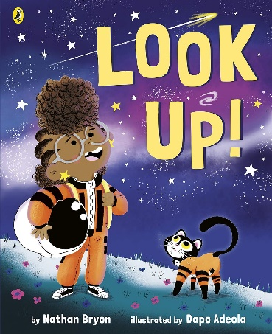

School days
Dapo always enjoyed drawing and creating. Toward the end of his time at secondary school, he decided to pursue a career in graphic design. He studied art GCSE and art A level.

Training to be an illustrator days
Afterward secondary school, he trained in fine art, graphic design and photography. There was no course on how to learn to draw illustrations so Adeola taught himself through online courses.

As Adeola's style and confidence grew, he started to share his artwork on Instagram. One of his lecturers said ‘whatever you do, do not stop drawing,’, and Adeola took their advice.
Career as an illustrator
Adeola met actor Nathan Bryon. Together, they started to write children's books. In 2019 Adeola and Bryon were signed by Puffin Books to write three books that explores the life of a young astronaut known as Rocket. The main character, Rocket, is based on one of Adeola's nieces.

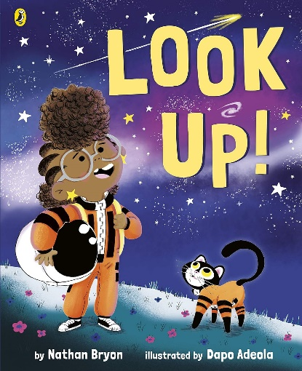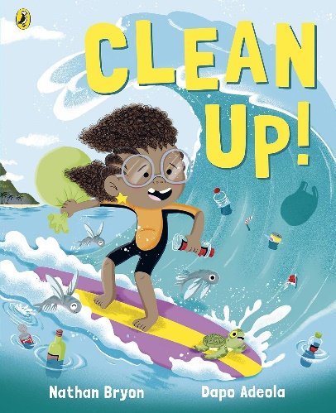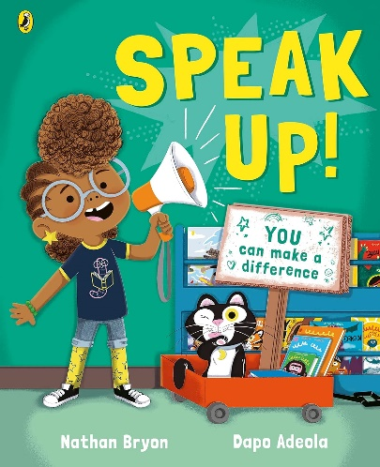
Adeola believes it is important all children see themselves in books and all children have access to books. He says, "if you're not exposed to certain kinds of books it is difficult to see yourself being in certain places, or to see positive and accurate reflections of yourself in the world."
Alongside his own writing, Adeola supports other Black illustrators.
Fascinating facts
- He has 14 published books.
- He always draws first because it gives him something to look at when he is trying to write the words.
- Dapo is a huge Marvel comics fan and he also likes Super Mario.
Cut up Sentences
Walter Tull was born on 28th April 1888 in Folkestone.

In December 1914, Walter joined the army.

Walter’s parents both died when he was a young child.

Walter was a successful soldier.

He was the first Black officer in the British army to lead soldiers on the front line of battle.

Walter received war medals after his death.

Walter and his brother were sent to an orphanage in London.

His early life was very hard.

Introduction and Early life | Football | Soldier
 |  | Wow Fact

