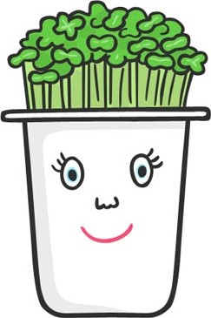
Grow your funny cress head
Reception summer1- home project

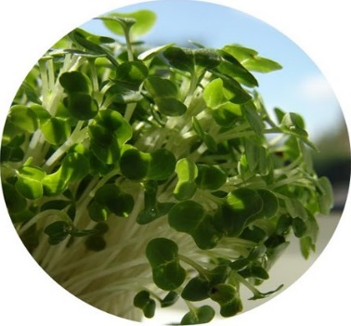
Cress is a leafy, green salad vegetable that can be eaten once it has grown. Your summer1 project is to grow a funny cress head.

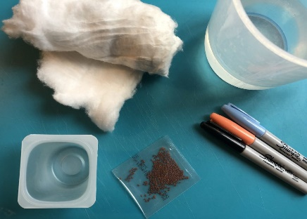
Please check if your child is allergic to some ingredients and/or materials used in this activity. Activities should always be supervised by an appropriate adult.
You will need:
*Yoghurt pot *cotton wool
*Cress seeds *felt tip pen

https://www.youtube.com/watch?v=hl1GGPELlvo
Instructions How to Grow a Cress Head:
1. Draw a funny face on the yoghurt pot.
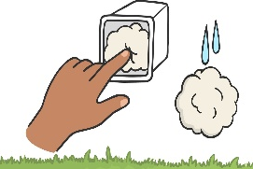
2. Wet some cotton wool and push it into the bottom of the yoghurt pot. Add another layer on damp cotton wool on top.
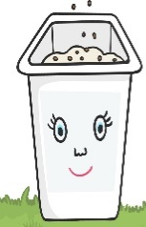

3. Sprinkle the cress seeds on top on the cotton wool.
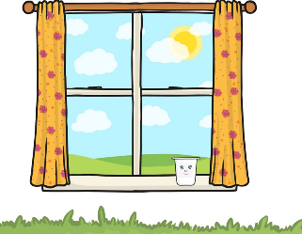

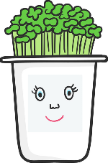
4. Place the pot in a warm, sunny spot.

5. After about a week, your cress head will have a head of cress hair!

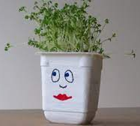
Here are some ideas for inspiration!
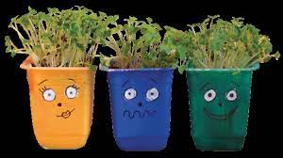

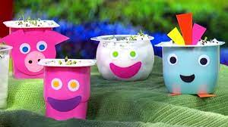
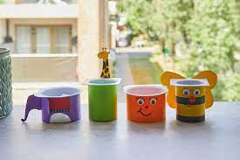

Questions to think about:
- What do the seeds need to grow?
- What can we do with the cress?
- Can you see the tiny seeds?
- What will happen next to the seeds?
- What can you see happening?
- Why don’t you take a photo of your cress seeds? Then, each day you can see how much they have grown.
Once the cress is about 5cm tall it can be cut with scissors, washed and then eaten. It is yummy in egg sandwiches or salads.
Your challenge is to make a cress and egg sandwich and write your own recipe. Remember to use the sounds and high frequency words you know in your writing. Remember the capital letters, finger space and a full stop at the end of your sentence.

Title of the recipe

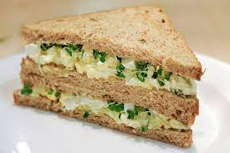

Ingredients :

