

Blue Gate Fields Infant School

Calculation Policy
Written Calculations
Expectations and guidelines

Agreed February 2025
Review February 2027

This policy is the responsibility of the Maths lead

This calculation policy has been adapted in line with the programmes of study taken from the National Curriculum for Mathematics (2014) and the White Rose Calculation Policy 2024. It provides guidance on appropriate calculation methods and progression.
A glossary of terms is provided at the end of the policy to support understanding of the key language used to teach the four operations.
What are the aims?
- For children to have a reliable, efficient written method for each of the four operations by the time they leave primary school.
- To ensure consistency and progression in our approach to calculation.
- To teach a series of mental and informal methods to develop children’s grasp of number and flexibility in approaches, before moving on to more efficient traditional ways of setting the calculations out.
- To ensure that children can use these methods accurately with confidence and understanding.
Progression from mental to written calculations?
- Establish mental methods, based on a good understanding of place value and numbers.
- Present calculations in horizontal format.
- Move on to expanded methods.
- Refine to more compact methods.
- Extend to larger numbers and decimals.

Children need to be taught to ask themselves:
- Can I do this mentally?
- Roughly what will the answer look like?
- If not mentally, jottings or a compact method?

The foundations of calculation in the EYFS
- Practical, hands-on experiences of using comparing and calculating with numbers and quantities and the development of mental methods are of crucial importance in establishing the best mathematical start in EYFS and KS1.
- This should be coupled with plenty of opportunities for developing mathematical language so that children learn to express their thinking using the correct vocabulary.
- In the EYFS and KS1:
- Develop and secure counting skills.
- Make mathematics interesting and personal.
- Hands-on, interactive learning is important – practical, playful, purposeful.
- Talk clarifies and refines thinking.

The calculation policy is divided into four sections: addition, subtraction, multiplication and division. At the start of each section, you will find an overview of the progression of skills. Calculations involving decimal numbers and fractions are included.
The calculation policy follows the same concrete, pictorial, abstract approach as the White Rose Math scheme of learning. Where appropriate, sentence stems and key questions are included alongside the key representations.
Where skills are divided into more than one section across the page, there is a progression in the level of difficulty from left to right.
For example, when adding across a 10, children need to be able to add across 10 itself, before making links with related facts.

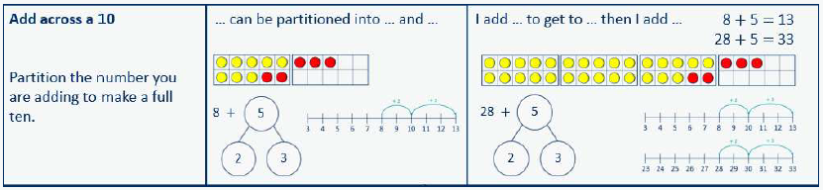

Progression of skills – Addition
Year Group | Skills
Nursery | - Subitise to 3  - Count how many  - Make numbers to 5  - Add 1 more (through songs and rhymes)
Reception | - Conceptually subitise to 5  - 1 more  - Notice the composition of numbers within 10  - Combine 2 groups  - Add more
Year 1 | - Add together  - Add more  - Bonds within 10  - Related facts within 20  - Missing numbers
Year 2 | - Add 1s to any number (related facts)  - Add three 1-digit numbers  - Add across a 10  - Add multiples of 10  - Add 10s to any number  - Add two 2-digit numbers (not across a ten)  - Add two 2-digit numbers (across a ten)  - Missing numbers
Year 3 | - Add 1s, 10s and 100s to a 3-digit number  - Add two numbers (no exchange)  - Add two numbers across a 10 or 100  - Complements to 100  - Add fractions with the same denominator within 1 whole  - Calculate the duration of events

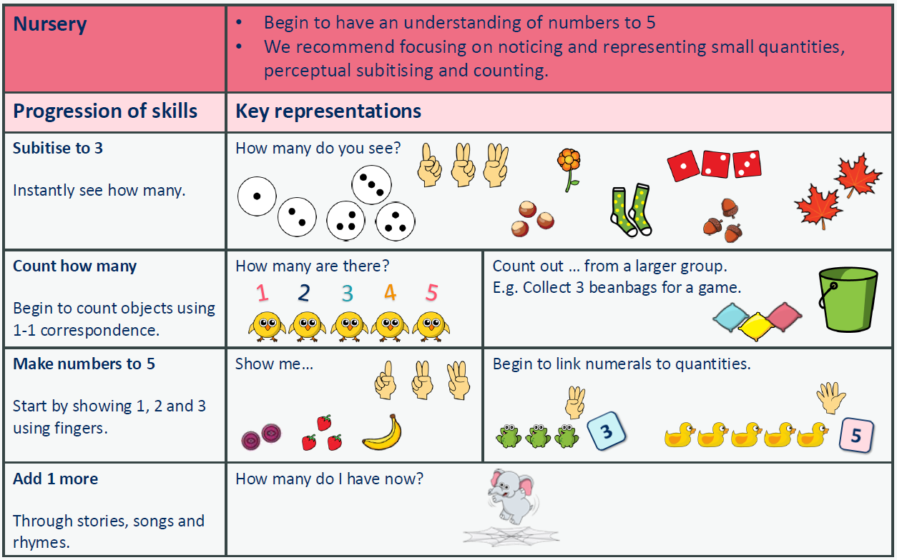

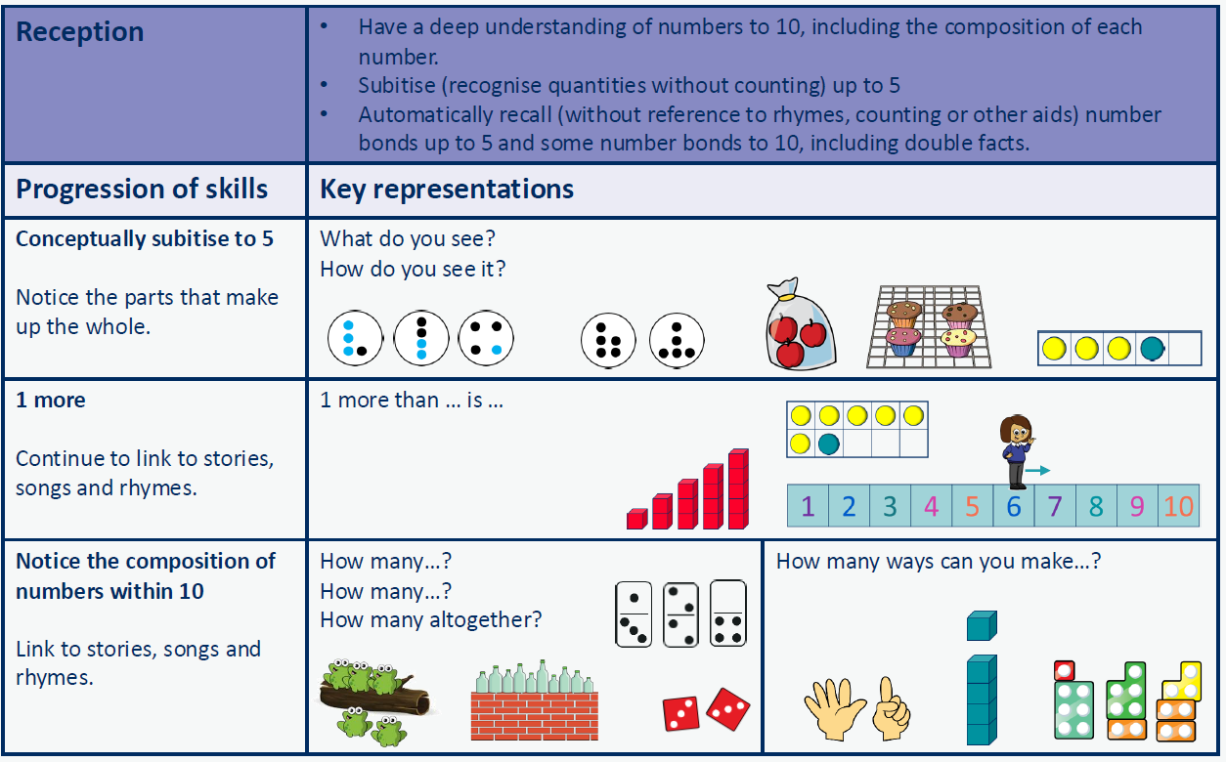
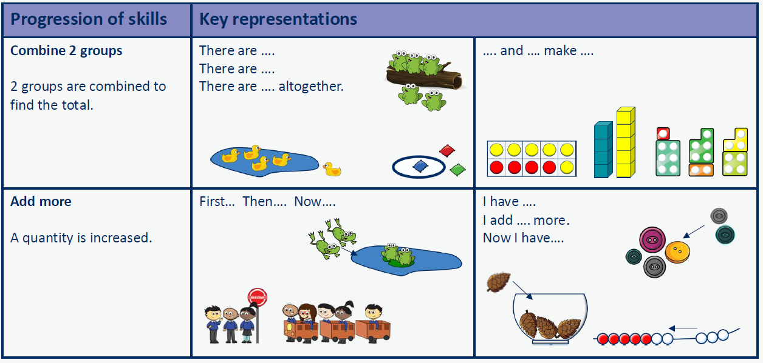

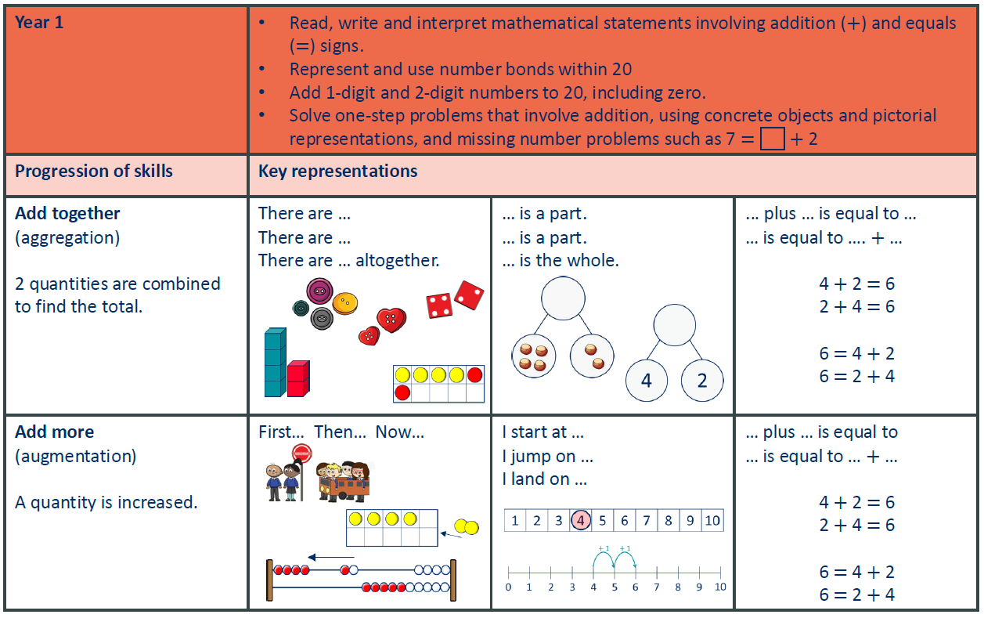
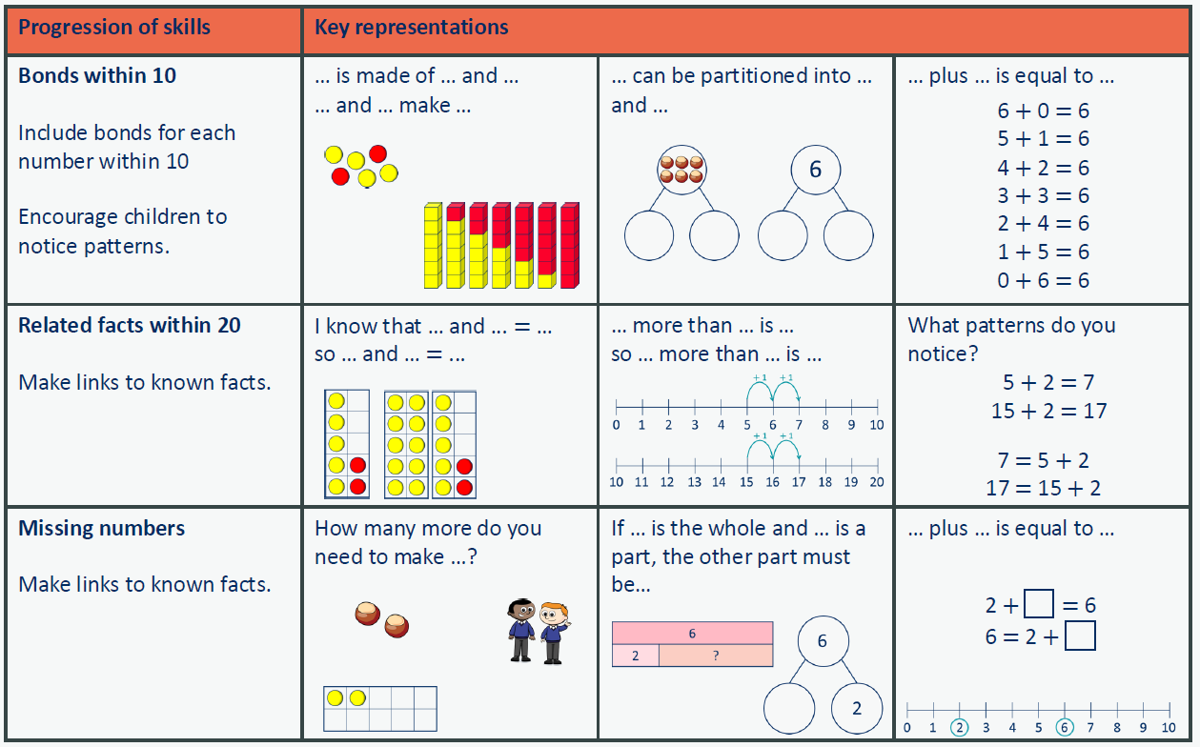

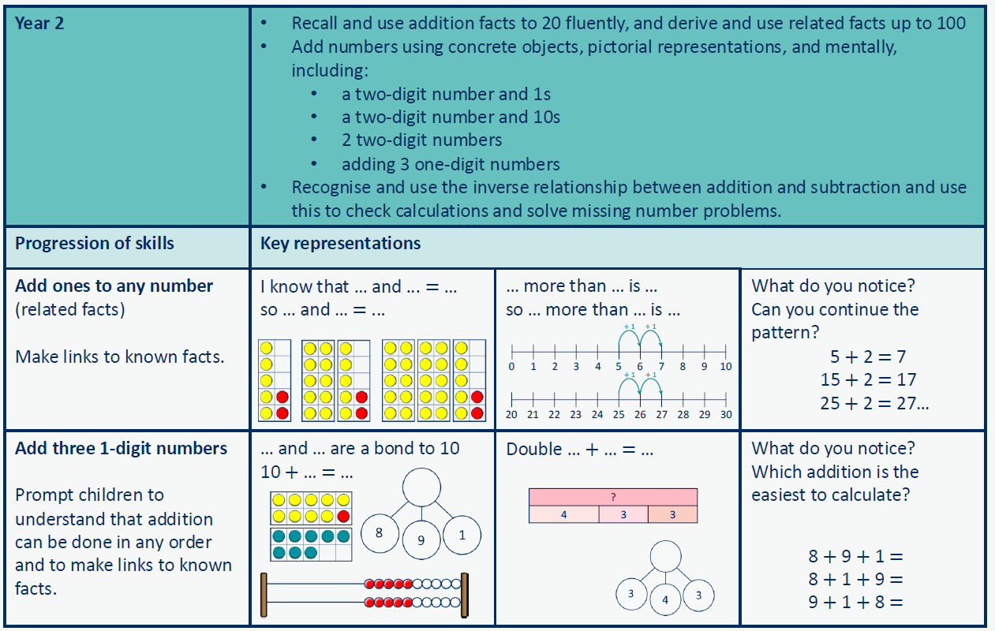

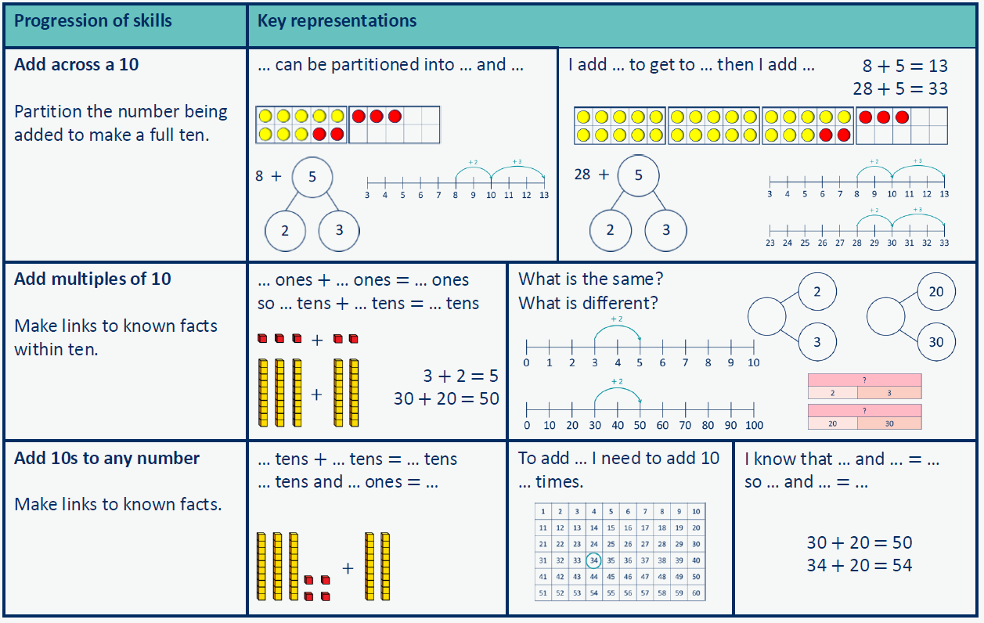
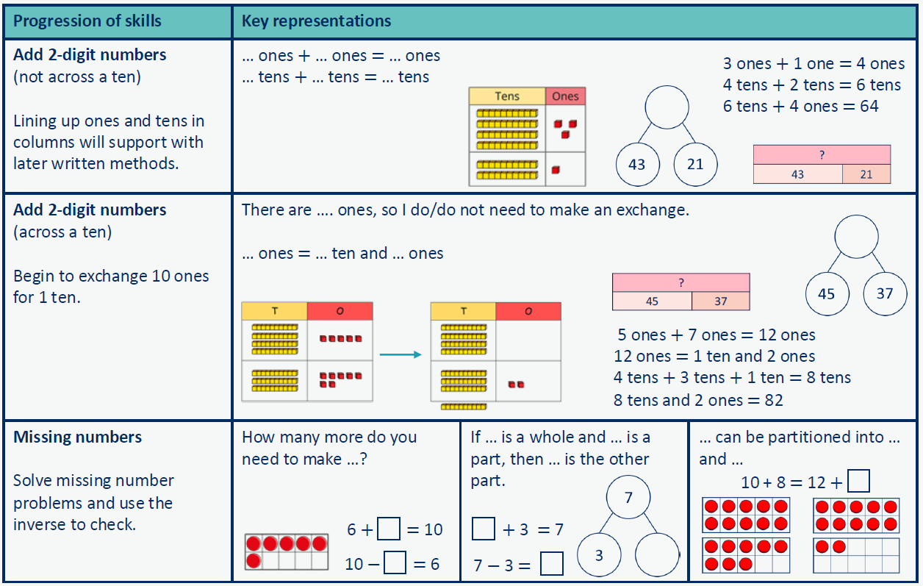

Progression in addition calculations: Year Three – Where to next …
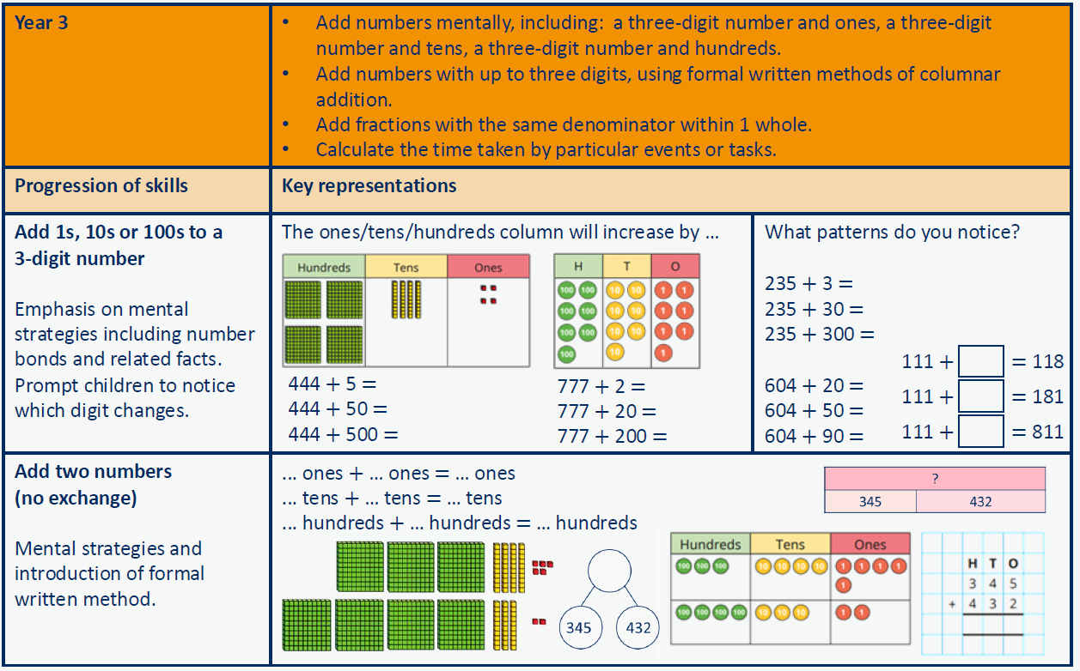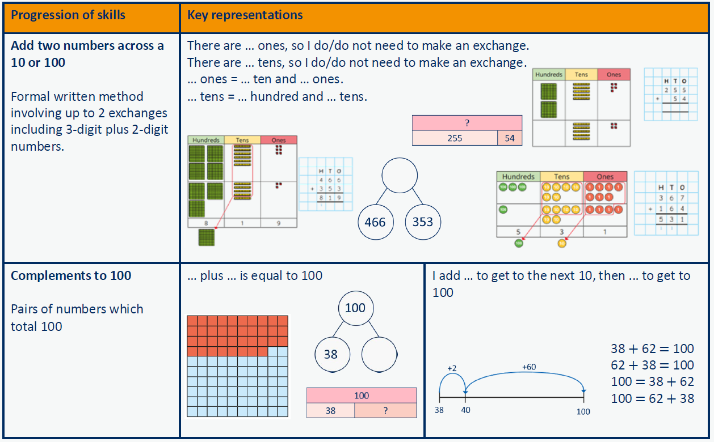
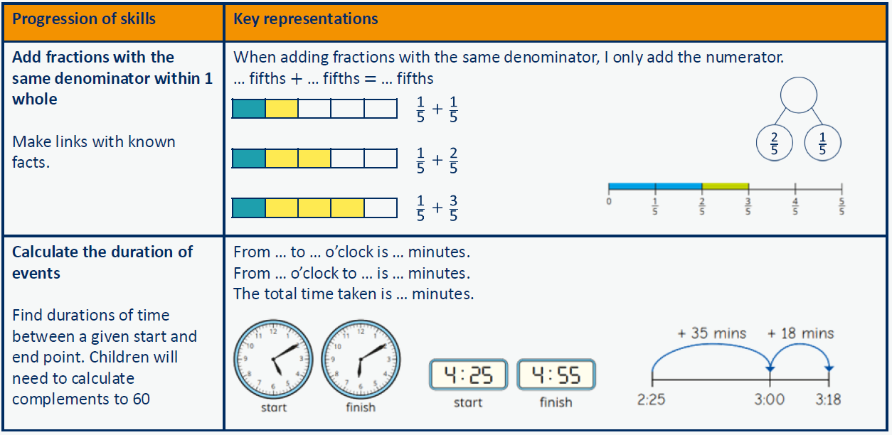

Progression of skills – Subtraction
Year Group | Skills
Nursery | - Subitise to 3  - Count how many  - Make numbers to 5  - Take 1 away (through songs and rhymes)
Reception | - Conceptually subitise to 5  - 1 less  - Notice the composition of numbers within 10  - Partition  - Take away
Year 1 | - Find a part  - Take away  - Bonds within 10  - Related facts within 20  - Missing numbers
Year 2 | - Subtract 1s from any number (related facts)  - Subtract across a 10  - Subtract multiples of 10  - Subtract 10s from any number  - Subtract two 2-digit numbers (not across a ten)  - Subtract two 2-digit numbers (across a ten)  - Missing numbers
Year 3 | - Subtract 1s, 10s and 100s from a 3-digit number  - Subtract two numbers (no exchange)  - Subtract two numbers across a 10 or 100  - Complements to 100  - Subtract fractions with the same denominator within 1 whole

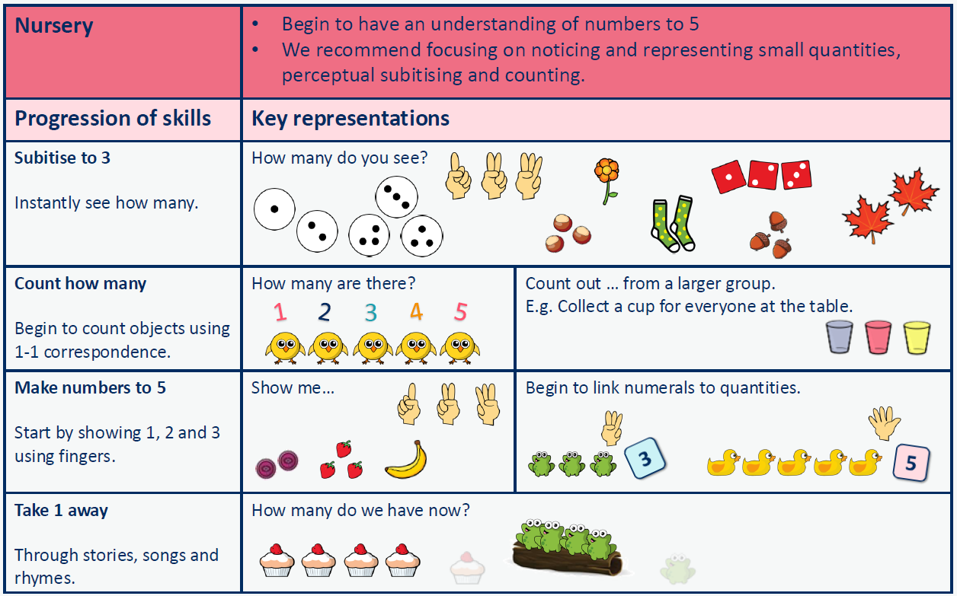

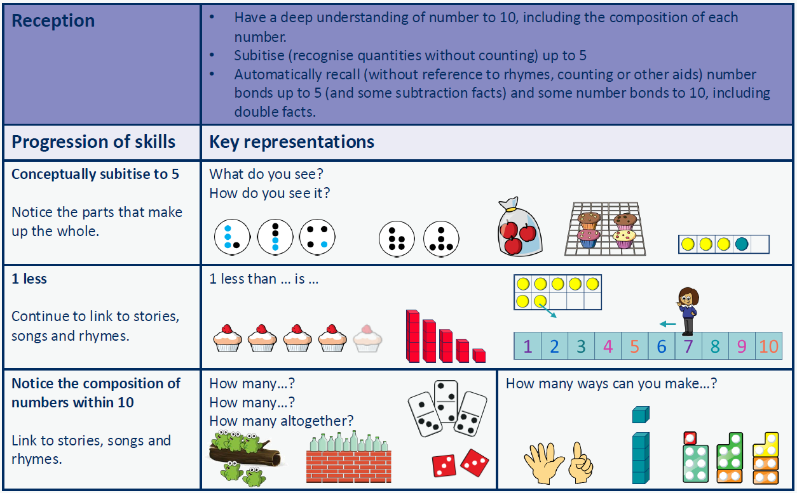

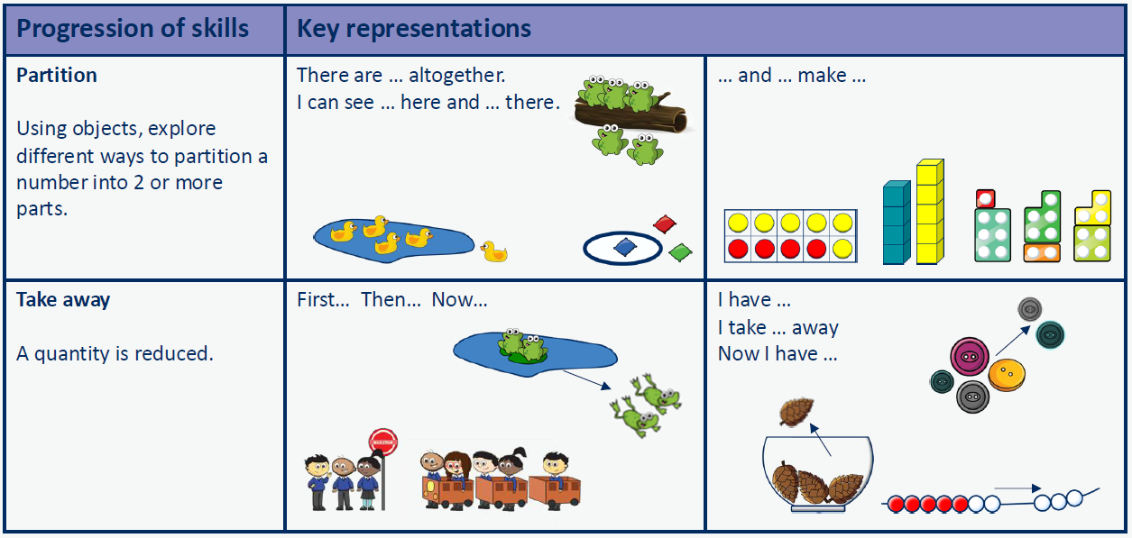

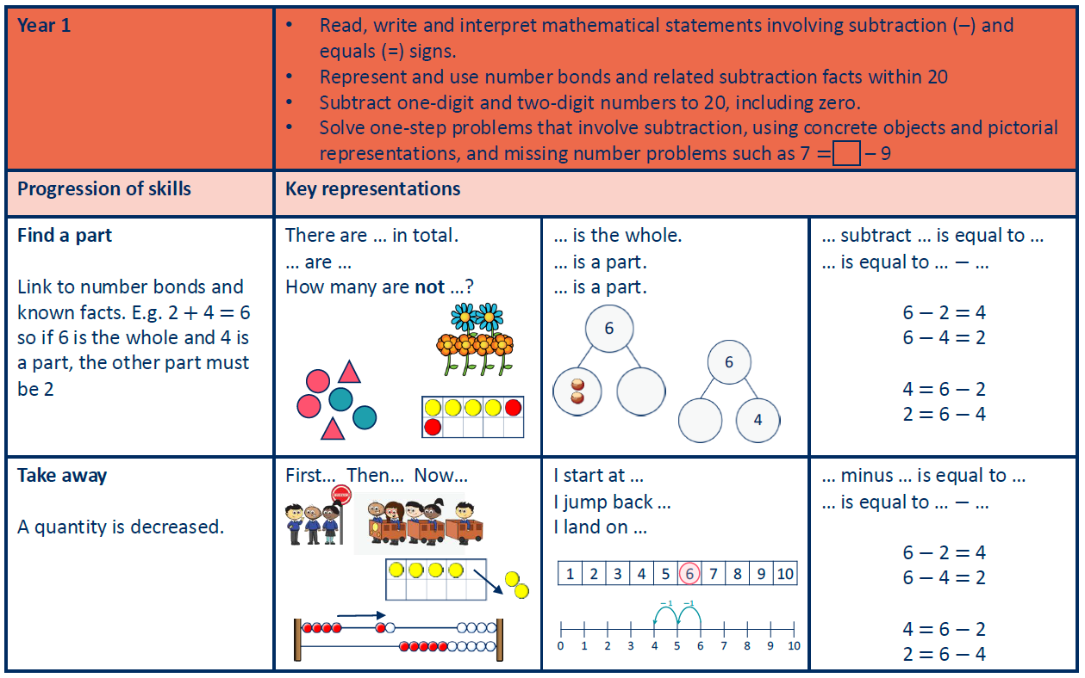

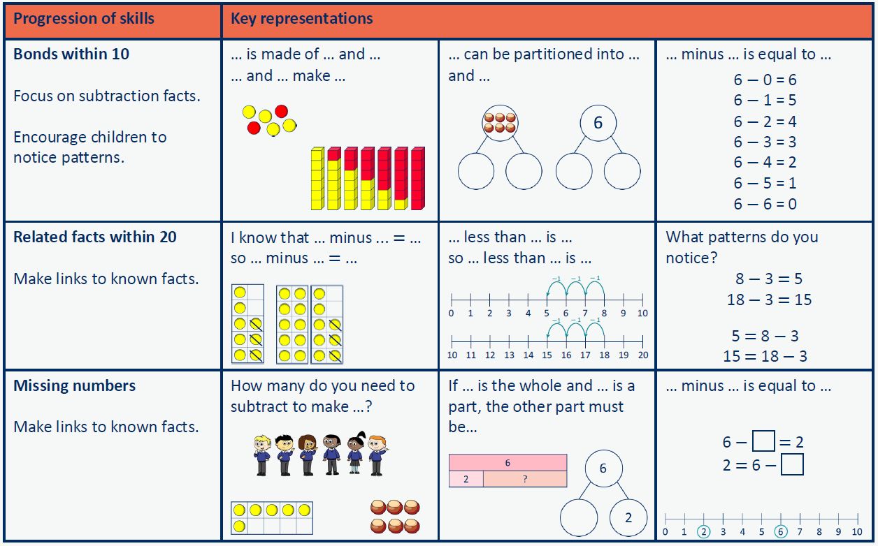

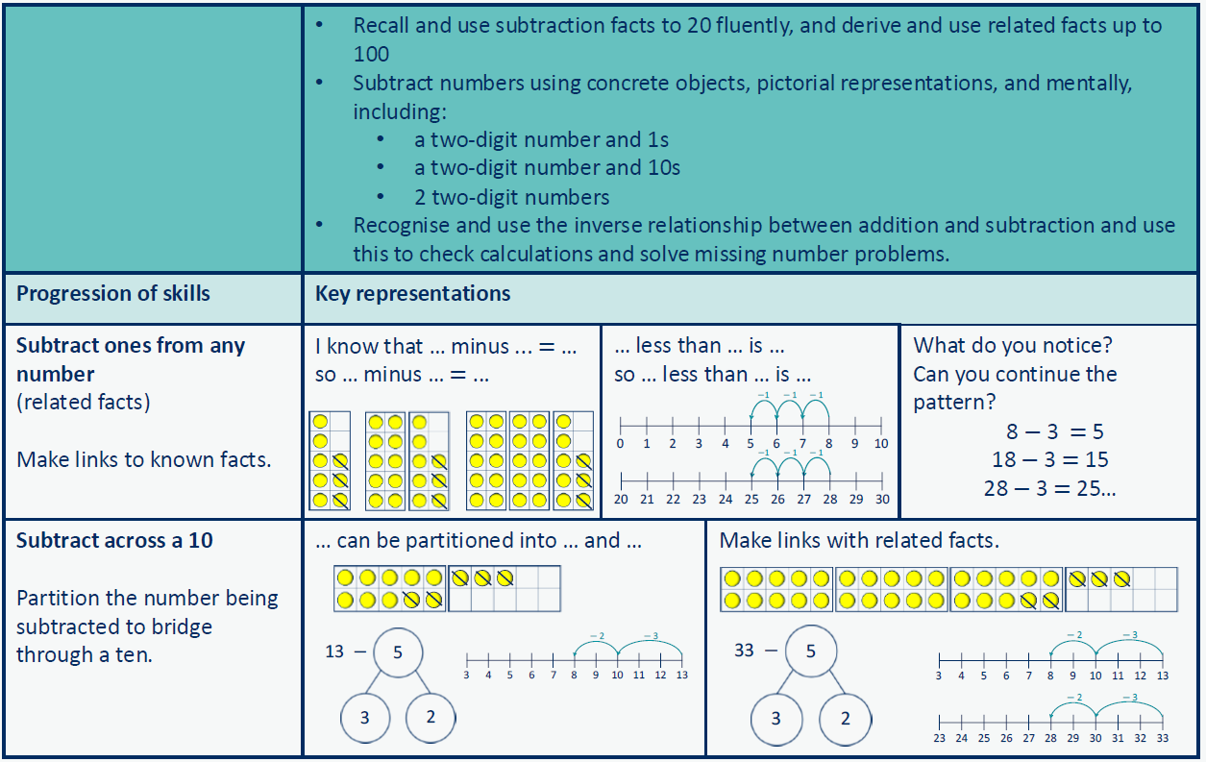
Year 2

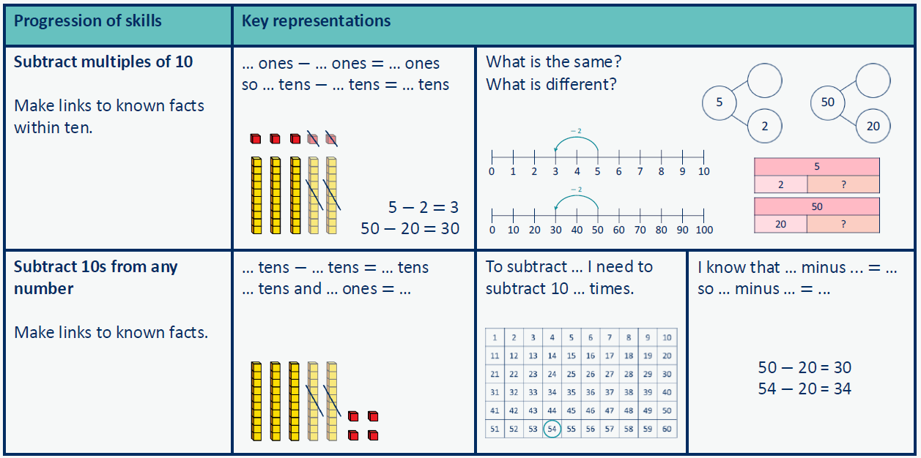

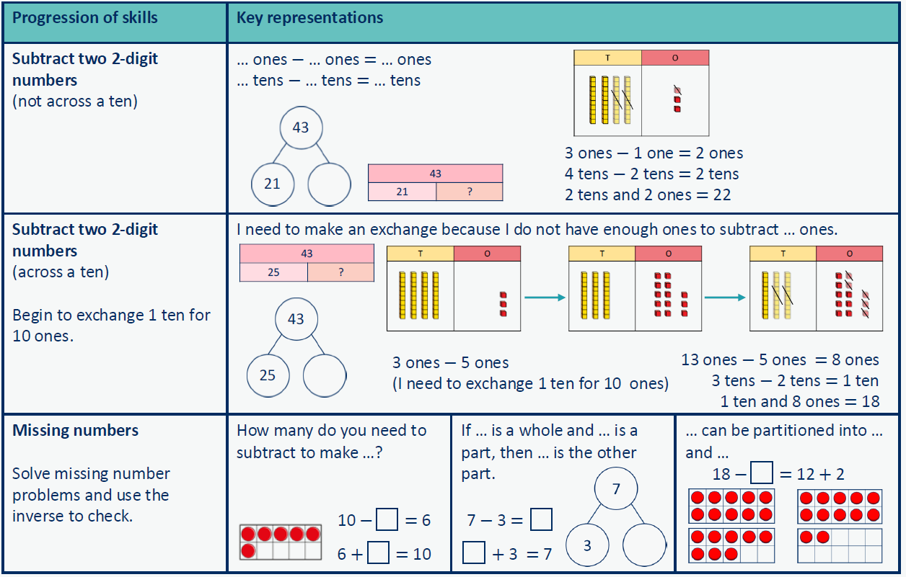

Progression in subtraction calculations: Year Three – Where to next …
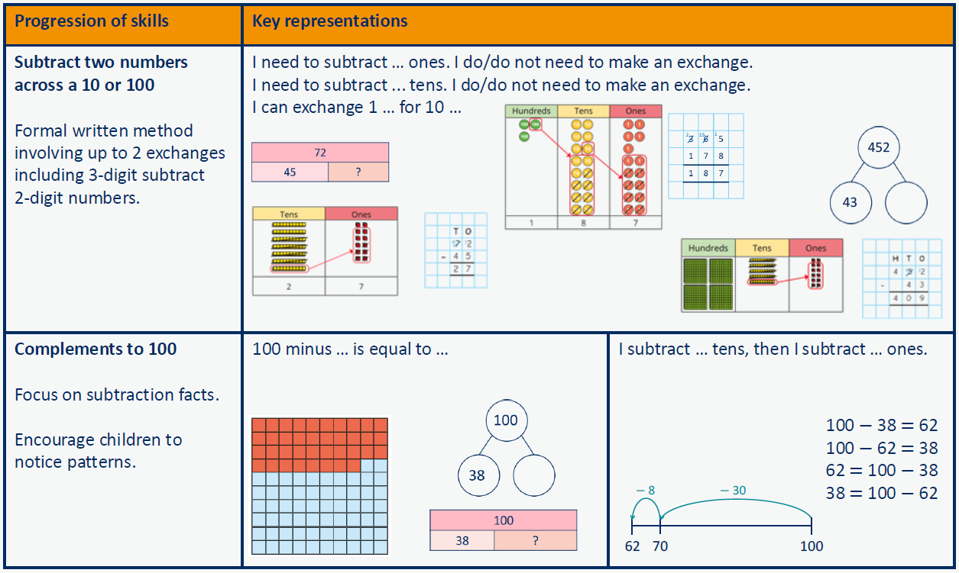
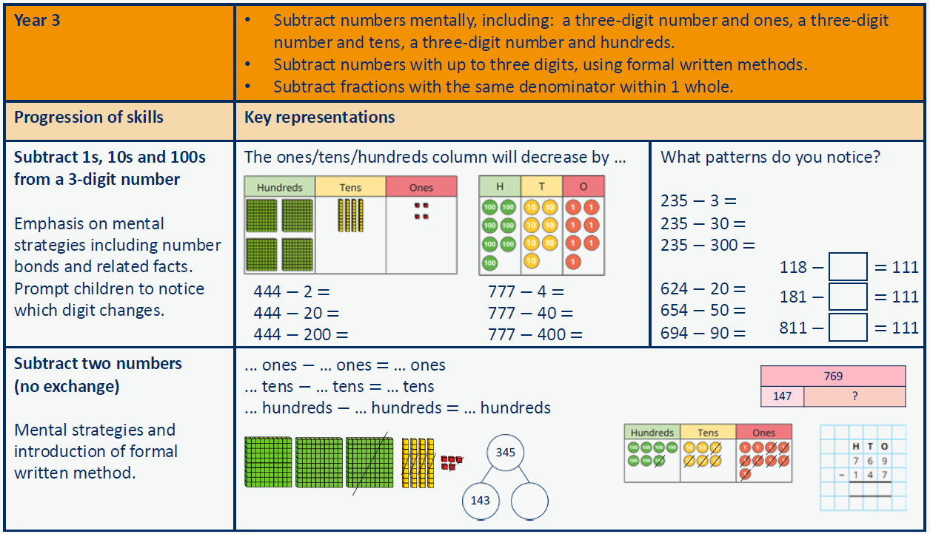
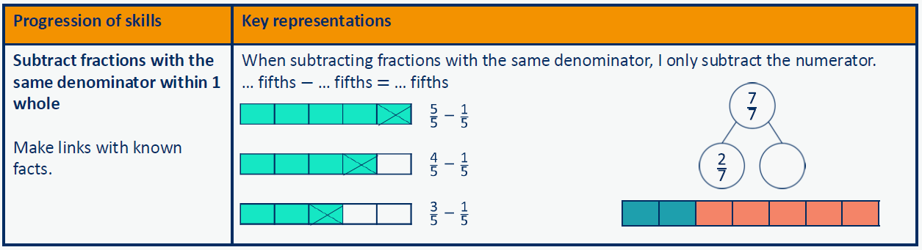

Progression of skills – Multiplication
Year Group | Skills
Nursery | - Continue with counting and subitising skills as a foundation for later work on equal groups. (see addition and subtraction sections).
Reception | - Double to 10  - Make equal groups
Year 1 | - Count in 2s, 5s and 10s  - Add equal groups  - Make arrays  - Make doubles
Year 2 | - Link repeated addition and multiplication  - Use arrays  - Double  - The 2 times-table  - The 10 times-table  - The 5 times-table  - Missing numbers
Year 3 | - The 3 times-table, 4 times-table, 8 times-table  - Related facts  - Multiply a 2-digit number by a 1-digit number - no exchange  - Multiply a 2-digit number by a 1-digit number - with exchange  - Scaling  - Correspondence problems

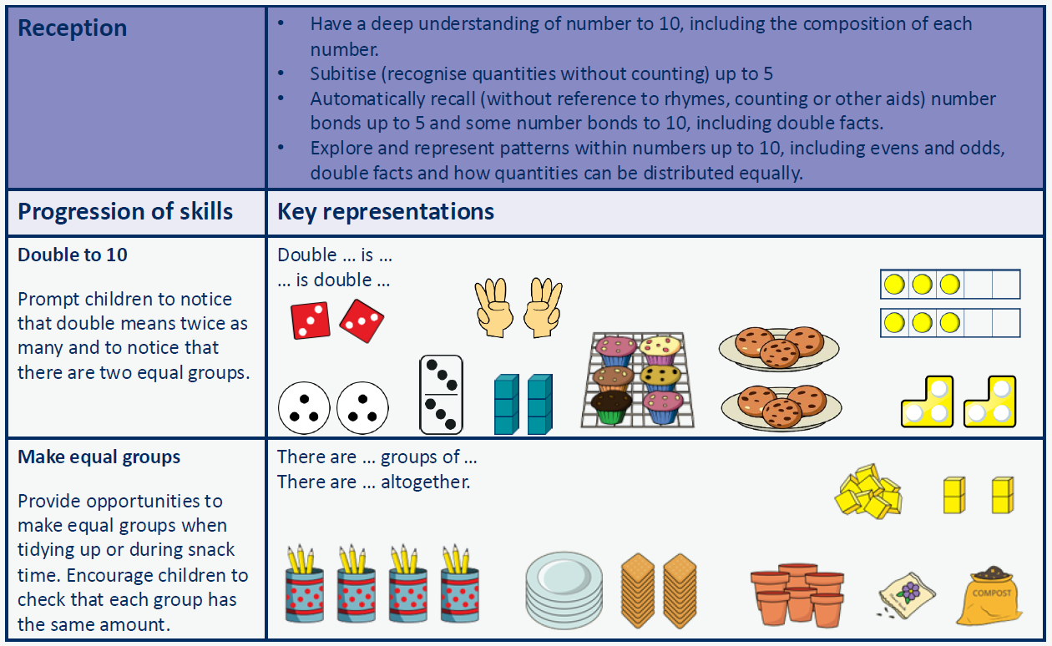

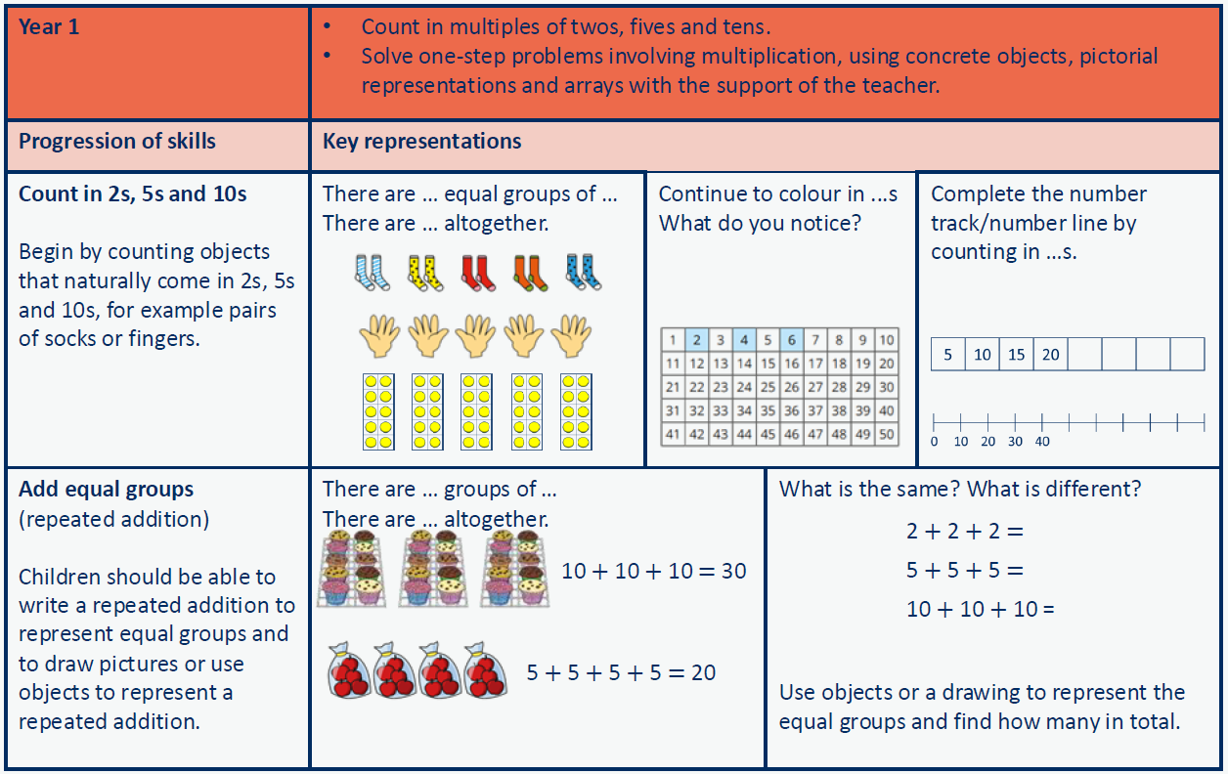

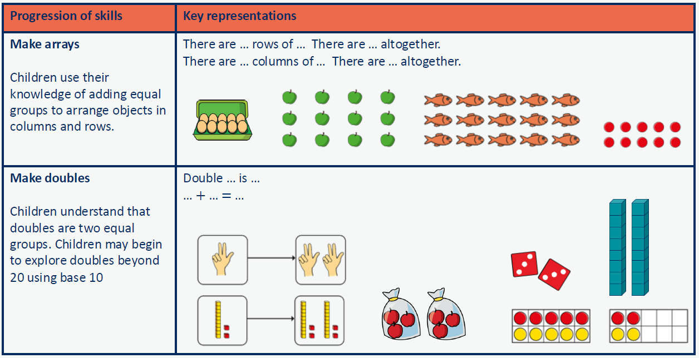

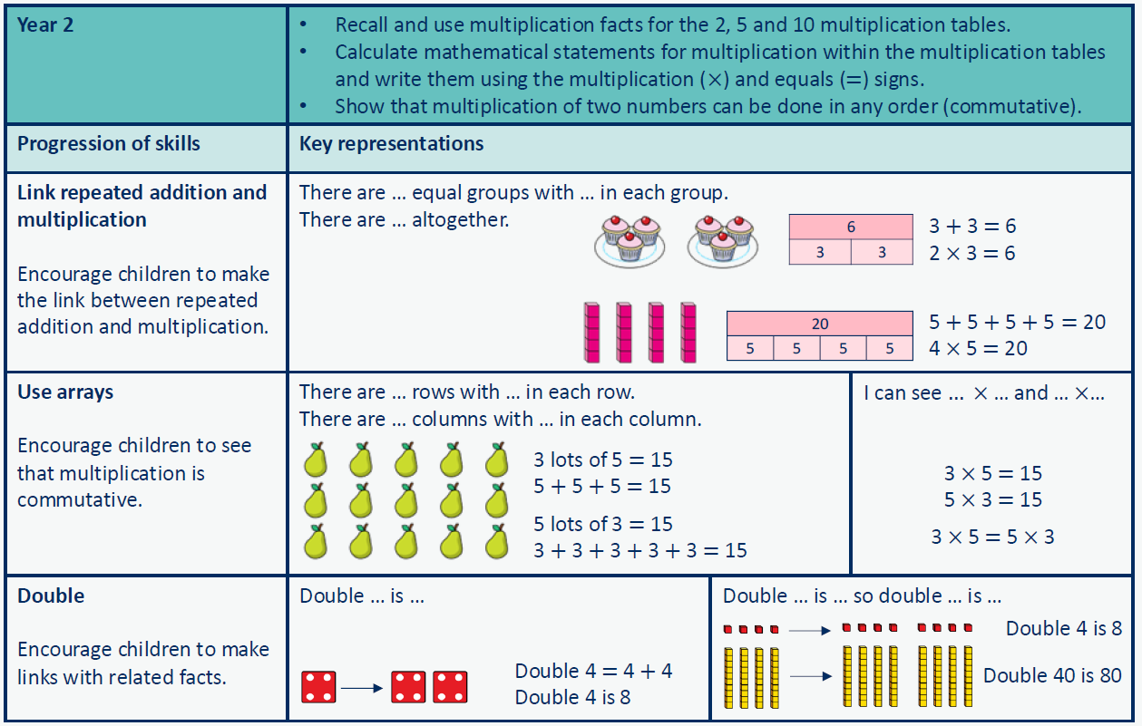

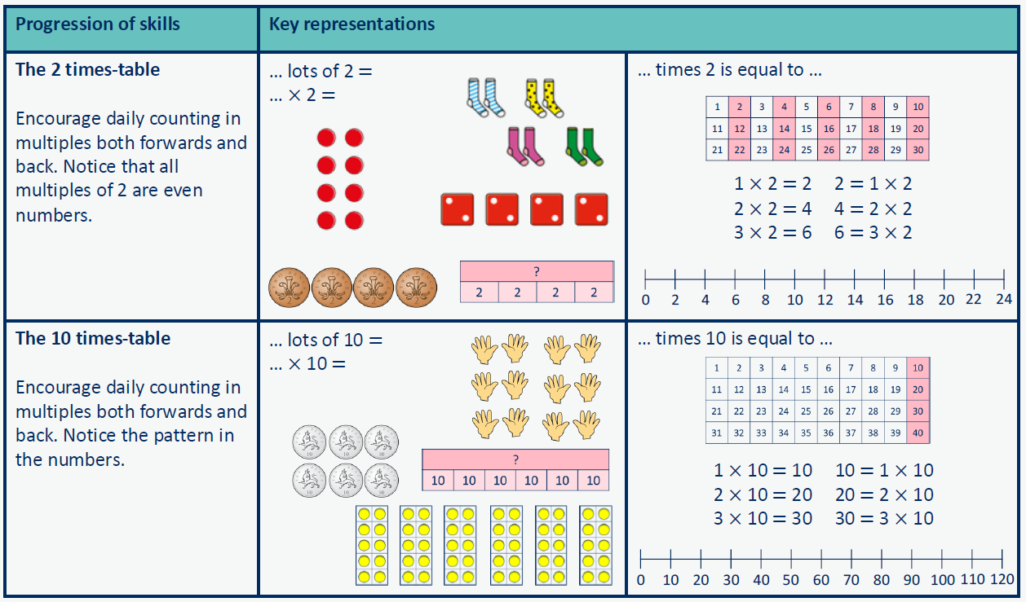

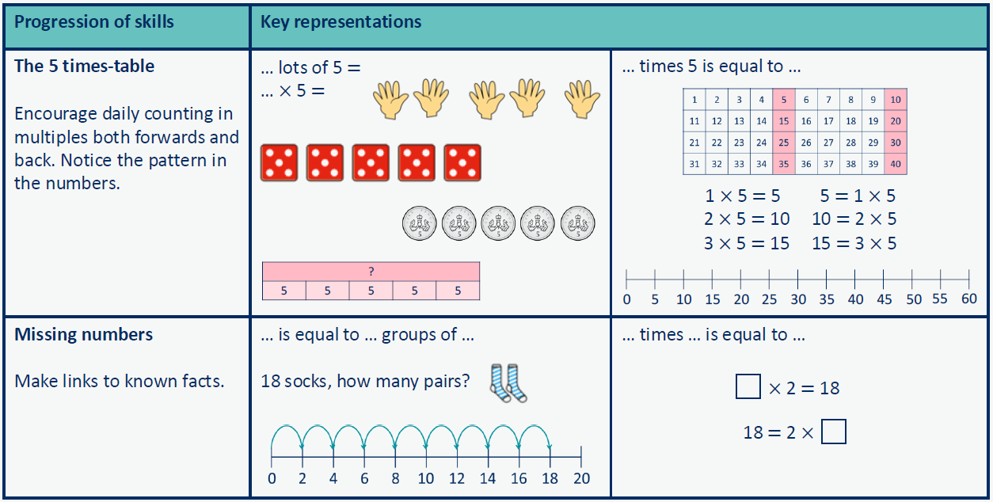

Progression in multiplication calculations: Year Three – Where to next …
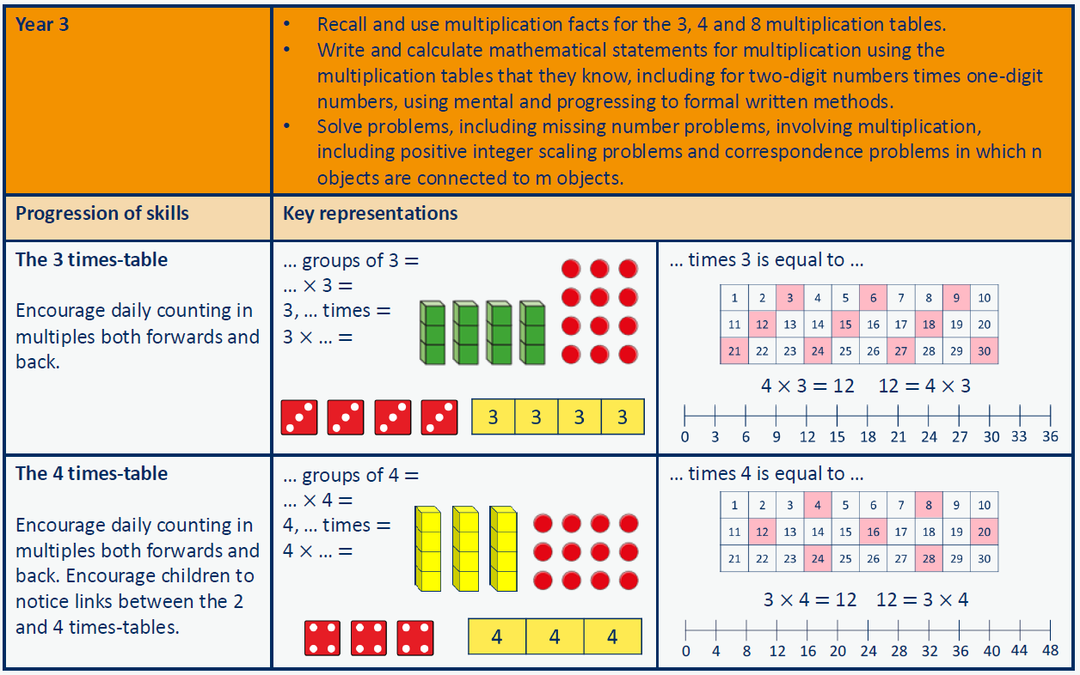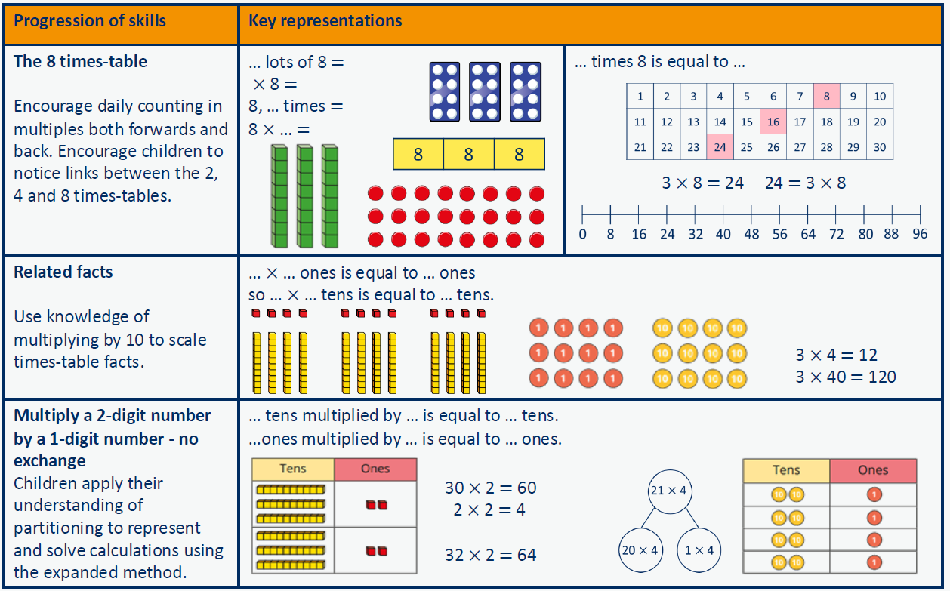
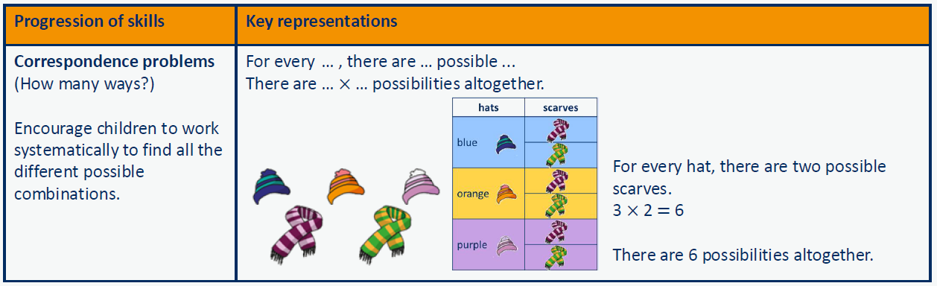
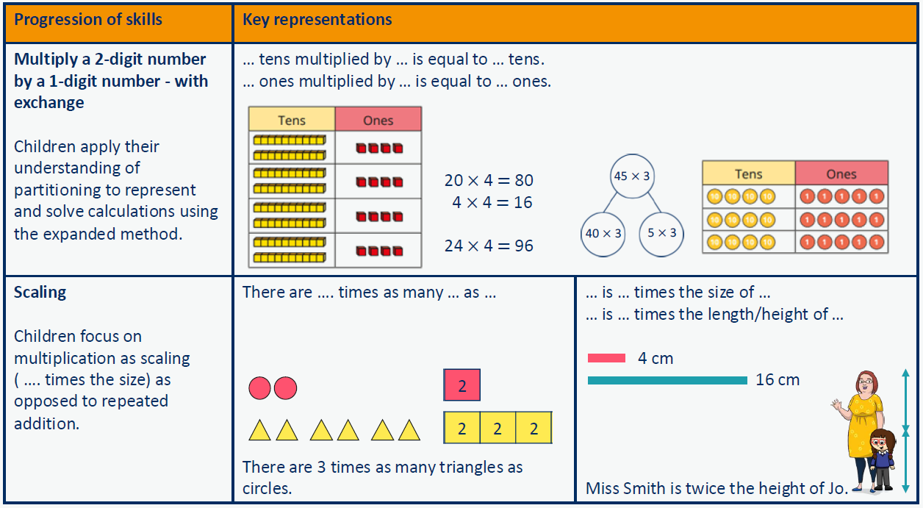

Progression of skills – Division
Year Group | Skills
Nursery | - Continue with counting and subitising skills as a foundation for later work on equal groups. (see addition and subtraction sections)
Reception | - Sharing  - Grouping
Year 1 | - Make equal groups – grouping  - Make equal groups – sharing  - Find a half  - Find a quarter
Year 2 | - Divide by 2  - Divide by 10  - Divide by 5  - Missing numbers  - Unit fractions  - Non-unit fractions
Year 3 | - Divide by 3, divide by 4, and divide by 8.  - Related facts  - Divide a 2-digit number by a 1-digit number - no exchange  - Divide a 2-digit number by a 1-digit number - with remainders  - Unit fractions of a set of objects  - Non-unit fractions of a set of objects

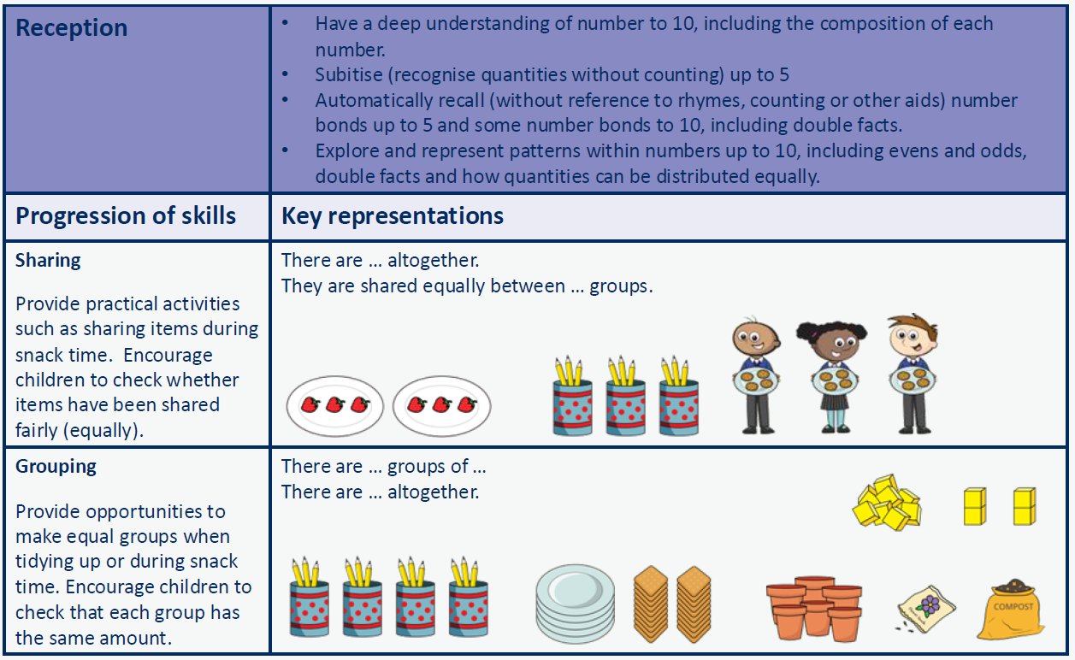

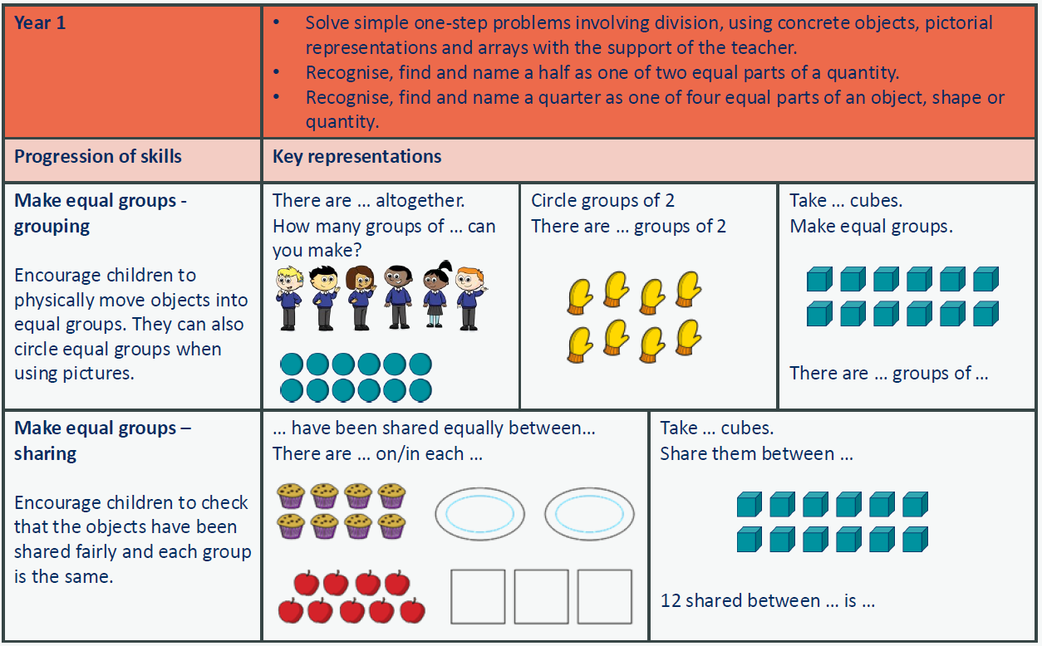
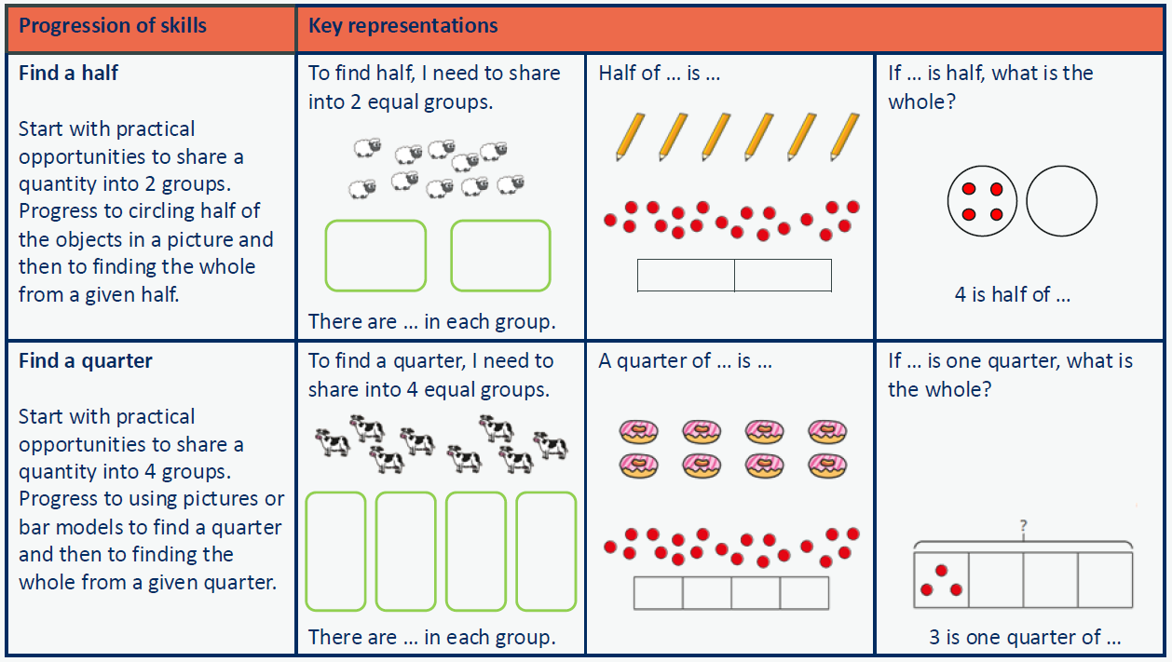

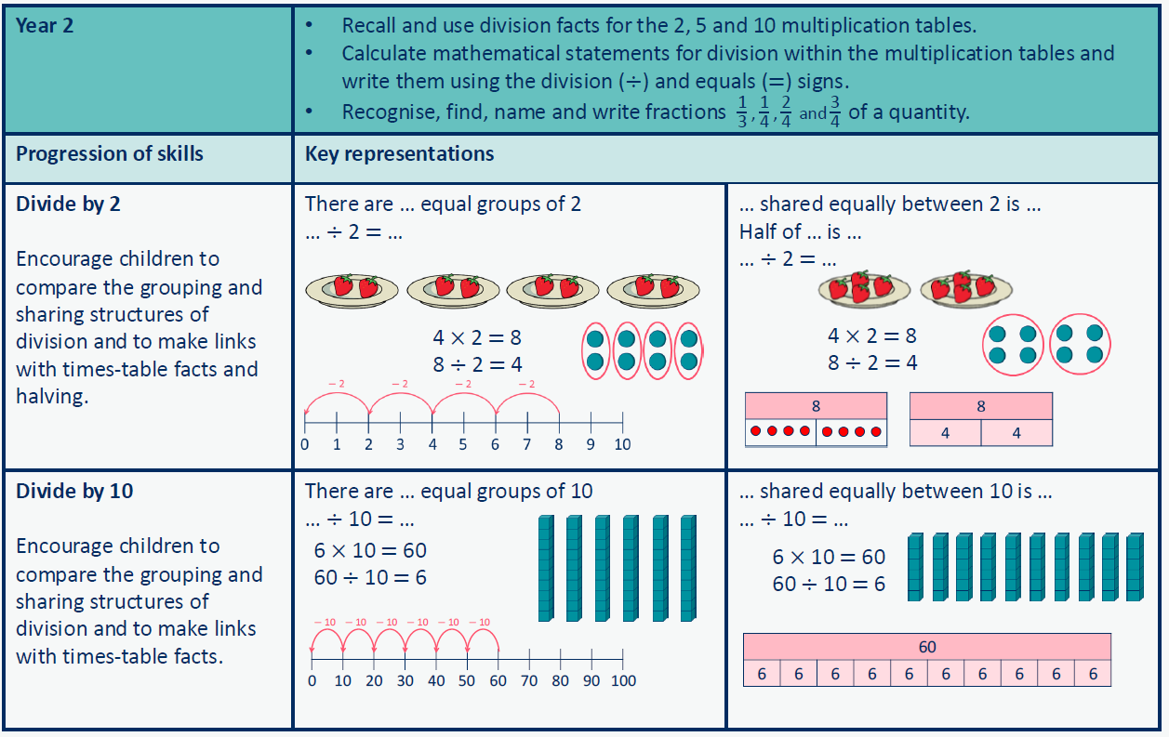

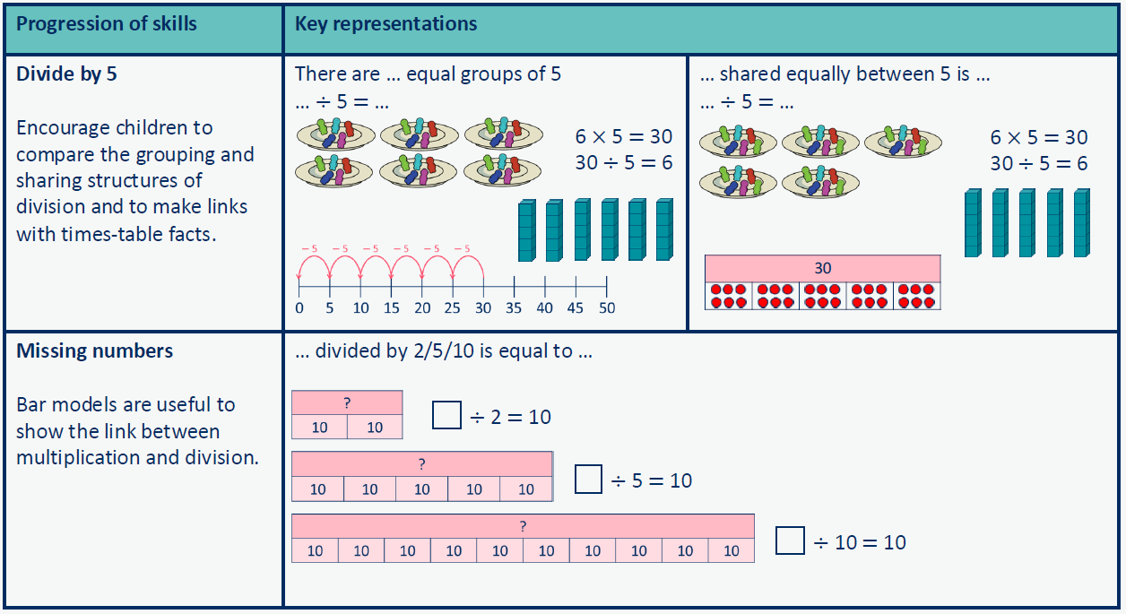

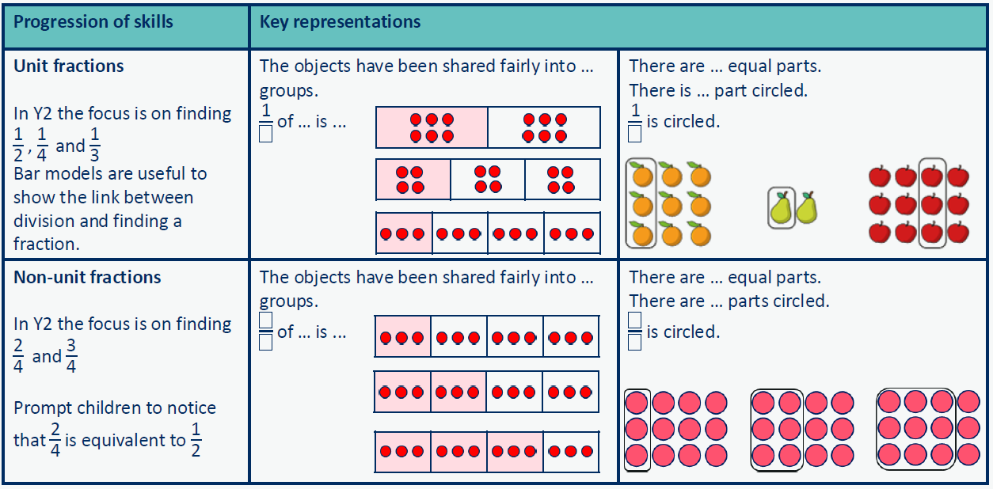

Progression in division calculations: Year Three – Where to next …
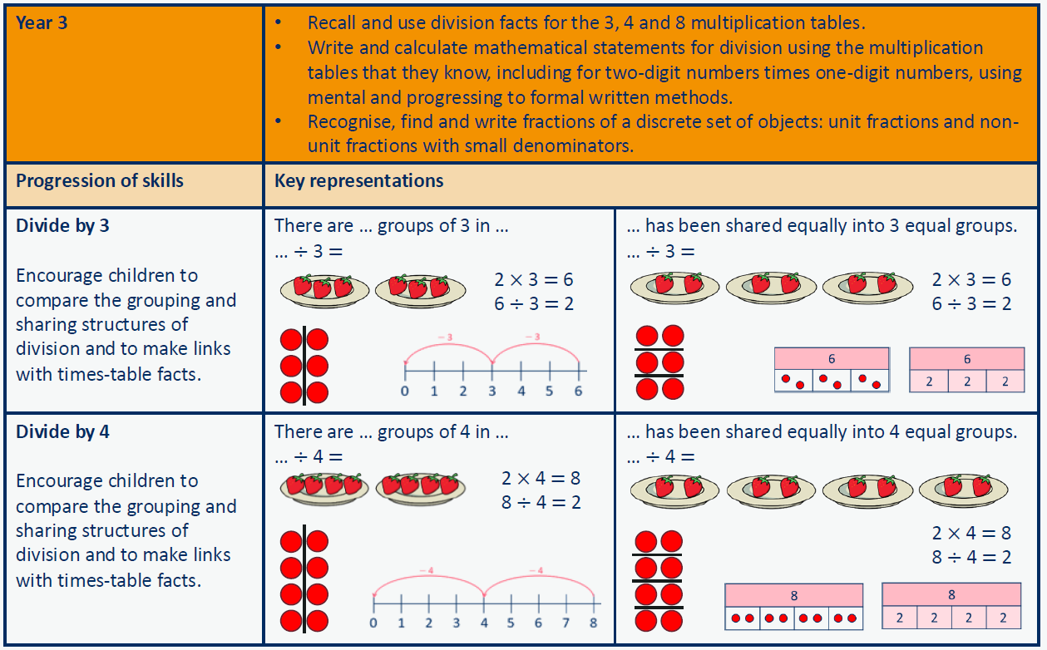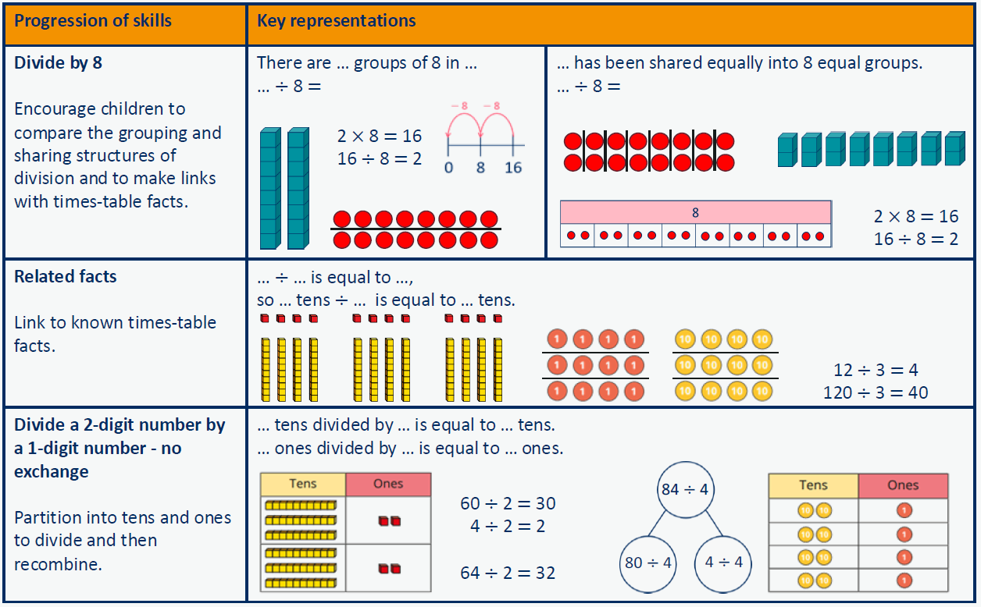
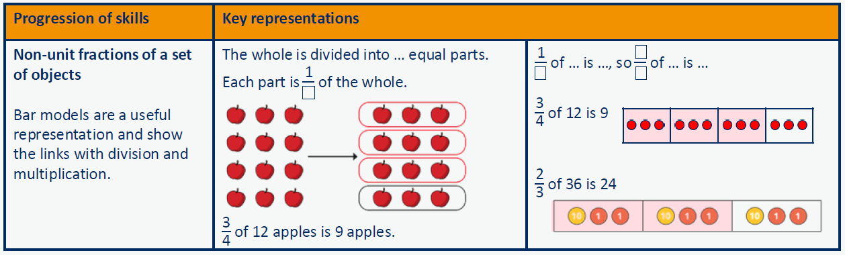
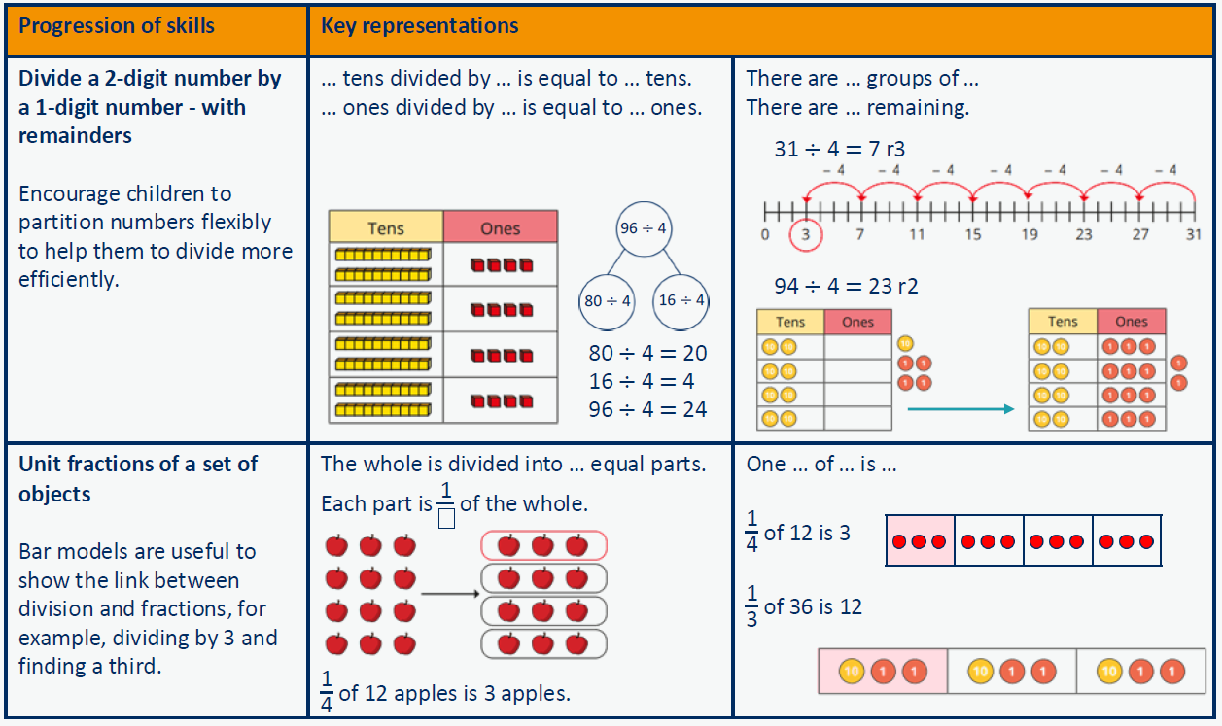

Glossary
Addend – A number to be added to another.
Aggregation – Combining two or more quantities or measures to find a total.
Array – An ordered collection of counters, cubes or other item in rows and columns.
Augmentation – Increasing a quantity or measure by another quantity.
Commutative – Numbers can be added in any order.
Complement – In addition, a number and its complement make a total e.g. 300 is the complement to 700 to make 1000.
Difference – The numerical difference between two numbers is found by comparing the quantity in each group.
Dividend – In division, the number that is divided.
Divisor – In division, the number by which another is divided.
Exchange – Change a number or expression for another of an equal value.
Factor – A number that multiplies with another to make a product.
Minuend – A quantity or number from which another is subtracted.
Multiplicand – In multiplication, a number to be multiplied by another.
Partitioning – Splitting a number into its component parts.
Product – The result of multiplying one number by another.
Quotient – The result of a division.
Reduction – Subtraction as take away.
Remainder – The amount left over after a division when the divisor is not a factor of the dividend.
Scaling – Enlarging or reducing a number by a given amount, called the scale factor.
Subitise – Instantly recognise the number of objects in a small group without needing to count.
Subtrahend – A number to be subtracted from another.
Sum – The result of an addition.
Total – The aggregate of the sum found by addition.

