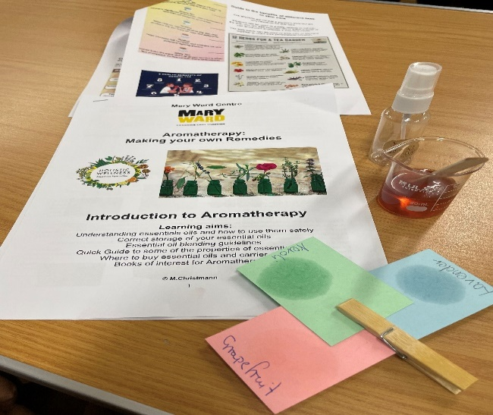
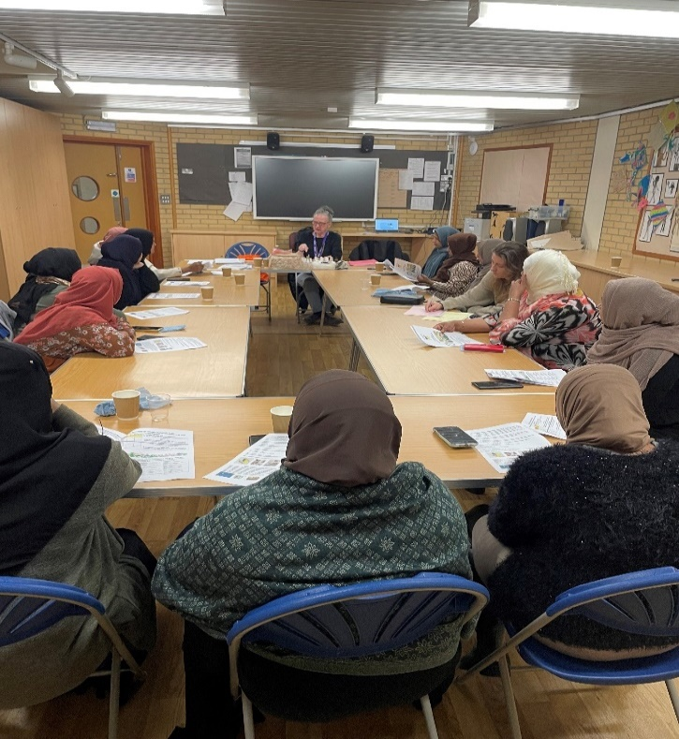
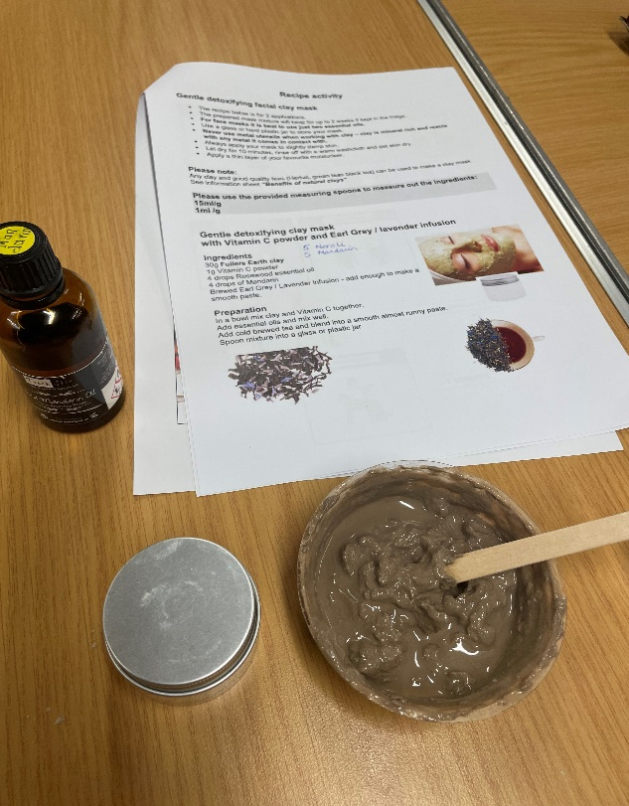
Parent Comments
I learned that aromatherapy supports mental, emotional and physical health. Using essential oils can enhance relaxation, reduce anxiety, and improve mood.
I really enjoyed this course; it was nice to meet other parents, and I learnt a few tips about how to take care of my skin and the good part was doing the exercises on a chair which I had never done before.
Really enjoyed making my own hand-made face spray oil and the face mask too. Learned how different aromas make you feel relaxed. It was therapeutic for me and just having fun, something different, something I haven’t tried before.
Mica from Mary Ward College ran a wonderful aromatherapy course for our parents. Blue Gate parents were introduced to aromatherapy, looked at guidelines around blending oils and were taught some of the properties of essential oils. The parents went away with a refreshing facial toner and detoxifying clay mask with vitamin c powder and an earl grey infusion. The sessions were filled with useful tips and ideas on how to provide relaxation using simple massage techniques. The Pilates chair exercise routine was great for the group but also useful to share with family members especially elderly relatives and those with disabilities.

