Textile Course- Mary Ward Centre - Blue Gate Fields Infants
Tutor Ann- Marie
Coordinator – Zoe
May-June 2024 No. of Parents -11
The parents enjoyed the course very much. For many parents it was about learning new skills. For others it was about making friends and for some it was about doing something creative in a safe environment which in turn impacted positively on their mental health. Through attendance on this course, parents were also in a better position to find out about other activities and events that have been going on in the school and the borough. Many of the parents in the group then went on to volunteer and make things to sell at the school fayre.
Parent Quotes
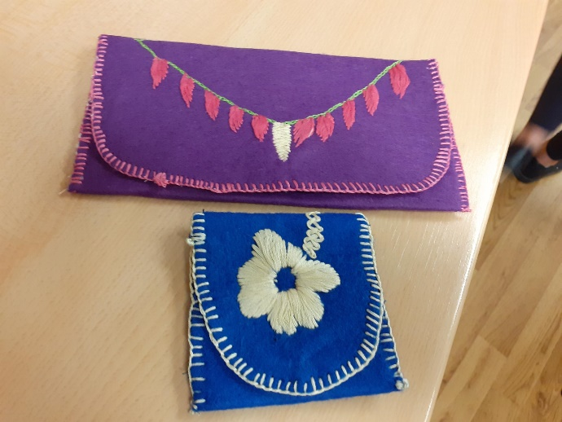
“I have developed my language skills in these sessions”.
“This course has helped me to improve my confidence. I would like to do more courses”.
“The resources and equipment we used was very good and I enjoyed making the purses very much”.
“I learned how to do hand embroidery. I’m really proud of myself”.
“The teacher was kind, patient and helpful”.


