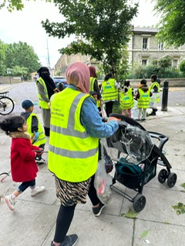
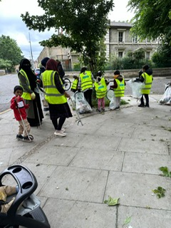
Litter Picking with the Wash Wombles
Stepney Green Farm 01.06.24
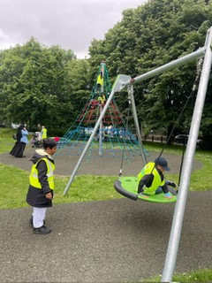
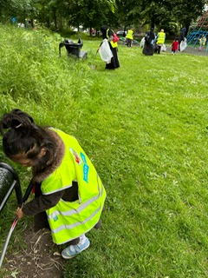
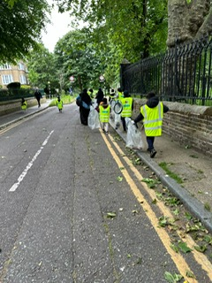
Blue-Gate families volunteered their time on Saturday 1st July to carry out litter picking near Stepney Green farm. Seven families turned up on the day and they managed to pick up 9.21kg of litter! Scientists estimate that up to 26 million tons of plastic waste end up in the ocean each year, killing millions of marine creatures. Around 80% of this plastic comes from the land as litter is carried out to sea by rivers and blown by the wind from landfill into the ocean.

The children were eager and enthusiastic and found it to be a positive experience. They even had time to take a quick rest and play on the swings at the park. The mums were also very surprised at how enjoyable the morning turned out to be. After the litter picking session, the children enjoyed seeing the farm animals.

“My favourite thing was using the picker, it was hard to pick up small bits of rubbish but it was fun too”. (Child)
“I’m so glad I came, the children really enjoyed it. I would recommend other families to do this as it is very rewarding and a fun morning out”. (parent)



