SCIENCE AT HOME yEAR 1

BUILD A SHELTER – NEWSPAPER STEM CHALLENGE

MATERIALS FOR A NEWSPAPER DEN
Newspaper
Masking Tape
Scissors
First, roll up the newspaper sheets tightly. If you roll along the diagonal, you get a longer, tighter roll. Depending on what you’re making, it might be a good idea to create rolls of different sizes.
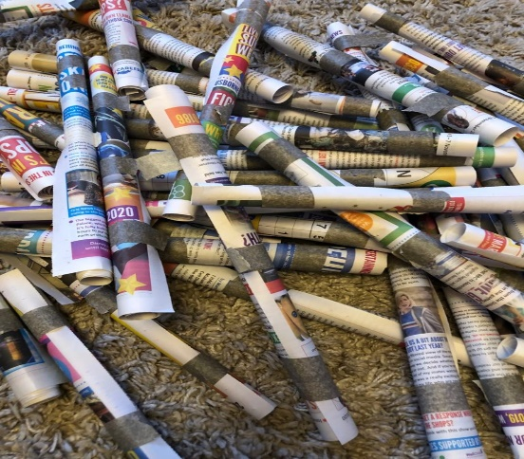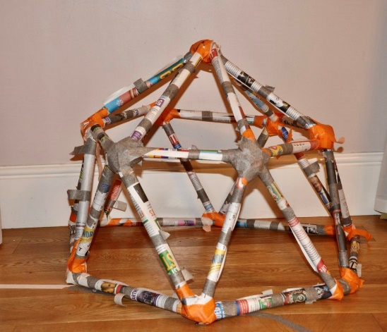
Use the masking tape to hold the paper roll in place. Tape the top, middle and bottom. GET CREATIVE

