AUTUMN 2 SCIENCE – for year one children
MATERIALS
Distinguish between an object and the material from which it is made.
Identify and name a variety of everyday materials, including wood, plastic, glass, metal, water and rock.

Look at a variety of objects and discuss what they are made of. Challenge children to find an object made of wood, plastic etc
Examples of activities
Sort into soft and hard
Sort into wooden objects and metal objects
Discuss why wood is a good material for a table, and fabric is good for clothes.

Find different materials outside.
Describe the simple physical properties of a variety of everyday materials.
For example: hard, soft, shiny, smooth, flat/bumpy, sharp/blunt,
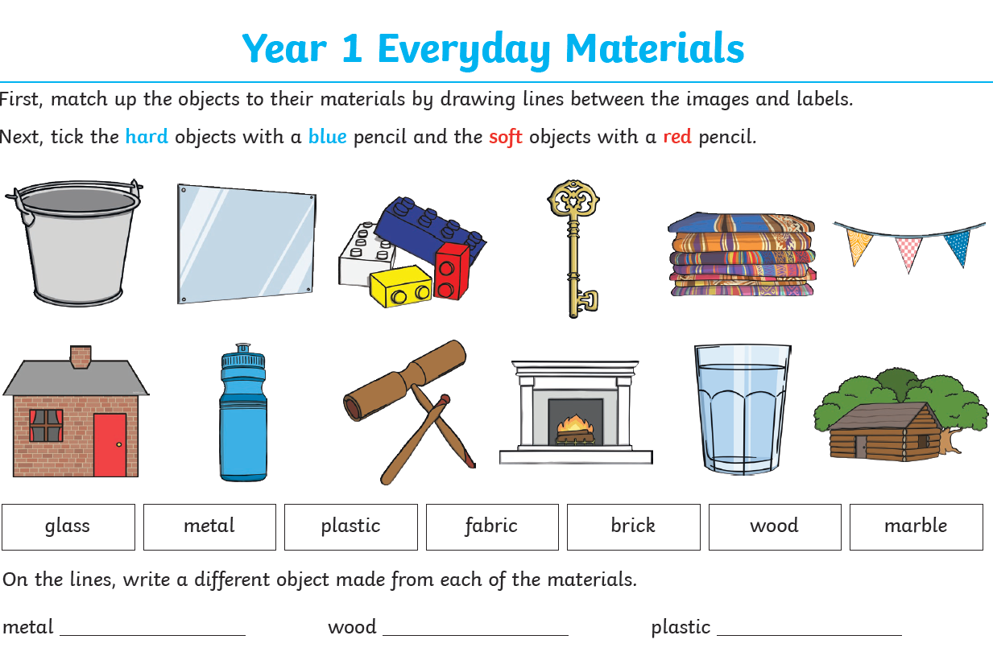
Use a variety of materials to make junk models or collages.
FUN ACTIVITY
Planning and Activities
Teaching
- Recreate the story of The Three Little Pigs using straw, twigs, bricks and other materials.
- Predict which material will be the most successful and why.
- Video the story retellings with commentary and explanations.
- Discuss why some pigs may not choose to use bricks (more expensive, heavier, harder work to build with, etc.) and suggest successful alternatives


