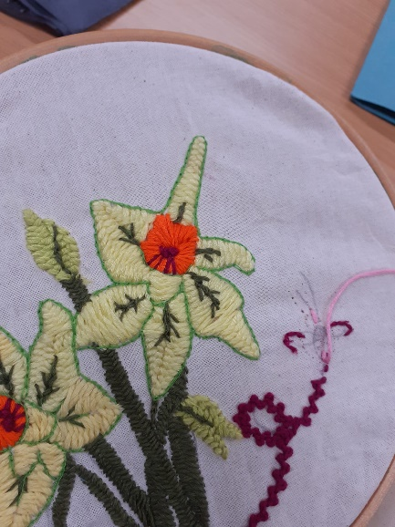
Embroidery Course - Spring 2024
Comments from Parents
With these sessions I’ve learnt new skills and made new friends. I have gained confidence to try out new things, it has been a safe place to share our worries and concerns.
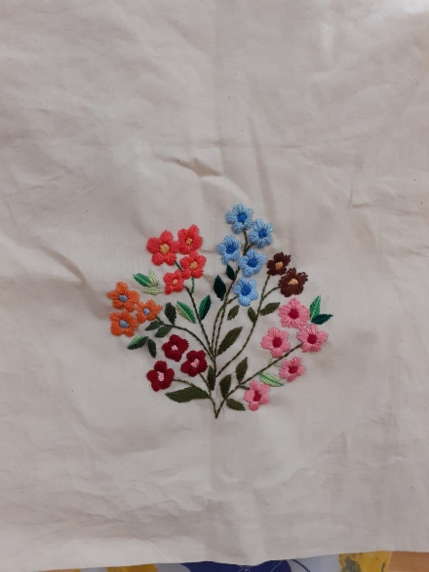
I enjoyed the class very much, I made new friends, met with different people from different backgrounds. I think we need more sessions like this.
I learnt a lot of new things and I found it very enjoyable.
I met with other mums and made new friends.
The embroidery sessions are a wonderful idea to help mums do something for themselves and pick up new skills. It allows mothers to get creative whilst making friends and have a sense of belonging. It would be nice to learn practical skills like painting, sewing and even food recipes.
This course was very good for my mental health. It was very interesting socialising with other parents, very fun and enjoyable, feel happy and proud as I have learned something new.
I feel like my migraines have improved; it has helped me to re-direct my focus on to something beneficial.
Wonderful sessions. It has helped me to socialise with other mums, making new friends, a space for yourself, away from your normal life. Really good for your mental health.
The embroidery sessions were so much fun. We got to learn new stitches. I had stress relief and it also helped with my anxiety.
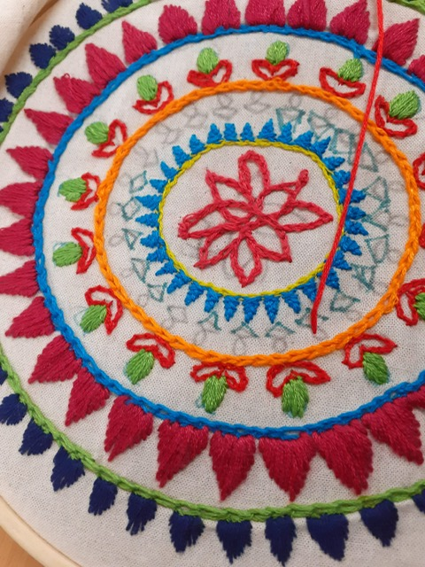
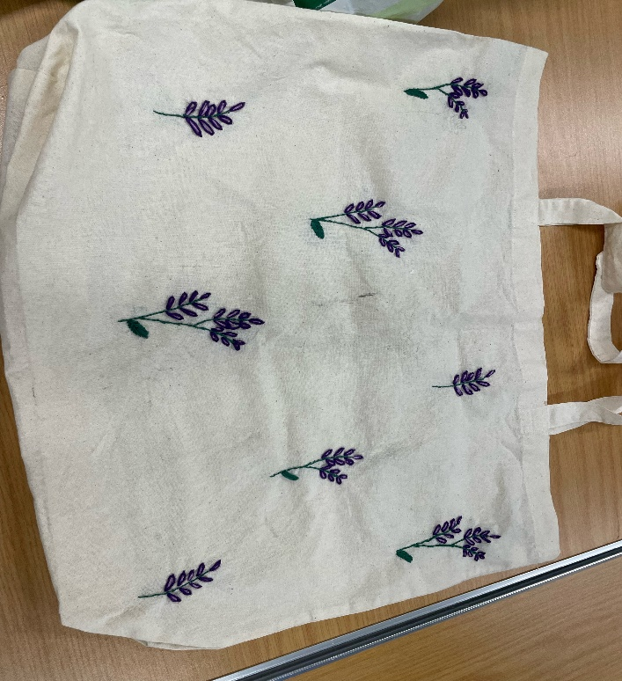
It was a great course. I learned a lot and relaxed. Its good for my mental health.


