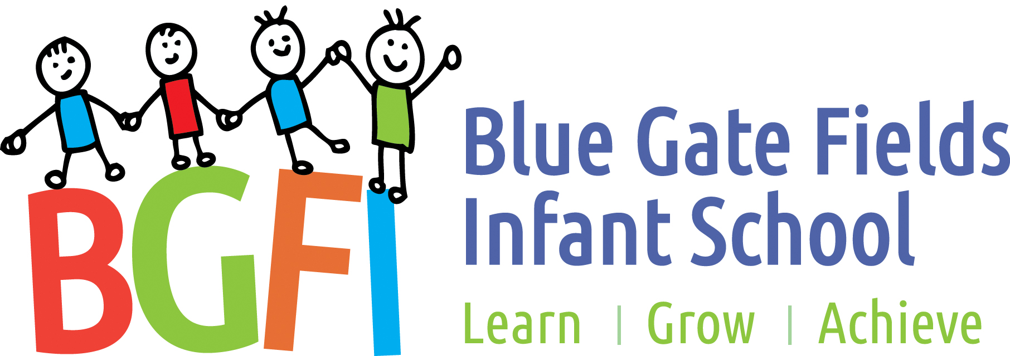
Blue Gate Fields Infant School

Physical Education Policy
Agreed by staff
Agreed by governors

Agreed July 2023 Review July 2026
This policy is the responsibility of the PE leader

Introduction
Blue Gate Fields Infant School is committed to promoting the health and well-being of its pupils and staff through physical activity. This policy outlines the organisation, teaching and management of physical activity at Blue Gate Infants.
Ethos and environment
Blue Gate Fields Infant School strives to maximise opportunities for children, young people and all associated with the school to be physically active by promoting all avenues for activity. This includes the curriculum, environment and wider community.
Definition of Physical Education
Physical Education educates young people in and through the use of the body and its movement. It aims to develop physical competence so that pupils are able to move efficiently, effectively and safely, and understand what they are doing. It is essentially a way of learning through action, awareness and observation.
Aims and Purposes
The order of Physical Education in the National Curriculum provides a basis for use to deliver a broad and balanced physical education programme which helps us to fulfil our main aims which are:
- To promote physical activity, physical development and healthy lifestyle.
- To develop social co-operation and positive attitudes and to compete with a sense of fair play.
- To develop children’s enjoyment of physical activity through creativity and imagination.
- To promote and develop safe practice in physical activities.
- To provide equal opportunities for all children regardless of race, gender, background or ability.
- To provide opportunities for all children to achieve their full potential.
- To enable pupils and staff to understand the importance of physical activity through the provision of information and development of appropriate skills and attitudes.
- To provide and promote opportunities for staff and pupils to be physically active throughout and beyond the school day.
- To increase physical activity levels of pupils in line with national targets.

Physical activity offers opportunities for all children to:
- Become more skilful and intelligent performers.
- Acquire and develop skills, performing with increasing confidence and competence, in a range of physical activities and contexts.
- Learn how to select and apply skills, tactics and ideas to suit activities that need different approaches and ways of thinking.
- Develop their ideas in a creative way.
- Set targets for themselves and compete against others, individually and as team members.
- Respond to a variety of challenges in a range of physical contexts and environments.
- Take the initiative, lead activity and focus on improving aspects of their own performance.
- Discover their own aptitude and preferences for different abilities.
- Make informed decisions about the importance of exercise in their lives.
- Develop positive attitudes to participation in physical activity.

Scheme of Work
The Val Sabin Scheme of work has been implemented in our school since 2007.
Aims of the various strands of P.E.
Dance: To use movement imaginatively, respond to stimuli, create and perform a dance. To develop awareness of the body as a medium of expression and communication.
Games: To provide opportunities for the child to learn and practice individual game skills, as well as providing a chance to put those skills into practice in game situations.
Gymnastics: To establish skilful control of body movement on the floor and using apparatus.
Asthma
All children with asthma should be noted and take medication 5 minutes before P.E if appropriate. In some cases, medication should be brought to P.E lessons.
Fasting
Teachers should be sensitive to children’s needs during times of fasting.
Hair
All long hair should be tied back and plastic/metal clips should be removed.

Jewellery
- No jewellery at all should be worn during P.E.
- Only stud earrings allowed.
- Tabis to be masked onto children’s T-shirt or chest.
- Religious symbols e.g. Cross, Star of David, Sikh bangle should be removed or made safe for P.E.
Clothing
- Children should wear t shirts, leggings, tracksuit bottoms, shorts and plimsolls.
- Any child that forgets their kit may borrow appropriate clothing that the school will supply.
- Head scarfs could increase the risk to safety in P.E, especially in gymnastics and climbing frame. They must be securely tied back or tucked inside t-shirts.
- Teachers should change footwear or take their shoes off when teaching P.E.
Planning
All year groups will follow the agreed syllabus and planning will be monitored by looking at termly planning sheets.
Where possible, some lessons will be observed by P.E coordinator to ensure progression and continuity.

All lessons should consist of:
Warm up
Skills session
Modified game or activity to enable skills learnt
Cool down or stretch

Equal Opportunities
Children should not be allowed to separate into groups on a gender or racial basis and are expected to take part in all strands of the P.E syllabus. All physical opportunities at Blue Gate Fields Infant School are designed to be inclusive and cater for different ability levels.
Inclusion
No pupils are excluded from any physical education programme. Lessons provide good quality experiences that are suitably challenging for all pupils. Pupils will undertake different activities, but all pupils are given the same opportunity to achieve the aims through an appropriate range of activities. For pupils with limited gross motor skills, the integrity of activities is maintained and expectations take into account the individual needs of pupils.
Assessment
This can be achieved by:
- Watching children at work/skills tick list
- Talking with the children about what they have done.
- Listening to them describe what they have done.
- Children discussing the importance of exercise and staying healthy.
- Photographs and videos (with parental permission)

Record Keeping
Recording children’s progress should be selective and brief. Significant achievements or weakness may be noted to serve as a basis for planning appropriate challenges or to form part of annual report on progress.
Accident Procedure
- Stop activity and isolate victim.
- Assess situation.
- Send for first aider.
- When person has arrived, teacher will return to classroom with rest of class.
- Teacher makes relevant notes, time and activity being taught.
- Parents are informed of accident.
- Accident book is filled in.

Safety:
Apparatus.
No apparatus to be dragged across the floor.
Mats should be carried by 4 children, one at each corner.
Benches should be carried by 2 or 4 children or two adults
Note: Children should begin to lift and carry equipment from an early age and be taught the correct techniques.
All apparatus should be checked by the teacher before their class use it.

Indoor P.E.
- Check apparatus and make sure it is good working order.
- Apparatus should not be placed too near to a wall and a suitable distance between each piece of equipment should be kept to avoid collision.
- Make sure mats have no overlap or space between them.
- At end of lesson, ensure all equipment/apparatus is stored neatly and carefully in its correct space.
Apparatus, which appears faulty, however minor, should not be used. A notice should be placed on it immediately and coordinator informed. Head teacher should be notified in writing.
Outdoor P.E.
- Make sure the playground is clear of obstructions.
- Make sure children can see and hear you clearly when giving instructions.
- Set boundaries/grids for children to work in using playground markings or cones/skittles.

Curriculum time that all pupils in each group spend taking P.E in a typical week.
Nursery / Reception: Ongoing continuous provision activities and games outside and within classroom. Fit in five every day. 30 Minutes total. Reception have one 50 minute PE hall time each week.
Year One and Two children all have 1 hour 30 minutes of PE/games/gym each week. Teachers adapt schemes of work to the needs of their own class.
The school employs a teacher who specialises in PE. Each year group gets a term of at least a 40 minute lesson per week with the specialist teacher. See appendix 1.
Teachers are encouraged to participate in these lessons to gain skills and strategies in teaching gymnastics and games skills.
Lunch time and after school physical activity clubs
The school runs at least one After School Club with the specialist teacher a week. This is normally football or games skills.

Resources:
Available areas: Hall and playground.
Range of gymnastics equipment including moveable apparatus, benches and mats.
Games equipment. Different size balls/bats. Quoits, hoops, ropes, beanbags, skittles, hockey sticks, cricket bats, tennis and basketball equipment.

Promotion of physical activity
The school encourages children, staff and parents to be physically active. The school has an up-to–date School Travel Plan that is regularly reviewed and updated. There are displays around the school encouraging children and parents to walk to school.
The school holds parent workshops, to encourage parents to consider more healthy lifestyle choices such as walking to the shops or park rather than taking the car; encouraging parents to take their children swimming regularly; how to cook food using less fat and salt; etc. These sessions have been led by the Parental Engagement Team. Parents are encouraged to evaluate these sessions at the end of the course.

FINAL STATEMENT
Our aim is to link good health, behaviour and achievement through a whole school approach.
We believe in achieving better outcomes around health and well-being for children and young people and within P.E and other areas of the curriculum, such as science and PSHE, to help children gain the confidence, skills, knowledge and understanding to make healthy life choices.

This PE policy was approved by governors in July 2023 and signed by the chair of governors.

……………………………….. …………………. Chair of governors.
……………………………………………………. Date
It will be reviewed in July 2026 or sooner in the case of new information, changes or legislation.

Appendix 1
Class | Autumn 1 | Autumn 2 | Spring 1 | Spring 2 | Summer 1 | Summer 2
Saturn Rec | Games | Games | Dance | Dance | Gym | Gym
Venus Rec | Games | Games | Dance | Dance | Gym | Gym
Pluto Rec | Games | Games | Dance | Dance | Gym | Gym
Jupiter | Games | Dance | Gym | Games | Dance | Gym
Mars | Games | Dance | Gym | Games | Dance | Gym
Moon | Games | Dance | Gym | Games | Dance | Gym
Mercury | Dance | Dance | Gym | Gym | Games | Games
Neptune | Dance | Dance | Gym | Gym | Games | Games
Sun | Dance | Dance | Gym | Gym | Games | Games

