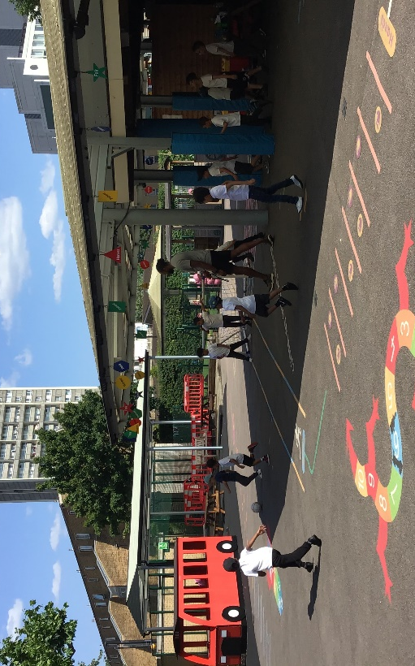
After School Club – Football
In Football club, we have focused on developing the children’s spatial awareness and various football skills. This includes dribbling, passing and shooting with accuracy.
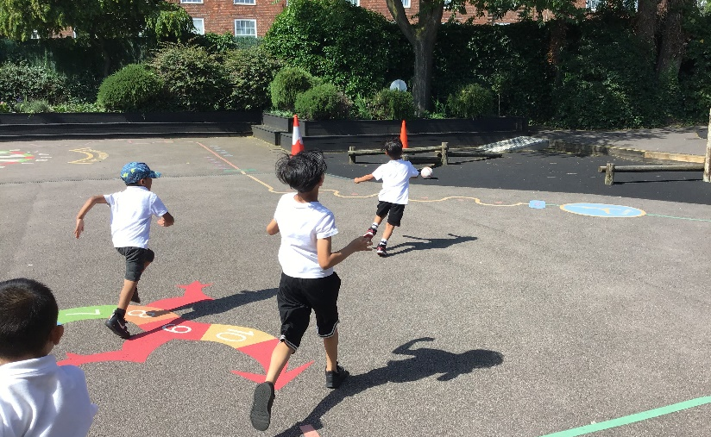

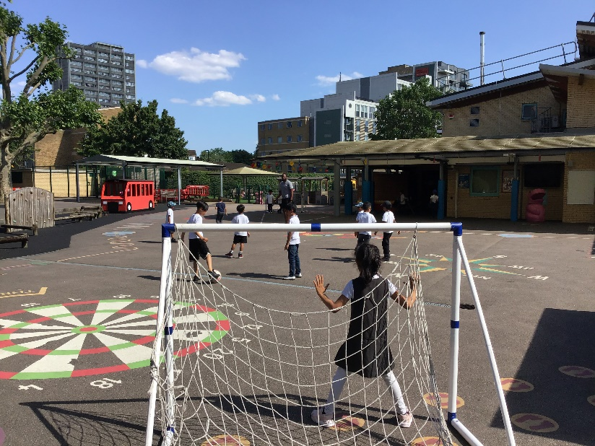
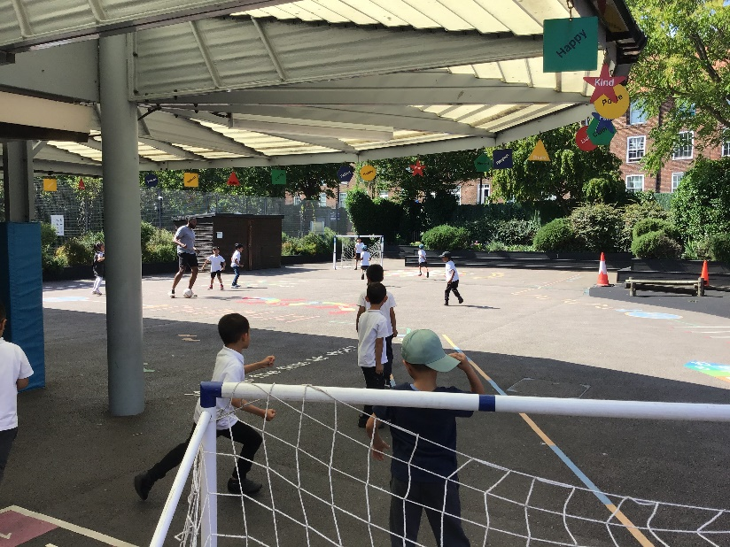
“I have learnt new skills. I enjoy football.”
Child M, Reception
“I love football club with Chika and Raquel”
Child A, Y1



