Year 2 Geography spring 2 – Seas and Coasts Knowledge Organiser
Key Knowledge:
- Pacific Ocean, Atlantic Ocean, Southern Ocean, India Ocean and Arctic Ocean.
Where they are located and what you know about them?
North Sea, Irish Sea, Celtic Sea, English Channel, Straits of Dover, Bristol Channel, Bay of Biscay. Where they are located and what you know about them?
- Asia, Africa, North America, South America, Antarctica, Europe, Australasia.
- To read and use a compass to navigate a map.
- To know about the countries that make up the of the United Kingdom.
- To compare the similarities and differences of the local area with a contrasting area in another country.
- To understand the importance of oceans and seas in everyday life and what important resources they are and provide.

Key Vocabulary:
ocean– is a huge body of saltwater.
sea – A body of saltwater of second rank.
coastline – where the sea and the land join. They are adjacent top each other.
continent – a large solid area of land. There are seven continents in the world.
country– a land lived in by people.
compass points – directions listed on a magnetic compass. The four main points being, North, East, West and South.

Key skills: Identify and name the fiver oceans and surrounding seas of the UK. Identify and name the points of a compass and use to describe where something is. Use different resources to find out informative information.

Do you remember learning? In Year 1 you looked at the local area of Shadwell and the River Thames

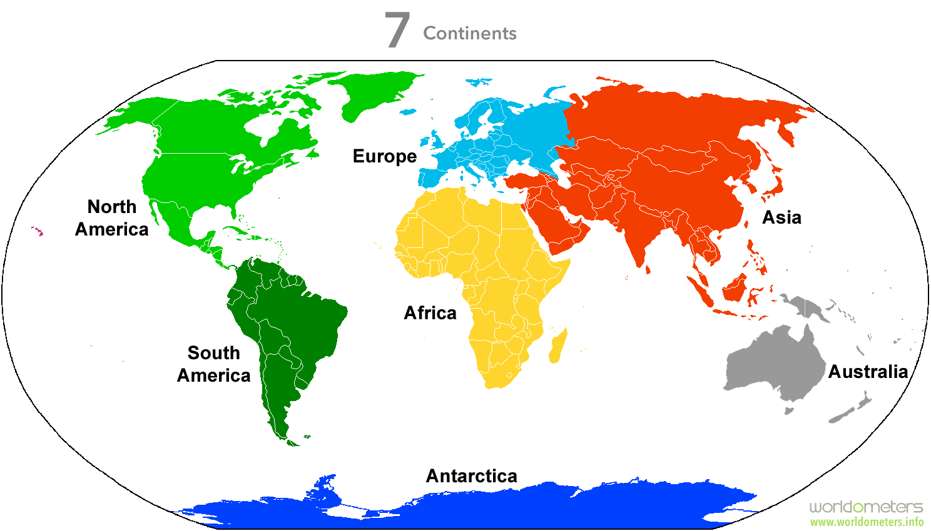
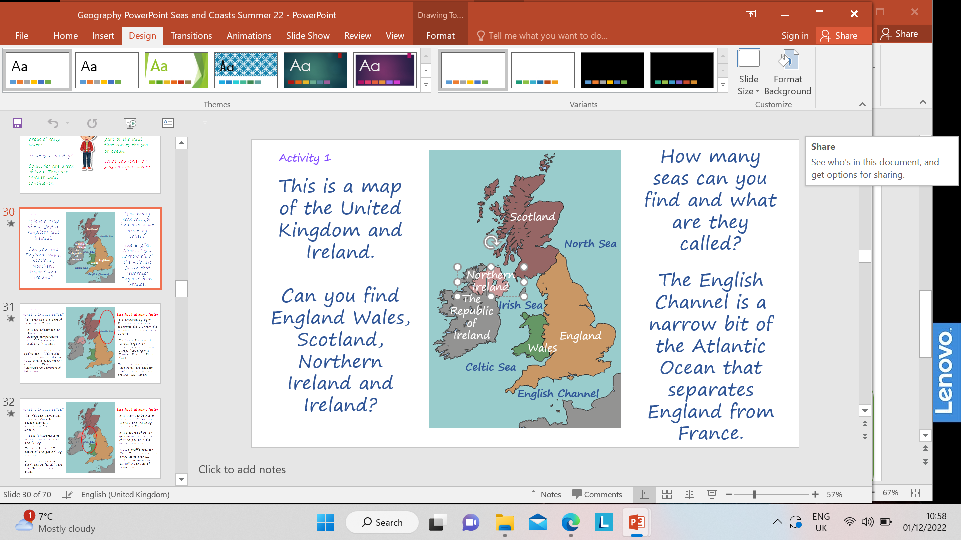
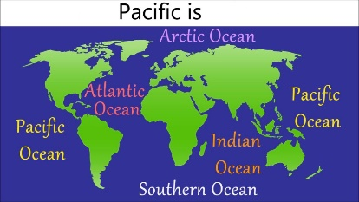
Can you recognise the difference between an ocean and a sea?

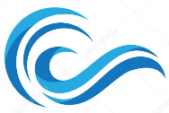 ocean 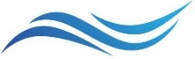 sea

