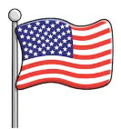

KNOWLEDGE ORGANISER
NEIL ARMSTRONG
Overview  A photograph of Neil Armstrong from April 1969. |  |  | Answers to Important Questions and Key Vocabulary
Neil Armstrong (1930-2012) was an American astronaut who is famous for being the first person to walk on The Moon.  He went to the moon as the Commander of a NASA (the American Space Agency) mission called ‘Apollo 11.’  Joining him on the mission were two other astronauts – Buzz Aldrin and Michael Collins. Buzz Aldrin was the second man on The Moon.  As he set foot on the moon, he is famous for saying the words “That’s one small step for man, one giant leap for mankind.”  Before he became an astronaut, he was test pilot who tried out many different kinds of planes. | 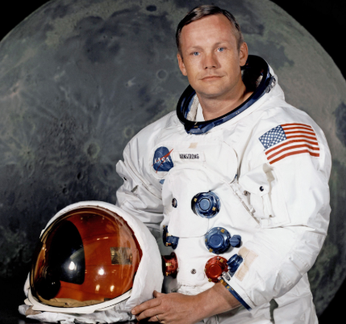 |  | What did Neil Armstrong do on The Moon? | 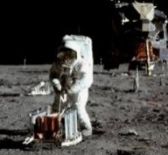  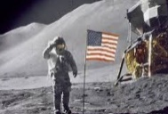 | -Immediately after landing on the moon, Armstrong and Aldrin prepared the Lunar Module for take-off in case there was an emergency.  -They spent most of their time on the moon collecting samples from the Moon to take back to Earth.  -They placed an American flag about 8 metres from where they landed.  -They also took lots of photographs of the surface of The Moon. |  |  | Key Vocabulary  Astronaut  Space  NASA  Earth  Moon  Lunar Module  Launch  Apollo  Flight  Pilot  Commander  Orbit  Quarantine
 |  |  | How were the astronauts chosen for the moon landing? | 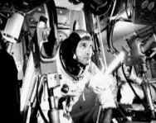 | -The men on board Apollo 11 were all experienced astronauts who had been into space before. Armstrong has dealt with difficulties in space before during the Gemini 8 mission.
 |  |  | How did the astronauts get back to Earth? | 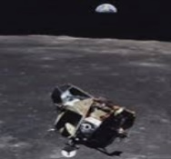  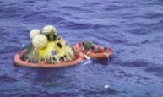 | -After just over 21 hours on the moon (2 ½ hours of which were spent walking out of the lunar module) Armstrong and Aldrin lifted off from The Moon.  -Their lunar module then joined back together with the command module (which Michael Collins was still in) before firing back to Earth.  -The spacecraft reentered back into the Earth’s atmosphere and into the Pacific Ocean on 24th July.
Times in His Life
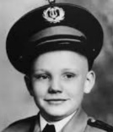  Early Life  -Neil Armstrong was born on 5th August 1930 in Wapakoneta in Ohio, USA. He went to air shows from an early age with his father. This made him want to be a pilot when he was older.  -At the age of 16, he achieved his pilot’s licence. He then went to college to study aerospace engineering. | 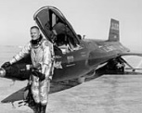  Korean War  -In 1949, Armstrong trained as a pilot in the navy.  -Two years later, in 1951, he was sent to fly in the Korean War.  -He flew 78 missions before returning to college. |  | What did Neil Armstrong do during the rest of his life? | 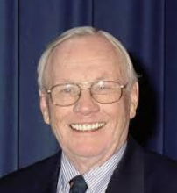 | -The 3 astronauts had to spend 21 days after the mission in quarantine, to make sure that they could not spread any harmful Moon diseases on Earth!  -Because of their success, they became very famous.  -Neil Armstrong became a Professor at colleges and universities, and then helped NASA with understanding their later missions.
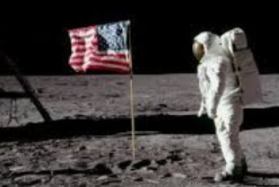
NASA/ The Moon Landing

-Armstrong applied to become an astronaut, and in 1962 he trained to be an astronaut at NASA. In 1966, he went aboard the Gemini 8 ship – his first trip into space.

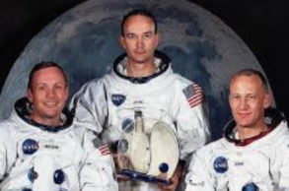
-On 23rd December, 1968, Armstrong was offered the commander position for the Apollo 11 mission, which was to be the first American attempt to put a person on The Moon.

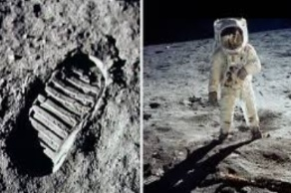
-After months of preparation, the crew (Armstrong, Buzz Aldrin and Michael Collins) were launched into space from the Kennedy Space Centre on 16th July 1969.

-There was one scary moment where Armstrong had to take over control of the landing. If this had gone wrong, there wouldn’t have been enough fuel to get them home! Luckily, Armstrong did the job well. As they touched The Moon, he said ‘The Eagle has landed.’

-Armstrong stepped out onto the moon’s surface on 21st July 1961, stating ‘That’s one small step for man, one giant leap for mankind. Buzz Aldrin joined him on the moon 19 minutes later. Michael Collins kept the command spaceship in orbit around the moon. They stayed for around 3 hours before setting off home. They landed in Pacific Ocean on 24th July, returning to earth as heroes!
 |  |  | Top 10 Facts!
 |  |  | - Six hundred million people watched the moon landing on television (600,000,000 people!)  - Neil Armstrong was given the Presidential Medal of Freedom, which is the highest honour that a civilian can be given.  - He had to stop signing autographs for people, as they were selling them on the internet!  - He was a boy scout as a child, and earned the Eagle Scout Badge.  - Neil Armstrong learnt to fly before he could even drive! |  |  | - The footprints made by Neil Armstrong and Buzz Aldrin are still on the moon. There is no wind to remove them.  - Neil Armstrong received an engagement star for his heroics in the war.  - Neil Armstrong’s left foot was the first to touch the moon as he stepped from the module  - After his return to earth, Neil Armstrong became an immediate celebrity.  - In later life, he helped NASA to investigate why some of their missions had gone wrong.

1971: Becomes a University Professor.
Late 1969: Receives awards including Medal of Freedom.
25th August 2012: He dies in Ohio, aged 82.
July 1969: Apollo 11 – the moon mission. On 20th July, he becomes the first person to walk on the moon.
1966: Goes into space for the first time.
1962: Armstrong joins the astronaut programme at NASA.
1952: Armstrong joins the organization that became NASA.
1949: Armstrong fights for the US Navy in the Korean War.
1946: At 16 years old, Armstrong gains his pilot licence.
Neil Armstrong Timeline
5th August 1930: Neil Armstrong is born in Ohio.

