Knowledge organiser – Topic – Journeys ~ Food
Knowledge skills and concepts | Key vocabulary | Features of the topic
In this unit, the children will:  - understand geographical similarities and differences through studying the human geography of their local shops, and physical geography through studying nearby food growing or production  - use locational and directional language (e.g. near and far) to describe the location of features and routes on a map  - name, locate and identify characteristics of the four countries and capital cities of the UK, and its surrounding seas  - to use world maps, atlases and globes to identify the UK and its countries, as well as the countries, continents and oceans studied at this key stage. | High street, shops, supermarket, market, farm, local, locality, fast food, frozen food, fresh food  Kitchen, food, lunchbox, food story, farm, plant, raw ingredients, whole animal, change (processed), packet, factory, delivered  Farm, farmer, tractor, big or small area, flat, hilly, mountainous, stream/river, coastal, fields, eggs, chickens, wheat barley  Cow, milk, farm, farmer, wheat, barley, oilseed rape, pasture, grassland  United Kingdom, Wales, Scotland, Northern Ireland, flat, lowland, pig, pork pie, oats, oatcakes, traditional, picnic  United Kingdom, Wales, Scotland, Northern Ireland, South East, London, North West, East of England, West Midlands, South West, Yorkshire and the Humber, East Midlands, North East, landscape, landmarks, human, physical | 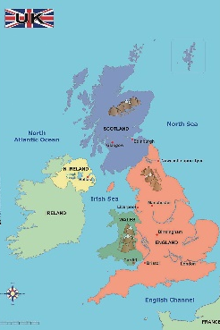  Name the four countries  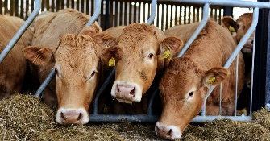  Meat and dairy farming  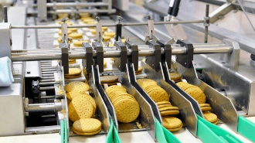  How food is produced  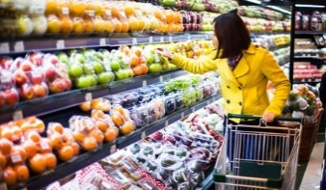  Food in shops

