Year 2 History autumn 2 – The Great Fire of London Knowledge Organisor
Key Knowledge:
- The fire started Sunday 2nd September 1666 in Thomas Farriner’s bakery in Pudding Lane.
- The fires used for baking was not put out properly.
- In 1666 the buildings were made of wood and straw and were very close together.
- It was also a very dry summer that year.
- People used leather buckets and water quits to try and put out the fire.
- King Charles 11 ordered the buildings to be pulled down to stop the flames from spreading.
- On Thursday 6th September, the wind died down and this meant that people were able to put out the flames.
- Samuel Pepys witnessed The Great Fire Of London and wrote a first hand account of what happened in his diary.
Key Vocabulary:
Samuel Pepys – Famous for keeping a diary.
Pudding Lane – A small street famous for the bakery.
King Charles 11 – A king who reigned from 1660 – 1685.
fire break – a gap that stops a fire from spreading between buildings.
cart – a strong vehicle with two or four wheels pulled by a horse.
water squirt/ fire hook – items used for helping put out a fire.

Key skills: Discussing and ordering events around the great Fire of London. Enquiring using images of artefacts and evidence making suggestions. Researching by looking at simple resources.

Do you remember learning? In Year 1 you used a timeline to order events and finding out about events beyond living memory.

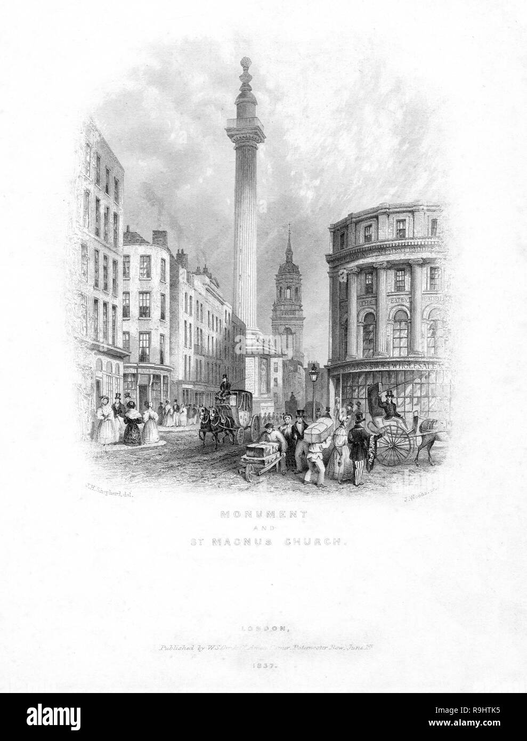
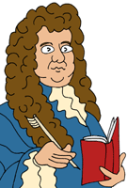
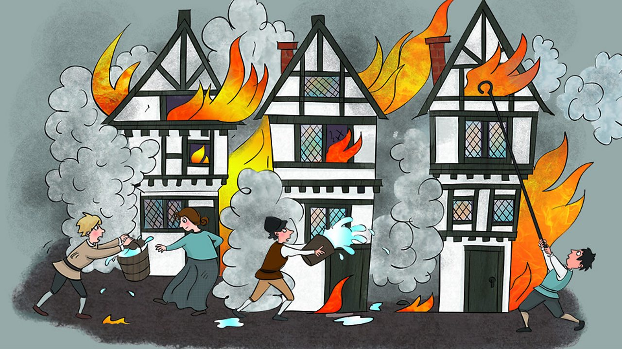
Where does ‘The Great Fire of London’ fit on the timeline?



